 Tip sheet – Training 2

Montana Alternate Student Testing (MAST) Pilot Program

Kite Educator Portal
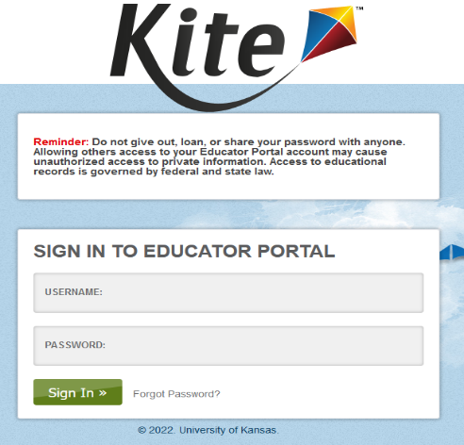
Kite Educator Portal is used by educators for entering student accommodations, monitoring test sessions, and retrieving student/class data through data extracts.
URL: https://educator-testlet.kiteaai.org
Users will use their full email for the username and the password they set when activating their account.
Users can request a reset password link to be sent through email if they have forgotten their password.
The account must be active to use the password reset function.


Here is the view of the Educator Portal Homepage. From top to bottom we have the “Role” dropdowns that allow users with multiple locations and/or multiple roles to easily switch between them. Below that is our blue navigation button set. These buttons and their sub-menus will take users through everything Educator Portal has to offer including student and roster information, user modification in some roles and data extracts on testing status.

Below that and to the right is the link to “My Profile” which contains personal account settings and allows for changes like password modification, display name change and view the user security agreements.

Navigation
The settings tab is where users will view and manage various types of data.
The organization page allows you to view the organization id and name, which is useful when uploading users, students and rosters.
The roster page is where users tie the students to their teacher.
The students page is where users will view student data and modify personal needs profiles for the students.
The users page is where everyone gets added to Educator Portal and accounts are managed.
Within the interim tab there is Build or Copy a test, manage groups and assign tests, these are not currently being used for the Testlet program.
However, within “My tests” there is the manage test tab, you can view the Interim test sessions, monitor students progress on the Interim tests and view and print the test tickets.
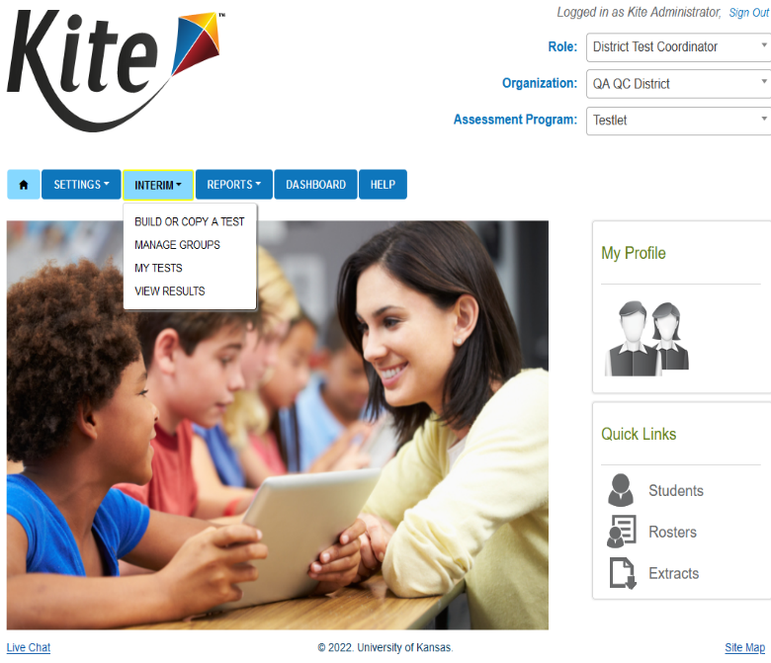
The final option is View Results, this option contains the reports for the Interim predictive tests.
The reports tab contains several different extracts, such as the Current Enrollment, PNP Settings(Abridged), Roster, and Users extract.
Extracts come in .csv format and it is recommended to use Excel to view and modify any extracts as that is what is used when uploading data.
You can also use the Users extract to upload to the User Upload tab if you need to correct multiple users at once
The Help tab allows user access to some answers to common questions. We also can put in assessment program or role specific documentation or content.

Setting Student Accommodations
Some students require additional supports during test administration. The Kite system allows for educators to identify those supports that are used in the classroom and enter them into the Personal Needs Profile (PNP).
If a student needs a paper copy of the test, please notify Samantha Walsh, Project Manager no later than November 4 by 5:00 PM MT.
Personal Needs and Preferences, (PNP)s should be set 24-hours before beginning an assessment for accommodations such as Spoken Audio (TTS) and Keyword Translation Display.
Other accommodations like Color Overlay and Magnification can be set shortly before beginning an assessment.
To navigate to set accommodations for student in the PNP profile, you would go to settings > Students > View Students, select the needed organization information in the drop-downs and click search. In the table you will see the student information and the PNP Profile with the blue hyperlink to set the accommodation. Alternatively, select the link in the PNP Profile column to go into that student’s PNP.
In the PNP Profile column there are two statuses that the PNP profile can be in. Either "No Settings" if the PNP has not been started yet and no settings have been selected or '"Custom", when the student has accommodations that have been set.
To set or modify the PNP accommodations click on the status link under the PNP Profile Column. You will then be brought to the summary page to view what has already been set or it will be blank showing no accommodations have been selected yet.
The basic process of making PNPs are to Review what needs to be selected, Make the selections, and then Save the settings.
Below is what it looks like when applying PNPs. You'll need to select the Edit Settings button first to make any changes. Use the tabs at the top to navigate between different accommodations. Select the Save button when finished.
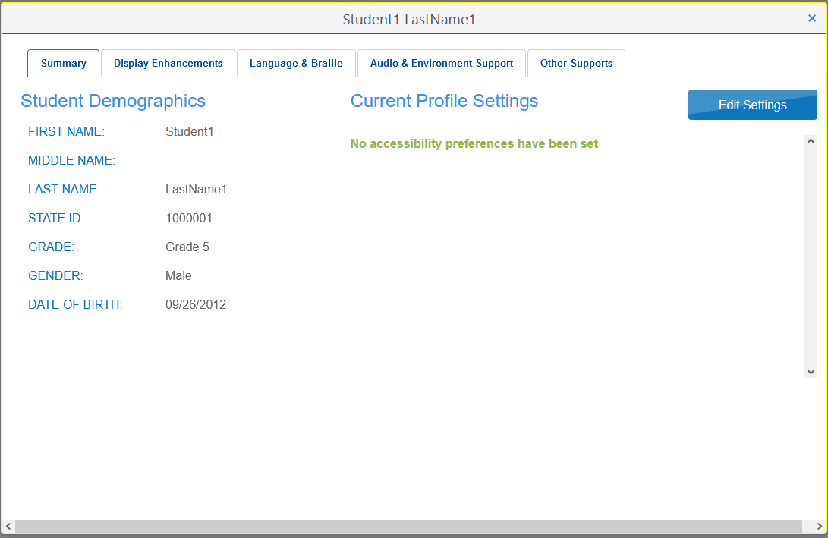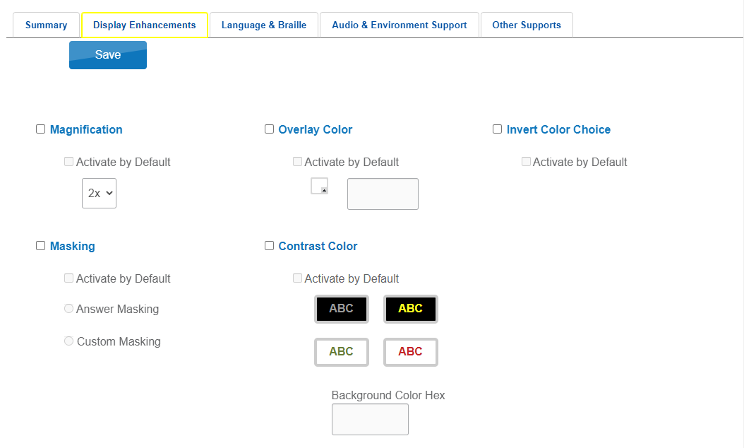
Another option to set or edit multiple students PNP settings at one time is with the PNP Setting (Abridged) Upload.
You would go to Reports > Data Extracts > PNP Settings (Abridged), Click new File in the Action column. In the create extract pop up you select any needed drop downs and Excel as this will provide the accepted options in dropdowns.
Click okay and the file will generate. Initially it will be in Queue and once it has generated you will see the Excel file icon. Select this icon to open the file. There are a few columns that need to be left blank that do not apply to Testlet.
Once all changes have been made to the PNP Settings (Abridged) Excel file you will need to save the file in the CSV format and then you are ready to upload it to Educator Portal.
Go to Settings > Students > Upload PNP tab, Click "Select File" and locate the file that you have edited and saved in the CSV format, click Open and then the Upload button.
The file will first be in a pending status as it is being uploaded and then once it is finished the table will state how many rows were completed and if any row were rejected. If there were rejected rows a file will generate with the explanation in the File column.

Reviewing Rosters
As a part of the test administration process, it is important to review rosters to ensure students are associated with the correct teacher. Rosters are an important step when it comes to test generation and assigning correct tests. Without rosters, students will not receive tests.

While “enrolling” simply states the student exists, this is their age and location. Rostering actually provides the system with what subjects the students will test and provides connections to teachers. While it may seem straightforward that all students take Subject X and Subject Y, there are exceptions and the rostering process allows us to build that out.

Teachers can then access the student’s login information and also have access to the student’s profile in Educator Portal. The teacher can then use that to add personal needs accommodations and enter other student-specific data.

The next two steps will include selecting the Educator. The list of users in that dropdown are all users who have “teacher” roles at the location you’ve specified in the first step. Once the is teacher selected, you can select students. Using the table you can filter and search for specific students or groups of students to ensure all are added. If you miss one, don’t worry. You can always modify the roster later by either adding students using the checkbox or removing them by unchecking the box.

There are no limits to how many rosters a teacher may have. One teacher could have 12 ELA rosters if they needed. We *DO* limit it by student, so a student can only be in a given subject’s roster ONCE.

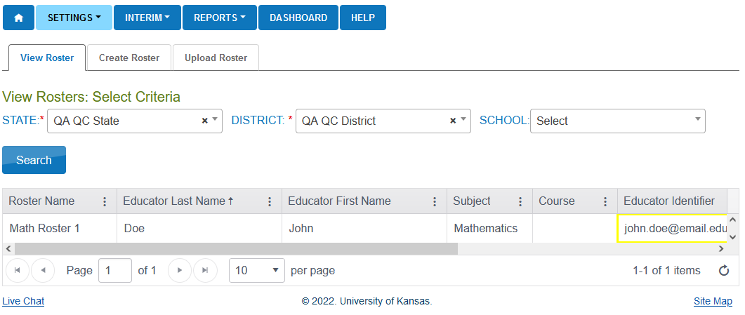
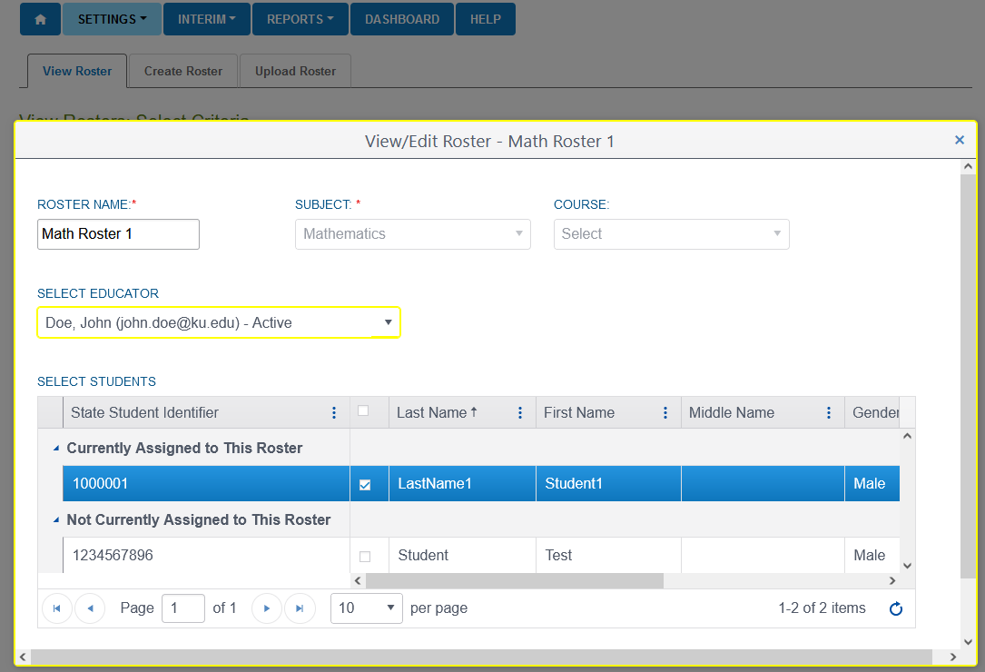

Retrieving Student Logins
In order for students to take our tests, they must have a username and password to access tests in Kite Student Portal.
Student logins for interim testing can be found under the interim tab when going to Interim > My Tests > Manage Tests > Click search > Select a row > Click on the tickets button located at the bottom of the grid. This will download a PDF with student logins who are assigned to that interim test.
You can also access student usernames and passwords from an extract on the Data Extracts page.
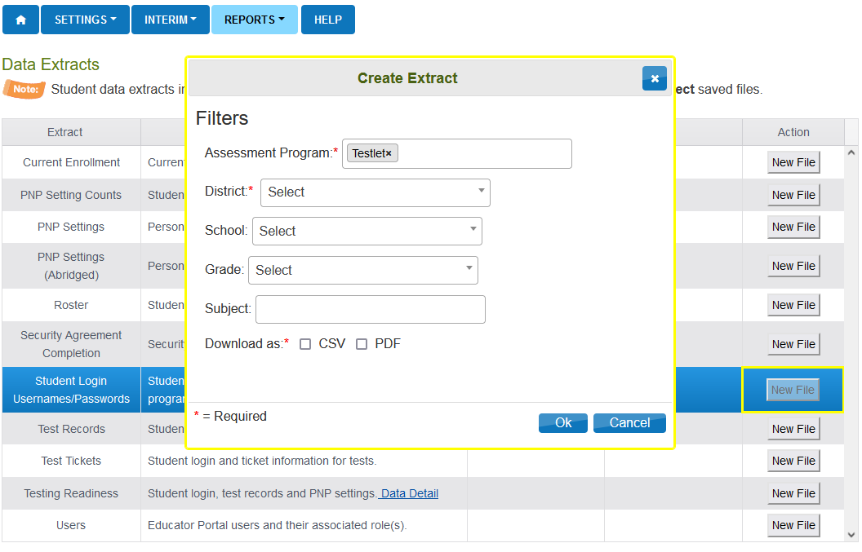

Student Logins can also be available in an extract. To download the extract to your computer, you can go to Reports > Data Extracts > Student Usernames and Passwords. Once the extract request has processed, a CSV or PDF icon will appear in the row along with the date in which the extract was requested. Student usernames and passwords will stay the same throughout testing.

Monitor Test Sessions
Educator Portal offers the ability for some roles to monitor test sessions in real time. When monitoring tests, you will be able to see which students have started the test and whether they have completed various sections of the test.
Monitoring interim testing can be done under the interim tab when going to Interim > My tests > Manage Tests > Select section to monitor > Click the Monitor located at the bottom the grid.
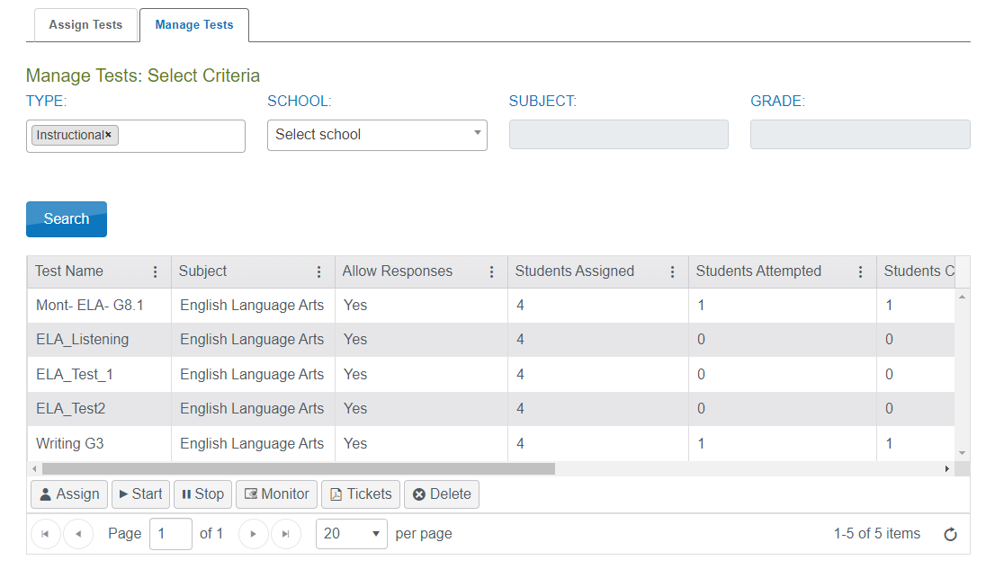
On the Monitor Test Session overlay screen, it will list the students name and show the Overall Status which will indicate whether the student has started a test. Test administrators can see the number of unanswered questions and the answer legend.
If there are any unanswered items, test administrators can see which specific item has not yet been answered for individual students. Many educators will have students wait to submit the test until they can confirm everything is answered.
Make sure to check the legend at the bottom as it corresponds to the blue circles on each column. They represent individual questions. The test shown is ONE test that has TWO sections and each section has TWO items within. Filled is answered, hollow is unanswered. While the test will automatically end after the student completes it or after a set timeout period, it may become necessary to reactivate the test session. Only a “complete” status will be able to be reactivated.

Reporting
Kite provides various levels and types of reports on student progress as well as various other metrics. Inside the interim tab we have a section for showing the predictive reports associated with the predictive assessments. We allow individual student reports as well as an enhanced bundling function allowing higher level users to choose from various locations and criteria to pull data together in one report.
The Individual Student Report will give information only on the student that is associated with that report. You will use the process of dropdowns we’ve shown before in various other areas of Educator Portal to select criteria and narrow down the location of the student and testing season. Clicking one of the student’s names provides the PDF copy of the student’s testing results, based off of the criteria you select in the dropdowns.
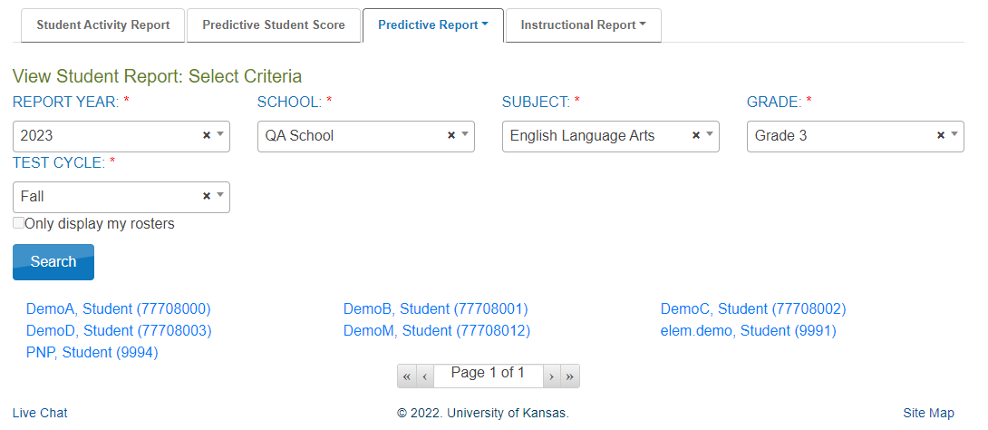
Bundled reports are great for district and upper-level building or school roles. They allow those users to select similar criteria as the individual student report, but with bundles it allows a collection of the reports to be viewed and downloaded at one time.
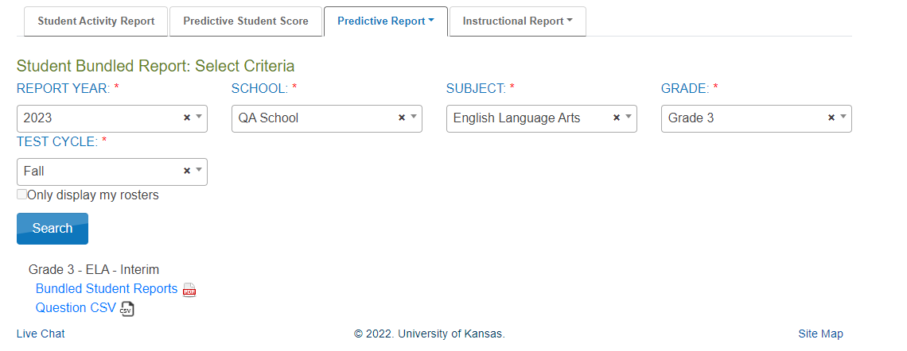

Kite Student Portal Install
Kite Student Portal is an application that must be installed for the students to take tests using our system. We provide applications, support and documentation for PC, Mac, Chromebook and iPad.
The following devices and operating systems are supported:
- ChromeOS 91+
- iPadOS 14.3 - 15.5
- macOS 11.1 – 12.0.1
- Windows 8.1, 10 & 11
Mac and Windows
- The current version is 10.0.0
iPad and Chromebook
- Current version is 10.0.0 for Chromebooks and 10.0.0 for iPad
  - If enabled, Kite Student Portal will auto-update

Here is a list of the current installation links available for the Testlet Kite Student Portal application.
Mac
- https://files.kiteaai.org/installers/test/New%20Meridian/1.0.0/Testlet%20Kite%20Student%20Portal.dmg
Windows
- .exe
  - https://files.kiteaai.org/installers/test/New%20Meridian/1.0.0/Testlet%20Kite%20Student%20Portal.exe
- .msi
  - https://files.kiteaai.org/installers/test/New%20Meridian/1.0.0/Testlet%20Kite%20Student%20Portal.msi

Provide this to your Technology Director/IT Team to get the whitelisting and application installed.

Kite Student Portal Navigation
The Kite Suite captures telemetry data through Kite Student Portal including testing time, response time, and click histories.
Whenever the student starts and ends the test, the start and end times are captured and stored in our database. In addition, the test status is updated to in-progress or completed to reflect the student’s testing status. The student responses are saved to the database as the student answers the question and navigates to the next question. This ensures all the student responses are saved to the database.
Students will launch the Testlet Kite Student Portal on their testing device. Enter the username and password that the test administrator got from Educator Portal and click sign in.
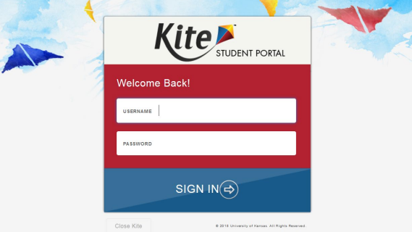
This will bring the student to the Student Portal Landing page where they will select Take a test to begin testing.
The App is easy to use and provides the student with options to take a test, practice first, sign out which will take you back to that login page or to “close” Kite which will close the app and return you to your normal desktop environment.
If a student has multiple tests, they will show within the take a test view. If a student has tests available from different testing subjects or programs they will also show by selecting the appropriate subject on the left side of the screen.
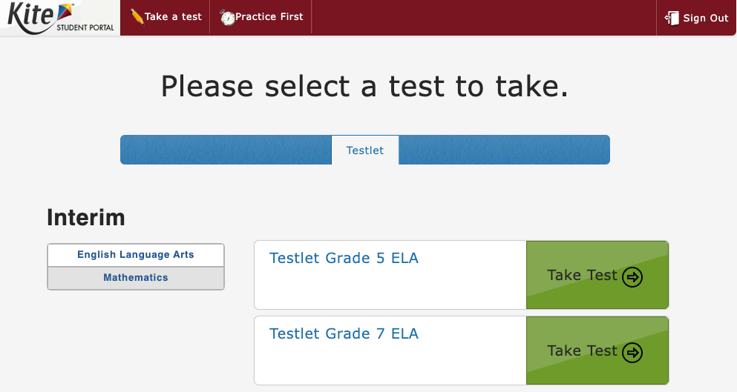
There are various tools within Student Portal and they are found with the Tool box on the left side of the screen.
If TTS is set within the PNP profile the play and forward and back controls will be available at the bottom of the screen.
In the upper right corner there is the help icon that will provide the student guidance on how to answer the question. There is also the flag icon to mark items for review.
In the bottom left there are the navigation buttons to move through the test. Additionally, the navigation bar at the top of the screen allows a specific question to be selected and the student is then brought to that question.
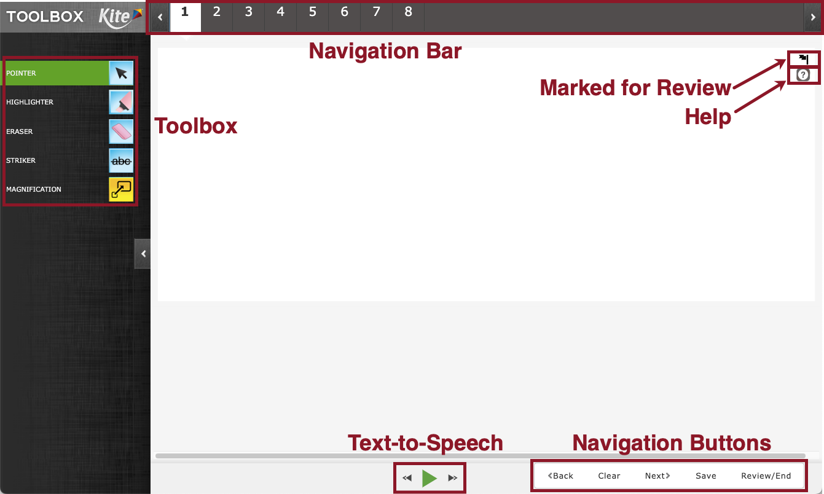
The Test to Speech accommodation is powerful for the students that need it. The student is able to simply press the green play button at the bottom center of the screen to being playing audio. The buttons on either side allow the use to skip ahead or reply sentences or sections.
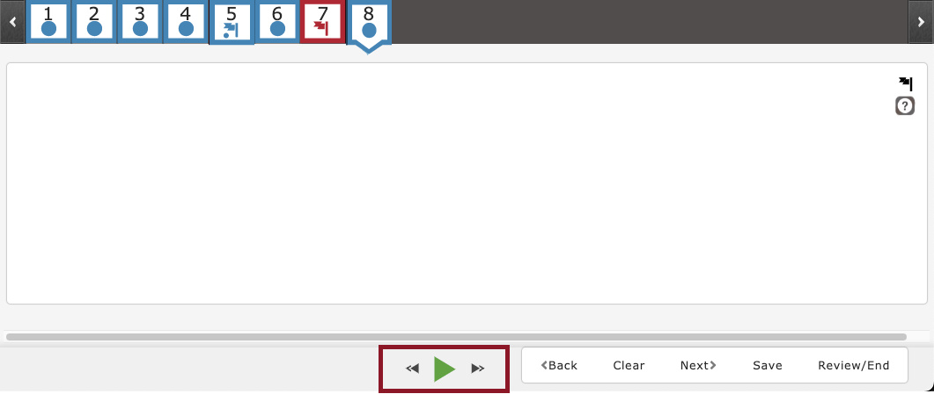
The text will highlight in yellow to show what is being read. Again, typically sentences or portions depending on the question type.
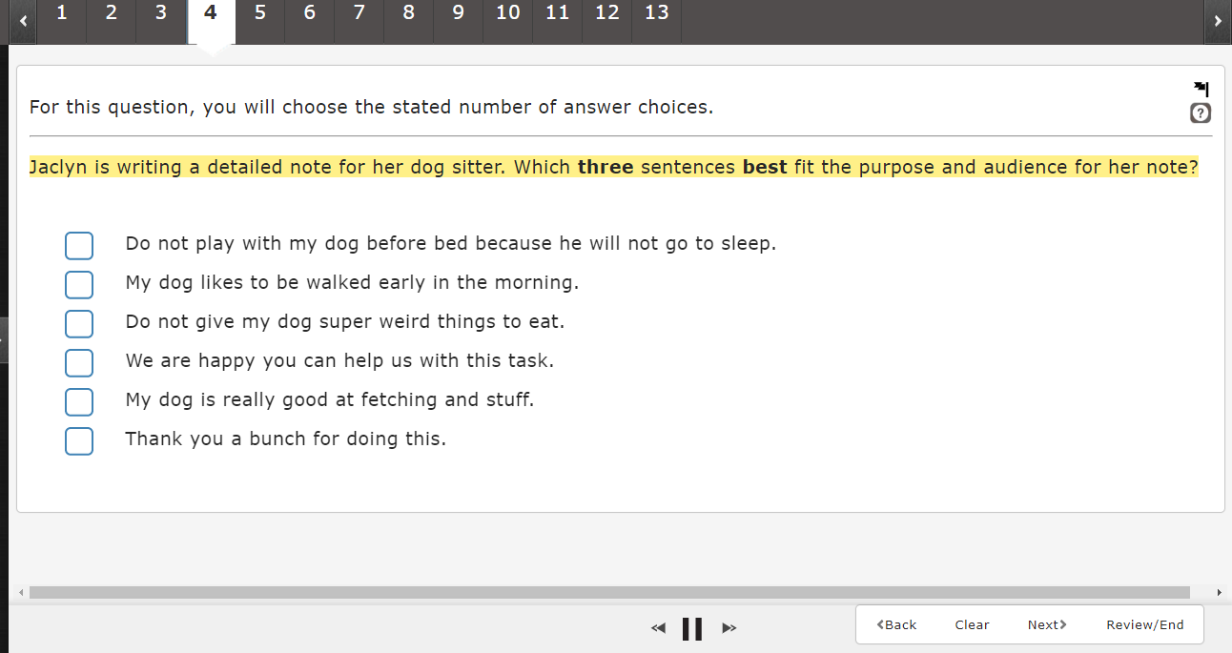
The help button displays additional information about how to manipulate and respond to the particular question type, although this does not cover the content itself.
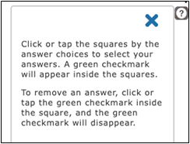
To exit out of the help window, students can select the 'X' in the top right and this will allow the student to continue answering the question.
The save button will save the Testlet and all of the work that has been completed.
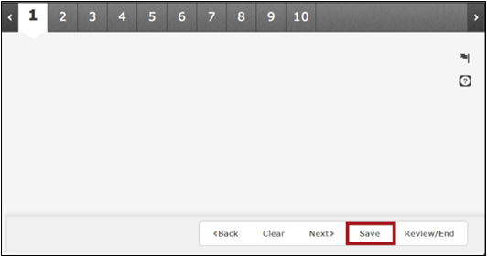
This is useful if the session needs to be interrupted at any point. Students can pick up where they left off once they get back into the test.
After clicking save the student will receive a pop up to confirm that they are saving the Testlet and that they are not submitting the Testlet by clicking save.
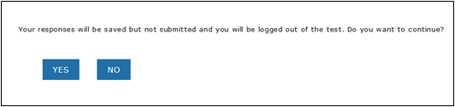
During a test, the student will have tools to mark and track if they need to come back to a question. We provide a system of flagging. Answered questions will have a blue dot. Unanswered questions get a red box at the end or in this view of the header they would be shown simply without any color or dot.
The student can also flag the question using the flag icon in the top right of the screen on every question. Flagging a question that has been answered will provide a blue flag icon as shown in the image for item 7. Item 10 on the other hand shows a flagged item that has not yet been answered.
At the end of the test session the student will be provided a review of their work and each question will have a similar box system to allow the student to visualize where they may want to return to before ending the test fully.

Tool Box
Here is a list of the tools that may be available in the toolbox within Student Portal. This will depend on what test the student is being given, and if the accommodation was added in the PNP profile settings for the student.
- Pointer
- Calculator (Grade 7 Math)
  - Basic
- Highlighter
- Eraser
- Striker
- Guideline
- Magnification
The Pointer tool is the tool that the students will use most. This tool allows a student to select items and click to answer questions.
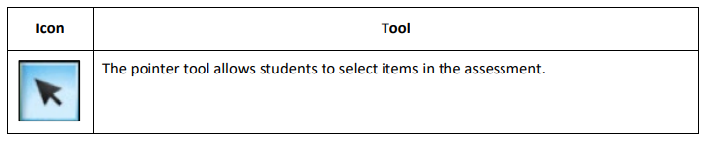
The basic calculator tool allows students to perform simple mathematical calculations.
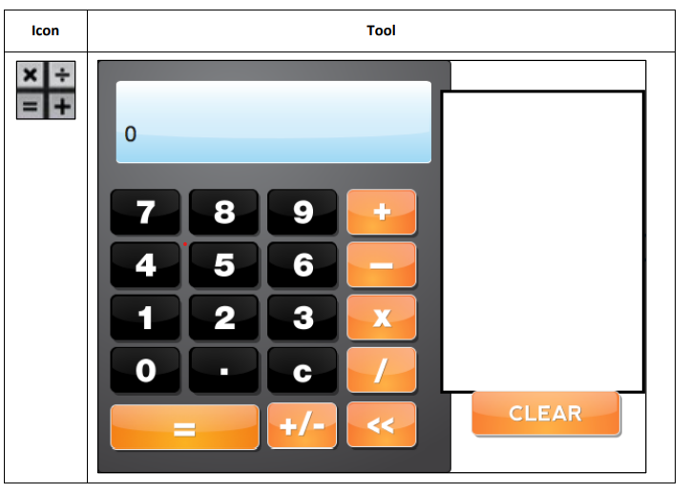
The highlighter tool allows a student to select and highlight text within the question or answer. The student can drag the tool to highlight a word or section of text. This tool changes the cursor to a pink highlighter marker.
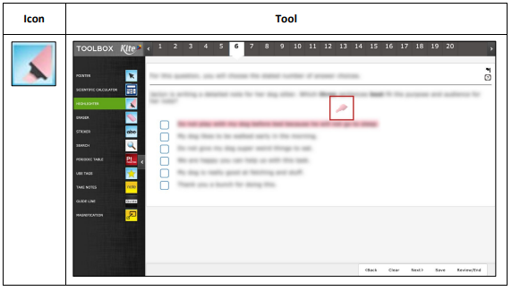
The eraser tool allows the student to remove highlighter and strikethrough effects from the selected text. To switch off from using the eraser, click the eraser icon or the pointer tool. The eraser tool changes the cursor from an arrow or highlight marker to pencil eraser.
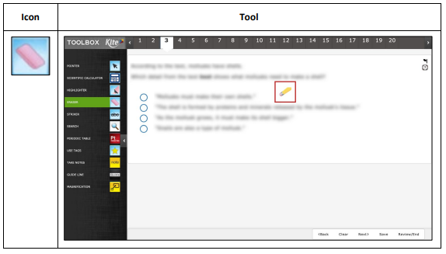
The striker tool allows a student to select a multiple choice or muti select answer choice and mark a line through the middle of the text to cross it out. The striker tool changes the cursor from an arrow to a blue marker. Clicking the answer option again it will “un-strike” the item, or if the student uses the pointer to select an answer that has a line through it, the answer will also become un-stricken.
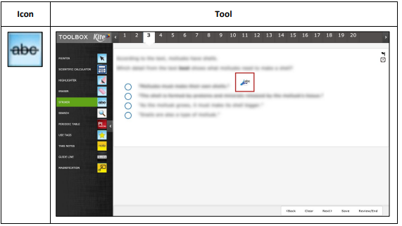
The guideline tool displays a yellow line that the student can move horizontally through a text passage.
To switch off from using the guideline, click the guideline icon or the pointer in the tool box. This tool changes the cursor from an arrow to a yellow line. And on iPad the guideline tool will have a dragger option on the screen to be able to move the yellow line.
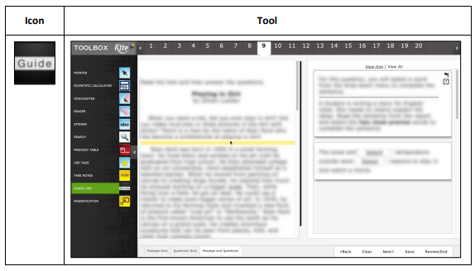
The magnification tool allows a student to enlarge the screen during the test. Students can click on a magnification level from 2.0x to 5.0x or use the magnifying glass to zoom in and out.
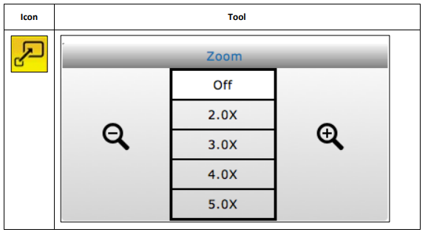
The color overlay tool allows a student to change the background color of the test. The standard background color is white.
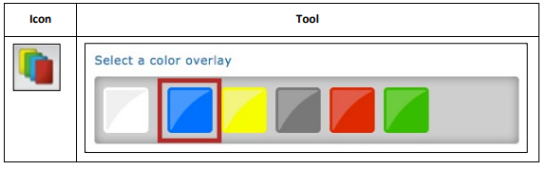
The color contrast tool allows a student to change the color of the assessment font and the background color. The upper (left) portion of the circle indicates the text color and the lower (right) portion of the circle indicated background color.
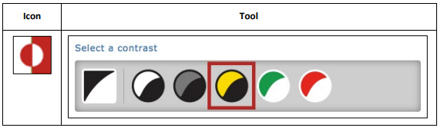
The reverse contrast tool allows a student to change the assessment background to black and the text to white.
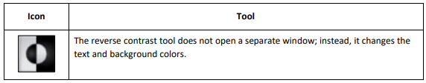
The masking tool allows a student to mask, or cover part of the test.
After a student clicks the masking button, a black box appears on the screen and the student can move the masking box by dragging it to different areas of the screen allowing the student to cover parts of the tests.
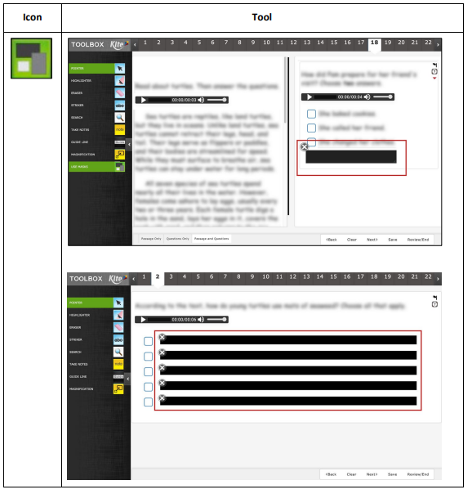
When the student has completed testing they are brought to the Review and End Page. This allows the student to view which questions have been left unanswered, which have been flagged for review and which questions have been answered and not marked for review. Students can then select the number in the "Your Progress" section and they will be brought back to that question to review or answer the question.
Once the student has reviewed their answers they will click on the "End" button, they will receive a confirmation screen that they are ending the test and once confirmed the student will be taken back to the landing page.
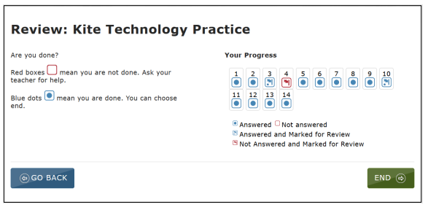
Once testing is completed students will log out and close Student Portal. This process looks slightly different depending on device. On PC, Macs and iPads, once the test session has been ended select the signout and then choose the close Kite button or just click the Sign out button.
On Chromebook in order to exit the student portal application, you will need reboot the device by holding down the power button.
If the internet connection were to drop during testing, the progress will automatically be saved and when the student logs back into Student Portal the student will be able to continue testing where they left off.
Student Portal may also lock up on a loading screen if the application detects that there is no internet connection. The device may need to be restarted to exit the loading screen and testing can resume once the connection has been re-established.
Should Kite Student Portal lock up or display an error message on any device, you may need to quit the application by entering Ctrl+Q and entering the quit password. This can happen when student portal is not closed properly or if there is no internet connection upon launching the application. To obtain the most current quit password, please call the Kite Service Desk, as the quit password is secure and is not available in any manual.
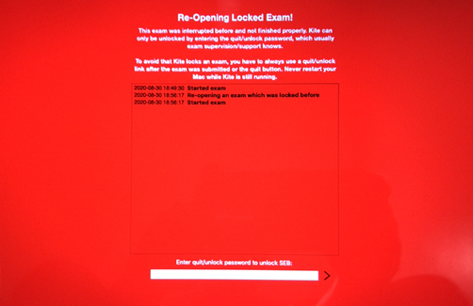
Kite Service Desk
855-277-9752
7:30 a.m. – 5:00 p.m. Central
7:30 a.m. – 5:30 p.m. Central (During Assessment Window)
Kite-support@ku.edu

How does Kite compare to Tide?

Identical to TIDE
- User Roles: All identical except the DTC (our STC). All other portals refer to the STC as the DTC.
- Like TIDE, only some of the tools are usable at the student level without having been turned on at the educator level (usable by students: pointer, highlighter, etc. - not usable by students unless turned on at educator level: color overlays, masking, etc.).
  - Tools that students can use are very similar to those available to them in TIDE.
- Like TIDE, Kite offers the ability for the TA to monitor student test progress in real time.

Differences from Tide
- Some settings need to be added 24 hours in advance (e.g., Text to Speech, Keyword Translation). In TIDE, all settings take effect immediately when you turn it on or off.
- “Student Portal Install” in Kite - “Secure Browser” in TIDE
- In TIDE, accommodations can only be turned on for students with an IEP or 504 Plan identified in AIM. In Kite, supports can be turned on and off for all students.
- Also in reference to accommodations/supports, the names are different. For example, in our other assessment portals, we have Text To Speech, Kite calls it Spoken Audio (TTS).

