### Content Standards Revision

**Purpose**

The purpose of the standards review process is to ensure that Montana public schools are setting high academic standards for all children of our great state. Our goal is to serve our Montana students and educators with the best possible standards to guide instruction and prepare our students for their lives beyond the classroom. There are currently four content areas that are in the revision process.

**Landing Page for all Content Standards Revisions**

* [*opi.mt.gov*](http://opi.mt.gov) *→ K-12 Content Standards → Standards Revision Information*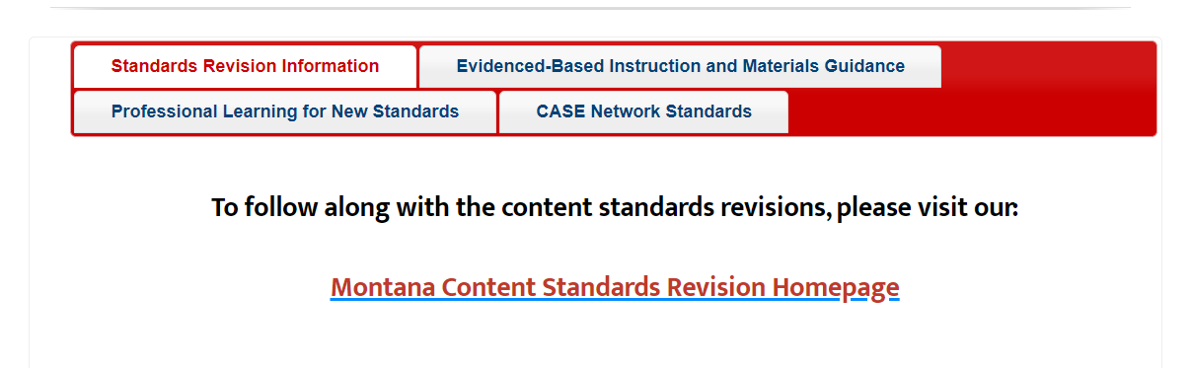
  + <https://opi.mt.gov/Educators/Teaching-Learning/K-12-Content-Standards>

**Montana Content Standards Revision Homepage:**

* <https://sites.google.com/opiconnect.org/mtcontentstandardsrevision/home>

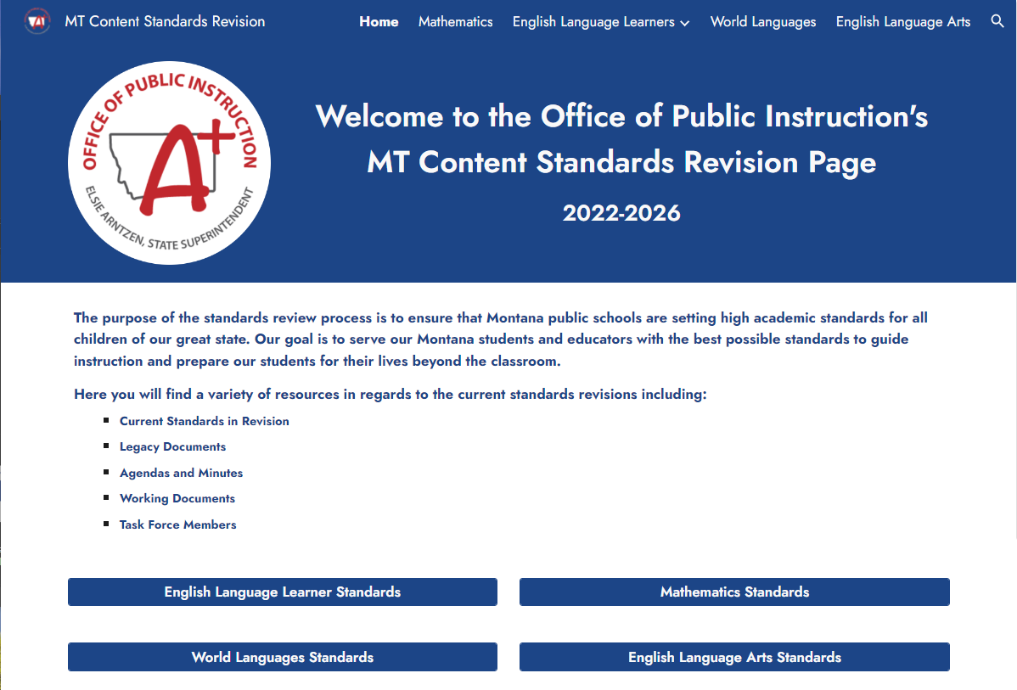

**Current Status for each set of Content Standards Revisions**

* **English Language Learner Proficiency Standards**
  + Negotiated Rulemaking Committee completed in October 2023
* **Mathematics**
  + The Task Force will have drafted standards for Superintendent Review in October 2023
  + Negotiated Rulemaking Committee Applications are being reviewed.
* **World Languages**
  + The Task Force will have drafted standards for Superintendent Review in September 2023.
  + Negotiated Rulemaking Committee Applications are being reviewed.
* **English Language Arts/Literacy**
  + Research questions have been prepared for the Regional Education Laboratory - Northwest, research window opens in September 2023. Applications for the task force will open this fall.

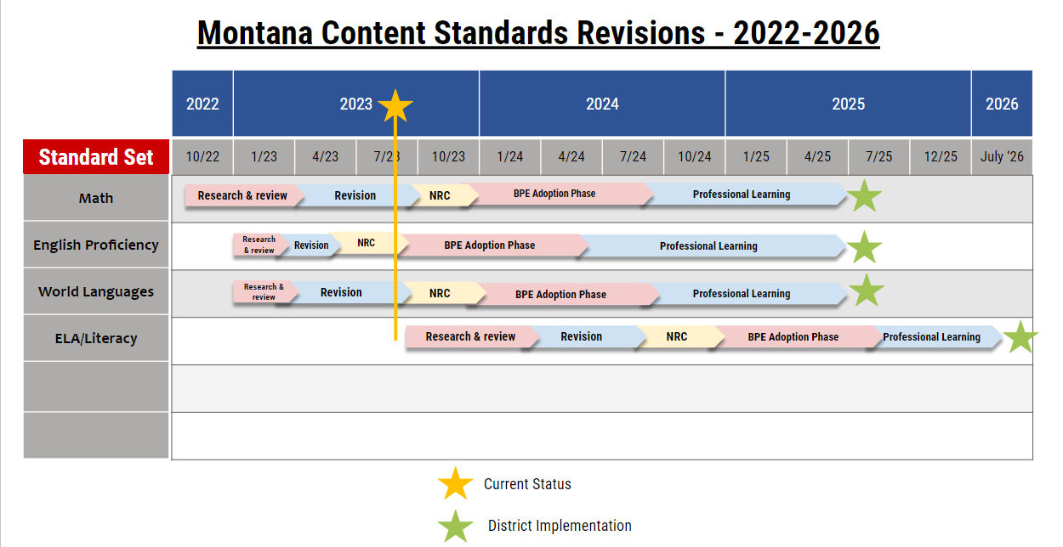

### 

### MT Ready Career Coaches

The Montana Office of Public Instruction’s (OPI) Montana Ready Initiative gives all Montana students the opportunity to be ***READY*** for college, career, community, and life.

|  |  |
| --- | --- |
| * Career Awareness * Internships * Pre-Apprenticeships * Apprenticeships | * Job Shadowing * Career Preparation * Career Launch * Career and Technical Student Organizations |

**Purpose of Montana Ready Career Coaches**

* Work with public and private sector, non-profit organizations, and other stakeholders to help all students be ready for college, career, community, and life
* Educate and connect business and industry to resources with the OPI and Montana schools, teachers, and students
* Collaboratively implement WBL to help teachers, parents, business, and industry guide students for quality world of work experiences
  + CTE Students
  + STEM Students
  + Adult Education Students
  + ALL STUDENTS
* Oversee and work with licensed, education professionals to ensure WBL experiences can be used for student-earned transcript credits and school-earned accreditation
* Utilize Career and Technical Student Organizations (CTSOs) to:
  + Connect business and industry to schools, teachers, and students
  + Build leadership qualities in students
  + Teach employability skills (aka “soft skills”) to students and give students opportunities to earn industry-recognized credentials

CTE Career Pathways is simply a coordination of people and resources aligning K-12 and postsecondary education in six (6) key elements outlined in the Perkins Collaborative Resource Network National Initiatives ([www.cte.ed.gov](http://www.cte.ed.gov/))

* + 1. **Build Cross-Agency Partnerships and Clarify Roles**
       1. Partnerships include K-12, post-secondary, and adult education, business, workforce, economic development, and community stakeholders with common vision and goals and clearly delineated and agreed-upon roles/responsibilities for all partners.
       2. Also include lead coordination efforts for day-to-day operations, partnering, planning, documenting, and evaluating partnerships above
    2. **Identify Industry Sectors and Engage Employers** and develop strategies utilizing:
       1. Labor market data and employer advisory groups and organizations to target high-demand industry sectors.
       2. Comparisons of education/training programs to the needs of employers and address skills gaps while identifying key employers as partners
       3. Technical skill assessments that apply knowledge along career pathways, use industry recognized assessments and award Industry Recognized Credentials (IRC)
       4. Partnerships with employers to regularly test the validity of technical skills training.
       5. Incorporate “employability” or “soft” skill training into technical skills and instructional strategies.
    3. **Design Education and Training Programs** that include (but not limited to) giving clear, non-duplicative sequence of courses, dual enrolment and IRCs, credit transfers, instructional strategies that instill work readiness skills, and provide *career-planning* counseling. Strategies include:
       1. Ensuring course content/curricula is sequential, has credential attainment and/or a degree, and has end-goal of employment/progression in high-demand career.
       2. Secondary and adult learners courses are in a skills pyramid with broad foundational support offered at introductory levels and more skill-focused in post-secondary level
       3. Develop career maps that cross secondary and post-secondary systems to include dual enrollment and IRCs.
       4. Identify, validate, and keep current technical and work-force readiness skills.
    4. **Identify Funding Needs and Sources** that stress federal, state, and local policies in promoting and sustaining career pathways and programs of study by:
       1. Identify the cost of system redesign, development, and operations.
       2. Identifying the areas of overlap, especially between CTE programs of study and adult education career pathways
       3. Conduct unified outreach and raise awareness for CTE, career pathways among stakeholders and public and private partners.
       4. Seek new funding sources from local, state, and national public and private sources.
       5. Research and develop alternative financing.
       6. Join local, state, private and public partners to develop a sustainability plan and set goals for scaling.
    5. **Align Policies and Programs** so funding comes from multiple sources to provide appropriate resources and continued programs and support professional development and other development activities with cross-agency and private team to:
       1. Conduct cross-agency audits to determine points of alignment.
       2. Identify policy changes.
       3. Examine impediments to systems that stand in the way of progress.
       4. Identify and make changes across agencies and institutions without legislative or complex administrative actions (informal policy or cultural changes) and then work to build support for more complex legislation and formal administrative changes.
    6. **Measure System Change and Performance** by starting with what is currently in place, identifying outcomes, measuring progress along the way, and have a process for collecting and sharing data in career pathways and programs of study by:
       1. Identifying system changes and performance indicators that extends from secondary CTE and adult education at post-secondary with credential attainment in high-demand occupations.
       2. Ensuring college and career readiness standards are consistent across secondary and postsecondary systems, reflect math and English knowledge expected of high-school graduates, incorporate industry-recognized technical standards.
       3. Aligning state databases and focusing on improvements to metrics and data collection methods.
       4. Setting short and long-term goals and measure progress along the way
       5. Provide timely, current data.
       6. Ensure data is used to drive decision-making.

**Regional Career Coach Placement Map**

### 

### 

### New Accreditation Roll-Out

**What revisions in Chapter 55 emphasize a shift to a proficiency-based learning model?**

* The accreditation process plays a major role in ensuring a personalized, proficiency and quality,  **learner-centered system** aligned to a district **graduate profile**.
* **Student performance outcomes** are a result of how well all parts of the education system meet the needs of students.
* The proposed student performance standards outcomes or outputs are **growth**, **proficiency**, **learning environment**, **college and career readiness**, and **opportunity gaps**.
* The **assurance standards** are the inputs, which include: School Leadership, Education Opportunity, Academic Requirements, and Program Areas.
* The **Integrated Strategic Action Plan** must clarify what specific steps must be taken to achieve the district graduate profile and reflect a continuous improvement process.
* The grade bands **provide support for teachers in planning for, teaching, and assessing student learning at various points along the continuum**. Grade bands recognize that learning develops over time and across multiple contexts. Grade levels provide a way to look at learning in shorter periods of time.

“Graduate profile” means a **learner** centered model(s) based on a shared vision of learner attributes that students should have when they graduate.

**Rules with Significant Changes**

10.55.601 - Accreditation Standards: Procedures

10.55.604 - Variance to Standards

10.55.901 - Basic Education Program: Elementary

10.55.902 - Basic Education Program: Junior High School, 7th and 8th Grade Program, or Middle School

10.55.904 - Basic Education Offerings: High School

**New Rules**

10.55.608 - Charter School Application

10.55.722 - Family and Community Engagement

10.55.723 - Mentorship and Induction

10.55.724 - Evaluation

10.55.806 - English Learners

**Which schools will be accredited in the school year 2023-2024?**

* **All** schools will receive an accreditation status in the 2023-24 school year based on the new rules.
* The Cycle of Accreditation will be established from a two-to-five-year cycle based on each district’s unique factors starting in the 2024-2025 school year. This allows each district’s specific circumstances to determine the cycle of accreditation.

**Separation of Accreditation and Annual Data Collection**

Annual Data Collection will still take place in the fall

•Moving from TEAMS to Infinite Campus (TOE, Teacher-Class, etc)

–Compensation Expenditure TOE for FY2023 (Due in December) will still take place in TEAMS

–Please contact Nicole Thuotte and the AIM Team for questions on that process.

•New Accreditation platform ready in January - Expected Accreditation Due date is March 29th.

–Licensing deadline for accreditation purposes only.

–All pieces for accreditation purposes only will be entered into this platform

–We will pull the data needed from Infinite Campus into the new system.

**What process will be used to accredit schools for the school year 2023-2024?**

**Tools on the OPI Website: opi.mt.gov/Leadership/Assessment-Accountability/School-Accreditation**

**Next Steps:**

**Teacher Residency**

**Overview**

The Montana Teacher Residency Demonstration Project prepares teachers to best serve their students. Through undergraduate coursework, the teacher-leader academy, targeted support, and a yearlong apprenticeship in the classroom, residents connect theory to practice and gain the skills of highly effective practitioners who will be ready on day one to successfully lead their own classrooms.

Residents begin the program with a two-day orientation, then enter a one-year in-school apprenticeship under a teacher-leader. During the year, residents engage in summits sponsored by the Office of Public Instruction while simultaneously completing coursework to earn a bachelor’s degree from their Montana university. In exchange for committing to teach in a rural Montana school district for two years, residents receive a stipend, partial tuition support, and district-provided housing.

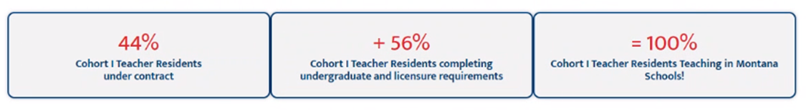

*Beginning in fiscal year 2025,* [*House Bill 833*](https://opi.mt.gov/Portals/182/Teacher%20Residency%20Project/HB%20833%20Summary.pdf?ver=2023-07-20-121638-153) *will provide funding for residency.*

## *A big shout out to Representative Brad Barker who sponsored HB 833, supporting teacher recruitment and retention in the state of Montana!*

**2023 Participating Districts: 23 residents, 13 districts**

#### Browning Public Schools-5 residents Havre Public Schools-1 resident

#### Cayuse Prairie Elementary-1 resident Kalispell Public Schools-1 resident

#### Columbia Falls Public Schools-1 resident Lodge Grass Public Schools-2 residents

#### Frontier Elementary School-1 resident Noxon Public Schools-1 resident

#### Great Falls Public Schools-1 resident Upper West Shore Elem- Dayton-1 resident

#### Hardin School District-5 residents Vaughn Elementary-2 residents

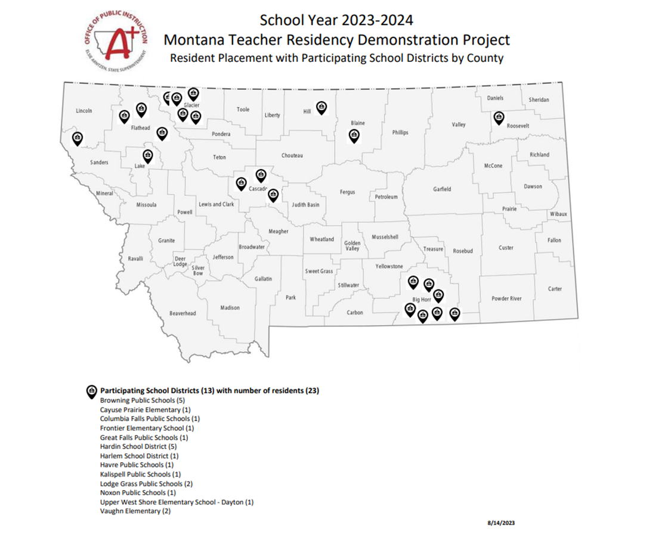

### Nutrition - Direct Certification with Medicaid

**Program Overview**

The Office of Public Instruction School Nutrition Programs is excited to announce the new Medicaid Direct Certification for eligible Medicaid students to qualify for free or reduced-priced school meals (the National School Lunch Program, School Breakfast Program, and Afterschool Snack Program). Children may qualify to receive free or reduced-price school meals without households having to submit a free and reduced application if children are directly certified. Directly certified means that eligibility to receive free or reduced-price school meals has been determined through participation in one of the following programs for the school year: SNAP, TANF, FDPIR, and new Medicaid Direct Certification (if the household’s current income falls within the National School Lunch Programs’ annual income guidelines). With the new Medicaid Direct Certification, students qualify automatically for free or reduced-price meals ($0.40 for lunch, $0.30 for breakfast) without submitting a free and reduced application to your school.

**Montana Medicaid Direct Certification (DC) Data as of 8/10/2023:**

|  |  |
| --- | --- |
| 8/10/2023 | Data in DCA |
|  |  |
|  | Medicaid DC in Participating Schools |
| Medicaid Free | 23,160 |
| Medicaid Free-EE* | 135 |
| **Total Medicaid Free** | **23,295** |
|  |  |
| Medicaid Reduced | 6,122 |
| Medicaid Reduced-EE* | 33 |
| Total Medicaid Reduced | 6,155 |
|  |  |
| **Total Medicaid DC** | **29,450** |

*Extended Eligibility (EE): If students are directly certified free for SNAP, TANF, FDPIR and now the new Medicaid Free & Medicaid Reduced, meal benefits may be extended to other children in the household to also receive free or reduced-priced meals without having to submit a free or reduced-price application to your school.

Schools that offer meals to students at no cost through the Community Eligibility Provision (CEP) and Provision 2 also do not require families to apply for benefits using a household application.

Schools that operate pricing programs determine student eligibility through household application or direct certification. If households are not already directly certified to receive free or reduced meals, you may apply for school meal/milk benefits at any time throughout the year by submitting a household application directly to your school or via the new Online Application for Free and Reduced Price School Meals (if your school opted into providing this online application option). Children may be eligible for free or reduced-price school meals or free milk via household application if household income is within the limits of income eligibility.

**Nondiscrimination Statement**

In accordance with federal civil rights law and U.S. Department of Agriculture (USDA) civil rights regulations and policies, this institution is prohibited from discriminating on the basis of race, color, national origin, sex (including gender identity and sexual orientation), disability, age, or reprisal or retaliation for prior civil rights activity.

Program information may be made available in languages other than English. Persons with disabilities who require alternative means of communication to obtain program information (e.g., Braille, large print, audiotape, American Sign Language), should contact the responsible state or local agency that administers the program or USDA’s TARGET Center at (202) 720-2600 (voice and TTY) or contact USDA through the Federal Relay Service at (800) 877-8339.

### 

### Special Education Family & Community Engagement Improvement Specialist

**Position Overview**

The OPI Special Education Family & Community Engagement Improvement Specialist will serve the community as a valuable resource to parents and schools in non-legal special education matters, functioning as a resource to guide parents in connecting with necessary supports for attaining higher levels of student success in transitions, engagement, and early assistance. This position will also assist parents/families in understanding special education processes, while connecting them with partners that can provide a deeper level of advocacy in working with their local school. The specialist position will foster and maintain collaborative, positive relationships with the parents of students with disabilities with the purpose of increasing student success. The Special Education Family & Community Engagement Specialist will command technology to provide timely feedback on internal and external data to drive improvement processes.

**Areas of Focus**

1. **Transitions – Improving Secondary Transition (Indicator 13) and Post School Outcomes (Indicator 14)** .

* Serving as a resource for disability related information and referral.
* Linking parents and families to community resources.
* Assists students and schools with developing Transition opportunities through CTE partnership development within communities.

1. **Improving Family Engagement in the Special Education Processes**

* Making recommendations to OPI and other stakeholders based upon common issues, misunderstandings, and state complaint data.
* Works to share important communications, events, and meetings from the OPI.
* Support schools in building strategies to increase and strengthen parent involvement.
* Assist with data monitoring and improve results in parent survey feedback (Indicator 8).

1. **Parent/Family Support in Early Assistance and Locating Resources**

* Supports families in understanding special education processes and procedures.
* Linking parents and families to community resources.
* Assists in coordinating family outreach with the appropriate school district resource or community agency.
* Work with families and the OPI Early Assistance Program to help families engage in resolving special education conflicts.