Tip sheet – Training 1

Montana Alternate Student Testing (MAST) Pilot Program

What you need to know for the pilot

OPI will provide the roster information on your behalf to New Meridian

There are four two-week administrations throughout the year

- Administration 1:
November 7 – 18, 2022

- Administration 2:
January 17-30, 2023

- Administration 3:
TBD

- Administration 4:
TBD

Each administration will include three math testlets and two ELA testlets

Each testlet should take around 10 minutes for a student to complete

Accommodations and Tools in the Pilot

Accommodations
- Spanish Testlets available online
- Printable paper testlets in both English and Spanish
- Printable paper testlet directions translated into Spanish
- Alternative color schemes for enhanced contrast

Tools
- Text to Speech (TTS) online (English Forms only)
- Zoom magnification of screen up to five times
- Highlighter
- Bookmark
- Notes
- Pointers
- Strikers
- Calculator (Specific Math Forms only)
- Test pause / resume

Items include multiple-choice and technology enhanced items and were developed in collaboration with Montana educators. There are no constructed-response items for this year.

Reports for the pilots will be available within 10 business days of the close of the administration window and will include:
- The content standards the item is measuring
- A brief description of the standard
- Indication if the student received full, partial, or no credit for the item

Kite information

- See introduction video: https://vimeo.com/716465995
This is what you will see when you log on:
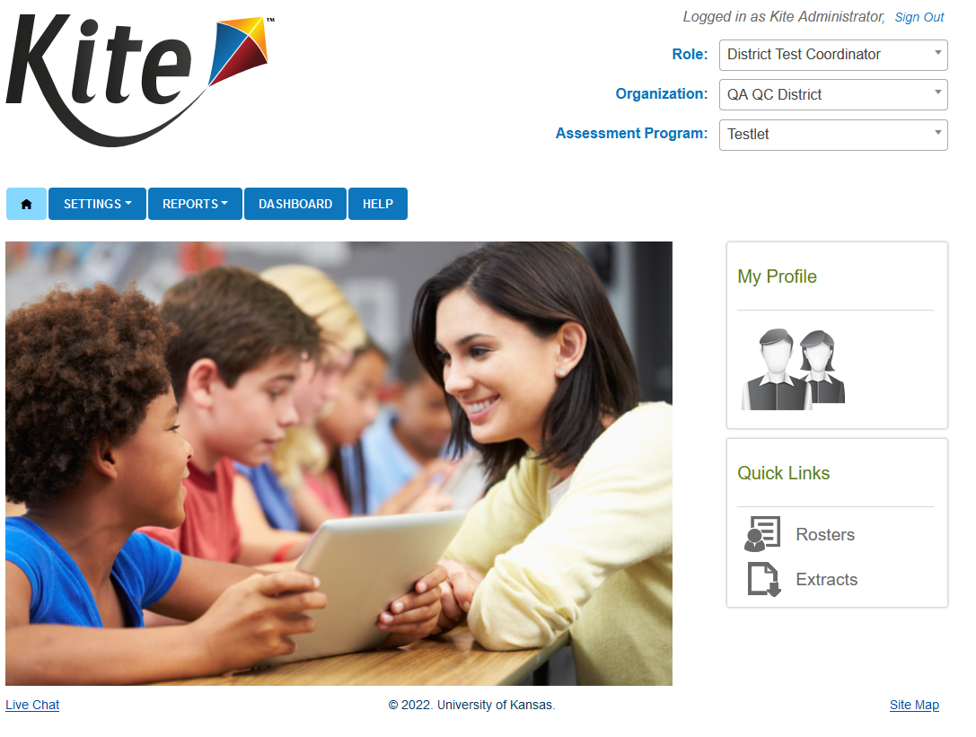

Functions of Kite
Facilitates the exchange and management of:
- Student data
- Score reporting
- Student monitoring capabilities
- Test administrators
- Enter student accommodations
- Monitor test sessions
- Retrieve data

This is what students will see:
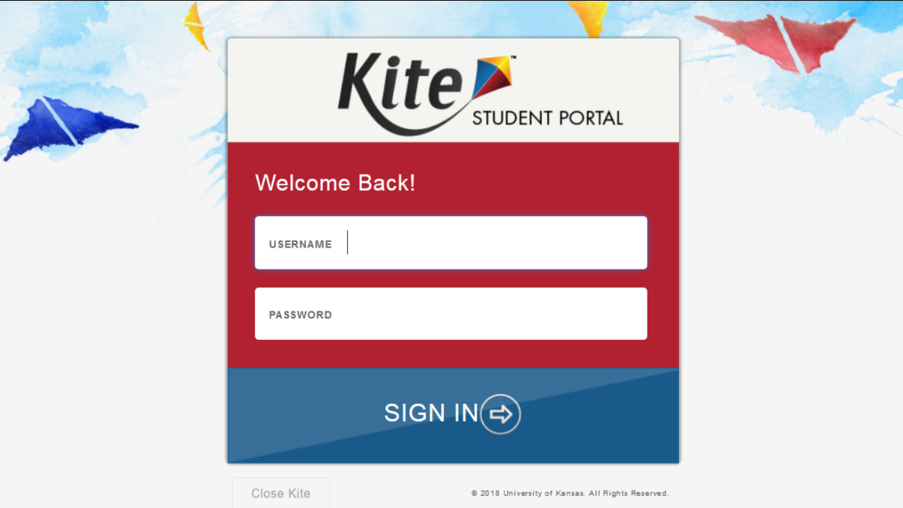

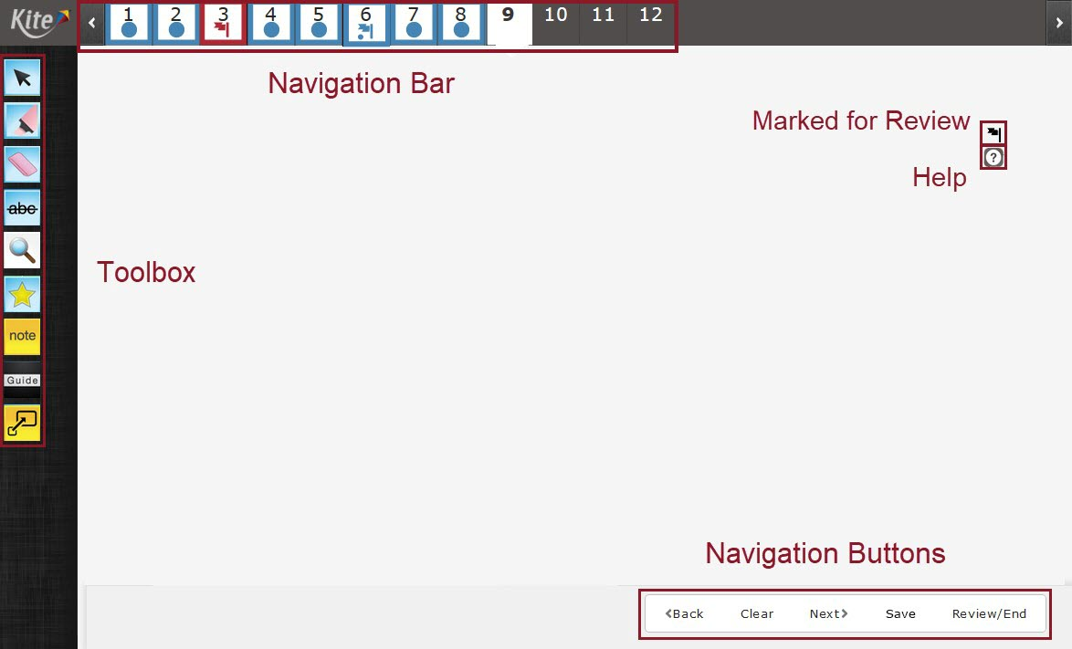

Before the next training, please check it out!

Link:
https://student-testlet.kiteaai.org/TDE/logIn.htm

Practice Login:
Username: tech.demo
Password: MAZE8

Instillation

Supported operating system versions

The following devices and operating systems are supported:
- ChromeOS 91+
- iPadOS 14.3 - 15.5
- macOS 11.1 – 12.01
- Windows 8.1, 10 & 11

Mac and Windows
- The current version is 10.0.0

iPad and Chromebook
- Current version is 10.0.0 for Chromebooks and 10.0.0 for iPad
  - If enabled, Kite Student Portal will auto-update

Installers
ChromeOS
- Still to be determined
iPadOS
- Available in the App Store
- Can be installed individually or through MDM software
Mac
- Available in .dmg
- Can be pushed or installed on a single computer
Windows
- Available in .exe and .msi
- Can be pushed or installed on a single computer

Install links
Mac
  - https://files.kiteaai.org/installers/test/New%20Meridian/1.0.0/Testlet%20Kite%20Student%20Portal.dmg
Windows
  - .exe
    - https://files.kiteaai.org/installers/test/New%20Meridian/1.0.0/Testlet%20Kite%20Student%20Portal.exe
  - .msi
    - https://files.kiteaai.org/installers/test/New%20Meridian/1.0.0/Testlet%20Kite%20Student%20Portal.msi

Whitelisting
Here is the list of the sites that the Technology Director/ IT Team will want to ensure are whitelisted.

Whitelisting using wildcards (recommended):
*.kiteaai.org
https://ssl.google-analytics.com

Whitelisting for applications that do NOT allow wildcards:
https://educator-testlet.kiteaai.org
https://student-testlet.kiteaai.org
https://kite-ohnp-student-login.kiteaai.org/
https://kite-ohnp-secondary-student-login.kiteaai.org/
https://kite-ohnp-student-click-history.kiteaai.org/
https://kite-ohnp-secondary-student-click-history.kiteaai.org/

Troubleshooting – common errors and their solutions

Certificate error
Issue:
- “**uses an invalid security certificate” error
Cause:
- This is caused by SSL inspection/decryption
Resolution:
- Add the URLs from the whitelisting information in to pass through this process untouched

Failed to start a new session
Issue:
- Error message: “Kite failed to start a new session! Please consult the log files for more information” or “Failed to initialize the Kite service! Kite will now terminate since the service is configured to be mandatory.”
Cause:
- Services are not running and not set to automatic
Resolution:
- Open Task Manager and use the services tab to ensure the service is running and set to automatic
- If the issue persists, uninstall remove the app data folders and then reinstall

Missing power options (Windows)
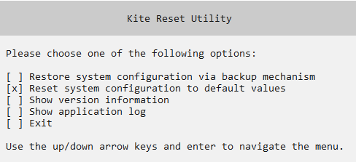

Issue:
- No options on the computer to shut down or restart
- Text: "No Power Options Available"
Cause:
- Rebooting the computer while Student Portal is running does not allow all the lock down features to close properly
Resolution:
- There is an executable file in C:\Program Files (x86)\KiteStudentPortal\Reset\KiteStudentPortal.ResetUtility
- Needs to be run as administrator. (The steps can be found in the Testlet Kite Student Portal Installation Guide Windows)

“Something went wrong” (Chromebook)
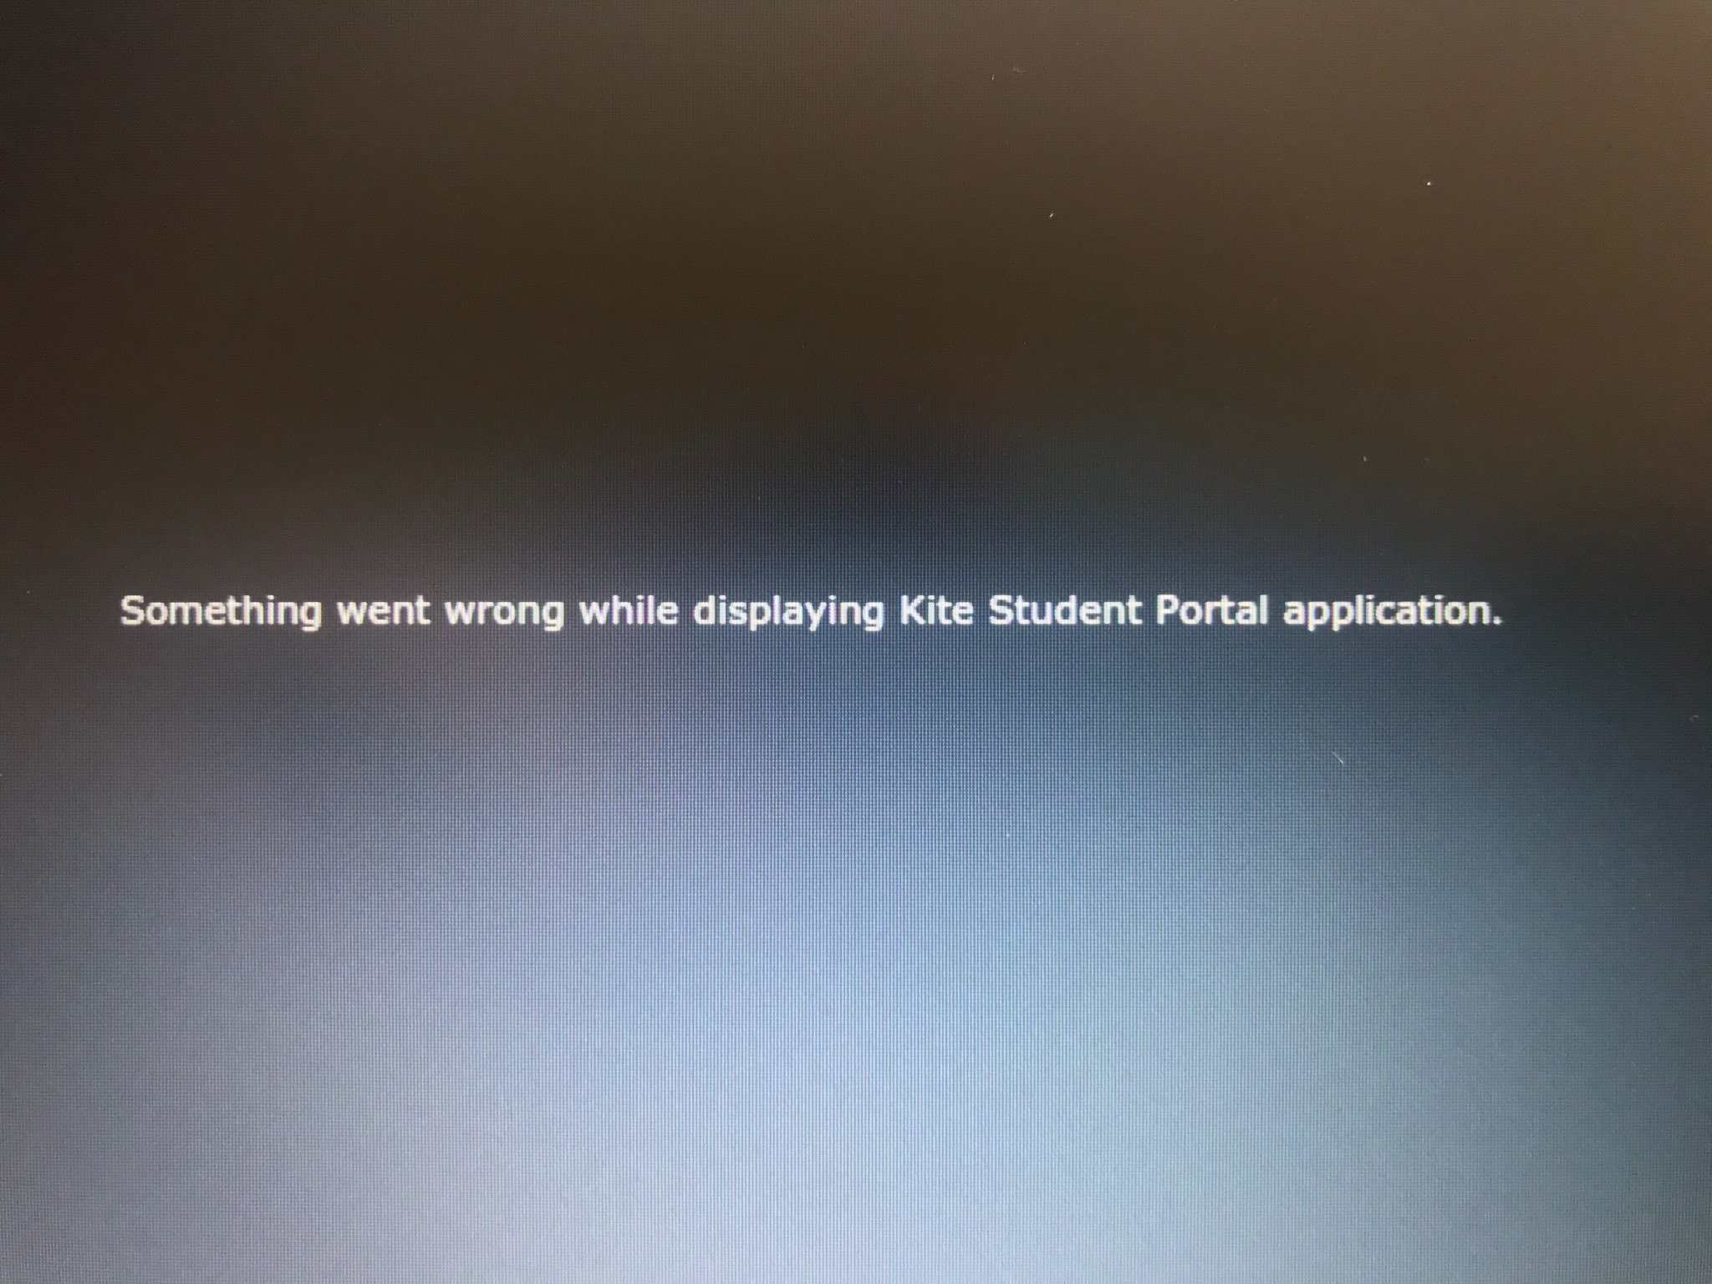
Issue:
- “Something went wrong while displaying Kite Student Portal”
Cause:
- The Chromebook cannot connect to the Kite servers
Resolution:
- Make sure the Chromebook has an internet connection
- Make sure the whitelisting has been done
Verify the URL has not been changed

Loading

Issue:
- A student is testing and a "Loading ..." message appears
Cause:
- Bandwidth or connection issue

Resolution:
- This usually resolves itself when the connection has been reestablished or the process of downloading/uploading is complete
- If the message does not go away, exit the test by rebooting the device, verify connection and proceed with testing

Red screen
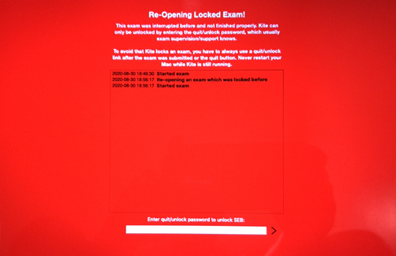

Issue:
- Red screen that cannot be exited. Could happen on Mac, PC, and iPads
Cause:
- Student Portal was shutdown improperly
Resolution:
- Enter the quit password
- Student portal needs to be closed with the “Close Kite” button every time

For questions and issues, contact:

Kite Service Desk
855-277-9752
7:30 a.m. – 5:00 p.m. Central
7:30 a.m. – 5:30 p.m. Central (During Assessment Window)
Kite-support@ku.edu

