2023-2024 School Score Report Guidance

Parent/Family Dissemination
Schools are encouraged to disseminate student testlet score reports accompanied by the OPI provided parent guidance letter in a manner that parallels progress report delivery. Parents/guardians should receive all available testlet score reports provided by the end of the year. Testlet reports delivery options include:
- Presenting score reports during parent teacher conferences
- Sending score reports home through the mail with report cards/progress reports
- Sending score reports home with district provided assessment results
- Secure file transferring digital reports
- Kite Parent Portal

Score Report Uses
As score reports include data on field test items, it is imperative for schools and families to understand while score reports can provide insight to how participating students performed on items aligned to topics taught in class, each question is still in the field testing phase and will undergo further analysis to ensure validity and reliability. Therefore, score reports should NOT be disseminated or saved in the following manners:
- Included in student cumulative files.
- Digitally included in district Student Information Systems (Infinite Campus/ PowerSchool)
- Used/included in IEP/504 determination, evaluation, or documentation
- Used to determine or influence student grades

Interpretation Considerations:
- Consider Results as One Data Point: Treat the pilot assessment results as just one data point in a broader context of student assessment and learning, acknowledging that multiple sources of data should be used for a comprehensive understanding of student proficiency.
- Do Not Treat Results as Definitive: Pilot assessments are often exploratory and may not fully capture student abilities or learning outcomes. It's important not to treat these results as definitive or conclusive about a student’s performance.
- Gather and Utilize Feedback: Talk to your teachers about the assessment and use the results, to think about potential learning gaps and areas needing support.
- Communicate and Collaborate: Encourage your teachers to share insights with one another and with your administrative team. We encourage all participants to join the monthly listening sessions to share feedback.
- Consider Limitations: It's crucial to understand the limitations and exploratory nature of these pilot assessments. Misinterpretation of these results can lead to unrealistic expectations or misguided educational decisions. Avoid using pilot assessment results to make high-stakes decisions.
Refer to the recording, Understanding the Student Score Report, for additional score report information and guidance.

Dear Parents/Guardians,

We hope this message finds you well. We are delighted to inform you about [Insert School]'s participation in the Montana Aligned to Standards Through-Year (MAST) Pilot Program administered by the Montana Office of Public Instruction. This initiative aims to revolutionize our assessment system and better address the needs of our students, teachers, and administrators.

Your child, along with over 20,000 Montana students in grades 3-8, has completed assessments in Mathematics and English Language Arts (ELA). Your child participated in the MAST Form B Summative testing window as outlined below:

Administration | Start Date | End Date | ELA | Math
MAST Form B Summative | April 15, 2024 | May 10, 2024 | 5 Testlets | 7 Testlets

The primary purpose of the MAST pilot is to introduce "through-year" assessments, replacing traditional end-of-year state summative assessments. This innovative model aims to provide more flexibility in test administration, yielding actionable data throughout the academic year to support the formative instructional process.

We want to emphasize several key points regarding the MAST test:
- Your child's grades will not be influenced by their testlet scores.
- Student data privacy is rigorously protected by state and federal laws, ensuring confidentiality.
- Students with IEPs, Section 504 plans, or English Learner plans are assessed based on their individual needs, in compliance with state and federal regulations.

Your child's score reports, detailing their performance on each question, are available to you. Here are some actions you should consider when interpreting pilot score reports:
- Consider Results as One Data Point: Treat the pilot assessment results as just one data point in a broader context of student assessment and learning, acknowledging that multiple sources of data should be used for a comprehensive understanding of student proficiency.
- Gather and Utilize Feedback: Talk to your child about the assessment and use the results, to think about potential learning gaps and areas needing support.
- Communicate and Collaborate: Share insights with the child's teacher for collaborative problem-solving.

While these score reports can provide insight to how your child performed on items aligned to topics taught in class, each question is still in the field-testing phase and will undergo further analysis to ensure validity and reliability. You should be cautious in your interpretation. Here are some guidelines you should consider when reading the reports:

- Do Not Treat Results as Definitive: Pilot assessments are often exploratory and may not fully capture student abilities or learning outcomes. It's important not to treat these results as definitive or conclusive about your child’s performance.
- Do Not Ignore Contextual Factors: Be wary of overlooking the specific conditions under which the pilot assessment was conducted. Factors like test environment, student stress levels, or technical issues can significantly impact results and should be taken into account.
- Do Not Neglect Limitations: It's crucial to understand the limitations and exploratory nature of these assessments. Misinterpretation of these results can lead to unrealistic expectations or misguided educational decisions.
- Do Not Base High-Stakes Decisions on These Results: Avoid using pilot assessment results to make high-stakes decisions.
- Do Not Overlook the Need for Feedback and Revision: Pilot assessments should be a learning experience for both students and parents. Not providing feedback about the assessment process and content from students is a missed opportunity for improvement.

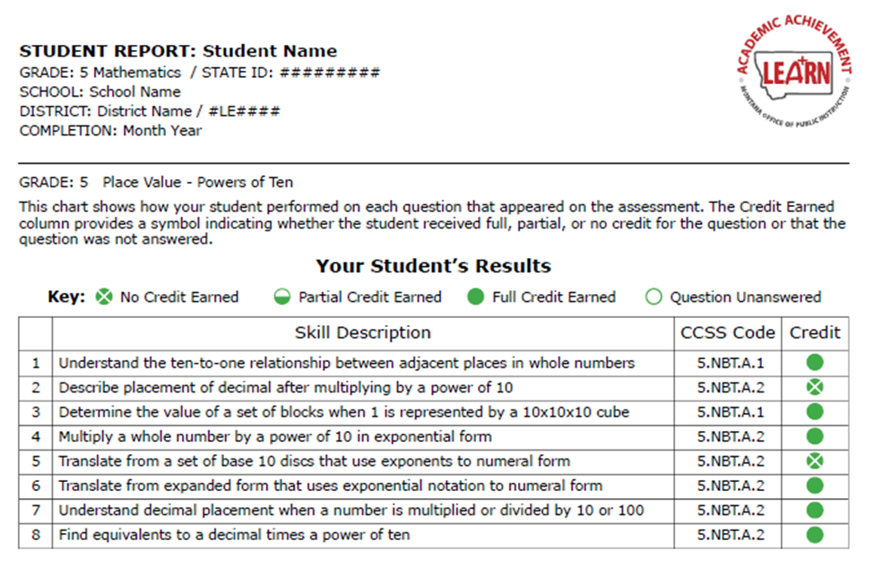
Pilot Score Report Guide
Administration Information
Testlet Focus

Understanding the Score Report:
- Skill Description: Description of the skill each item assessed.
- CCSS Code: Specific Common Core State Standard code the question aligned with.
- Credit: Amount of credit earned for each item, categorized as No Credit Earned, Partial Credit Earned, Full Credit Earned, or Question Unanswered.

Should you have any queries or require further clarification regarding the assessment or the score report, please feel free to contact [Insert school’s contact person] or visit the OPI’s MAST webpage. Your understanding and engagement are highly valued and appreciated.

Warm regards,

[Your Name]
[Your Position]
[School/Organization Name]
[Contact Information]

