We appreciate your willingness to participate in the pilot this year! This guide is intended to help you understand the pilot program and the data you are seeing on the MAST Pilot score reports.

Background
Throughout the 2022-2023 school year, your school will have four different windows in which you administer the pilot testlets. The testlets in each of the windows will assess different content and the information gathered will help inform the final product. This is a novel assessment and the pilot administrations are composed of new items that have not previously been administered to students.
One goal of the instructionally aligned assessment system is to provide useful information to teachers throughout the year. The items and testlets have been developed with that goal in mind and may look different from a traditional end-of-year summative assessment.
Some items, particularly in math, may appear difficult in the first administration because many students have not been taught the assessed content yet. This is not unexpected. It is likely that the same item, administered later in the year, may appear less difficult. The assessments have been designed and constructed to maximize the amount of information that can be gathered in a minimal amount of time. This innovative approach has led to the development of items that may look different from items that students have seen before.

Getting to Know the Score Report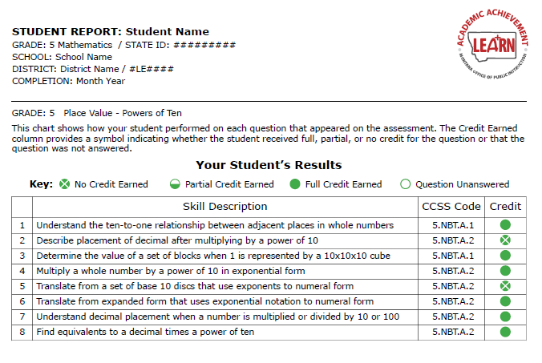

Skill Description – This is a description of the skill each item was assessing for a particular question.
CCSS Code – This is the specific Common Core State Standard code the question was aligned to. (Insert link to CCSS?)
Credit – This column shows the amount of credit earned for each item. Credit categories include the following:
  - No Credit Earned – the student attempted the question but did not answer correctly.
  - Partial Credit Earned – The student attempted the question, but the question was worth more than one point and the student only answered part of it correctly.
  - Full Credit Earned – The student attempted the question and answered all parts correctly.
  - Question Unanswered – The student did not attempt to answer the question and did not receive any credit.

Interpreting the Results

Have your students been taught the content on the test?
No – Students who have not been taught specific content should not be expected to perform well on assessments of that content. If the content has not been taught in the classroom yet, then the results could be used to inform whether students have prior experience on those skills.
Some students may have performed well on the math assessment even if they have not been exposed to that content in the classroom. Their results may indicate that these students may already have the prerequisite knowledge and skills to learn more challenging material in the assessed content area. In these cases teachers may want to adjust their instructional approach to include more challenging material.
Yes - If you have taught the assessed content to your students, then you can use the data in the students reports to better understand your students’ strengths and weaknesses in that content area. You may conclude that some students need to have more support for the skills assessed. This report can help you identify those areas. The results should be interpreted within the context of your instructional plan for the material as well as student performance on other assessments and assigned work.

Other Questions About the Assessment
Why are my students seeing content they have not been taught yet?
The order and timing of the testlet administrations are fixed by design in this year’s small-scale pilot. As this is a brand-new assessment the assessment has been designed to ensure administrative uniformity across the state. The ability for teachers or districts to select the order and timing of the assessments in order to match their scope and sequence will be available in a future phase of this program.
The custom ordering of the ELA testlets is limited by the design of the system because of the increasing complexity of the genre-based texts throughout the year.
Why did the assessment take longer than I expected for some students?
As a pilot assessment with new items, we can make an educated guess as to the average amount of time required to answer a question or complete the assessment. There will certainly be variability among students, with some requiring more time, and others less. As we continue through the pilot year, we will gain a better understanding of the actual time it takes to complete each assessment and the factors that contribute to the timing. This information will be used to improve future test administrations.

