Elementary School Logo here

_______________________ School
Kindergarten Orientation
for the school year 2019-2020

School Mission:
“Together we..........”

___________________ School Cafeteria

May 6, 2019, 9am-10am

Welcome Parents, Guardians, and Grandparents!

Come to our school with your child to see our campus, meet our Principal, Vice Principal, Counselors, have a story read by the librarian and learn about some of the programs we have available to you and your child.
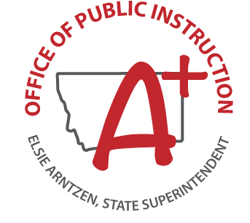
MPlease make sure your child is registered before coming to our Orientation! For any questions feel free to call _________________ AT __________________.

