

**2025-2026**

**Early Literacy**

**JUMPSTART**

This checklist and procedures must be completed by the conclusion of the district’s  
summer 25-26 Jumpstart program and certified no later than ***August 29, 2025***.

This collection is for the Early Literacy **summer** Jumpstart program. Qualified students, grades KG to 3, enrolled in a Jumpstart program are eligible for an additional 0.25 ANB. Jumpstart participants must have an Early Literacy eligibility record, an enrollment record in a Jumpstart calendar setup with a duration of at least 4 weeks and 120 instructional hours and be included in the district's Jumpstart certification. Districts will create calendars, courses, enrollments and eligibility records; then certify Jumpstart program information at the end of the session.

* **CREATE JUMPSTART CALENDAR(S)**
* **EDIT CALENDAR INFORMATION**
* **ENROLL STUDENTS USING THE STUDENT LOCATOR WIZARD**
* **CREATE ELIGIBILITY RECORD(S)**
* **ADD DISTRICT ASSIGNMENTS FOR TEACHERS**
* **CREATE COURSE, SECTION, AND ADD STUDENTS**
* **RUN END OF YEAR ATTENDANCE AFTER LAST DAY OF JUMPSTART (AND AFTER ALL ENROLLMENTS ARE ENDED)**
* **RESYNC DATA**
* **VALIDATE DATA**
* **CERTIFY DATA**

**STEP ONE: CREATE JUMPSTART CALENDAR(S)**

PATH: *Scheduling & Courses>Calendar Setup>Calendar Wizard*

1. Select **Create new Calendars by rolling forward selected data** or **create new blank Calendars** and click Next.
2. Select Year (25-26).
3. Enter Start Date and End Date (program start and end date for summer Jumpstart).
4. 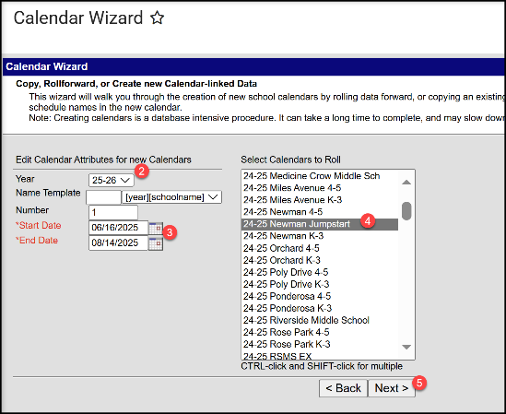Select prior year Jumpstart calendar/school to roll or   
   select school(s) to add new calendar
5. Click Next
6. Check boxes to copy data (rolled calendars) and Run Wizard.
7. Refresh browser page and select 25-26 Jumpstart calendar.

**STEP TWO: EDIT CALENDAR INFORMATION**

1. Calendar Information

PATH: *Scheduling & Courses>Calendar Setup>Calendar Information*

* 1. Change Calendar Name (optional) to identify as Jumpstart calendar/program.
  2. 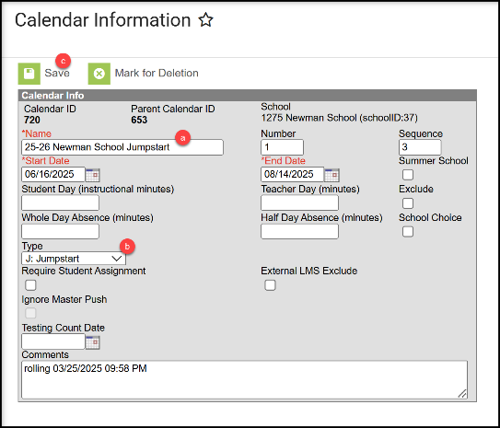Select **Type J: Jumpstart** (required).
  3. Click Save.

1. Grade Level Setup

PATH: *Scheduling & Courses>Calendar Setup>Grade Level Setup*

* 1. Review existing Grade Level(s) or click New to add Grade Level(s) to selected Jumpstart calendar.
  2. Enter Name, Sequence Number, and State Grade Level Code (KG, 01, 02, 03).
  3. Click Save (repeat for additional grade levels).

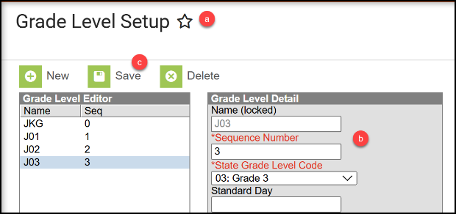

1. Term Setup

PATH: *Scheduling & Courses>Calendar Setup>Term Setup*

* 1. Review existing Schedule/Terms or click New Term Schedule/Terms to add.
  2. Schedule/Term Name should be ‘Full Year’.
  3. Select ‘Full Year’ and enter program start and end dates.
  4. Graphical user interface, text, application

     Description automatically generatedClick Save Term Schedule/Terms.

1. Period Setup

PATH: *Scheduling & Courses>Calendar Setup>Period Setup*

* 1. Review existing Period Schedule(s) or click New Period Schedule to add.
  2. Review/Enter the Number of Period Schedules (equals 1, unless schedule varies by day).
  3. Select Period Schedule.
  4. Review/Enter Start Time and End Time. Review/Enter the total non-instructional minutes (lunch, recess, etc.) in the Lunch Time field.
  5. Click Save Period Schedules. Repeat for each Period Schedule.

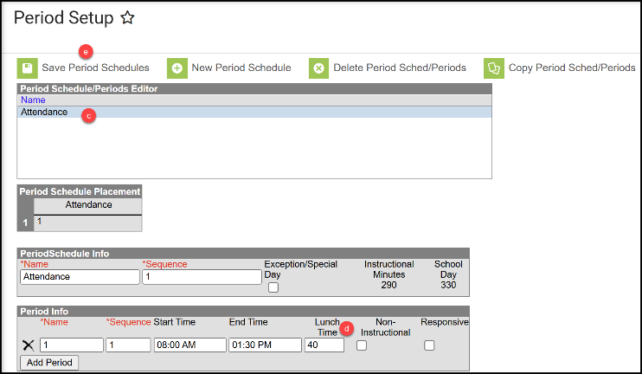

1. Day Setup

PATH: *Scheduling & Courses>Calendar Setup>Day Setup*

* 1. Click Day Reset.
  2. Enter Student/Instructional Start and End Dates.
  3. Select days of the week students will attend.
  4. Click Create Days.
  5. Remove non-school days by clicking the day and unchecking School Day, Instruction, and Attendance (e.g. July 4th). Then Save Day/Day Events. Repeat as applicable.
  6. Add school days by clicking the day and checking School Day, Instruction, and Attendance. Then Save Day/Day Events. Repeat as applicable.

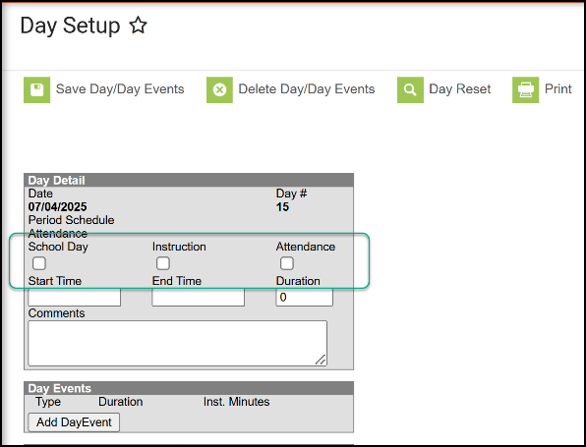

1. Copy attendance codes into this calendar.

PATH: *Attendance Office>Settings>Excuse Code Copier Wizard*

* 1. 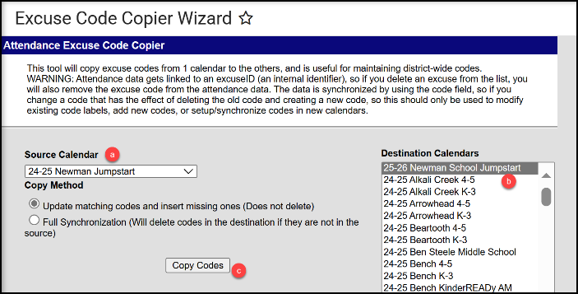Select the Source Calendar to copy from.
  2. Select the new 25-26 Jumpstart calendar.
  3. Click Copy Codes.

1. Verify Attendance Codes.

PATH: *Attendance Office>Settings>Attendance Code Setup*

Recommended Attendance/Excuse Codes:

* 1. 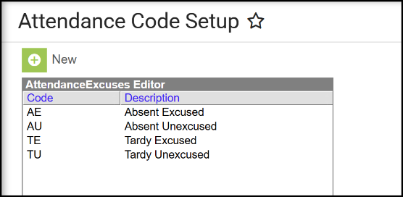EA – Excused Absent
  2. UA – Unexcused Absent
  3. ET – Excused Tardy
  4. UT – Unexcused Tardy

**STEP THREE:** **ENROLL STUDENTS USING THE STUDENT LOCATOR WIZARD**

1. Verify the 25-26 Jumpstart calendar is selected.
2. Open the Student Locator Wizard.

PATH: *Student Information>General>Student Locator Wizard*

* 1. Enter the Last Name, First Name, and Gender of the student to enroll.
  2. 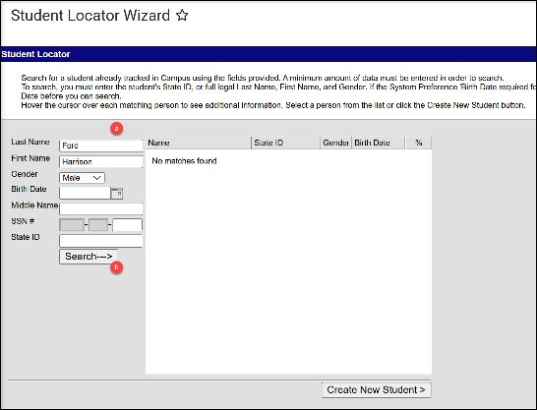Click Search.
  3. There are 3 scenarios for creating an enrollment:
     1. If the student is in district, the student’s name will be prefaced with a back arrow in the search list. Click the student’s name to create a new enrollment.
        1. Click New to add an Enrollment.
        2. Verify the Calendar is correct.
        3. Add Start Date and select applicable Grade.
        4. Select a Local Start Status.
        5. Graphical user interface, application

           Description automatically generatedClick Save.
     2. If the student is out of district, the student’s name will not be prefaced with a back arrow. Hover over the student’s name to verify the match and click to add enrollment.
     3. If the student is new to Montana or to public school, click Create New Student to add enrollment.

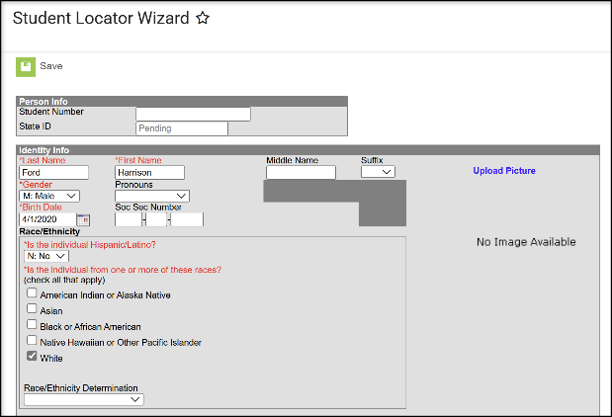

**STEP FOUR: CREATE ELIGIBILITY RECORD(S)**

PATH: *Student Information>State Programs>Early Literacy*

1. Search for the student.
2. Open Early Literacy.
   1. PATH: *Student Information>State Programs>Early Literacy*.
3. Click New to add a new record.
4. Enter Start Date – **Record Entry Date**
5. End Date**- June 30, 2026**
6. Enter School Year and State Grade (for year of eligibility – e.g. student is tested at the end of kindergarten year, school year is ensuing year and grade is 1).
7. Select Eligibility Domain(s) – Select all that apply for specific student as eligible.
8. Select Methodology Tool – if Other is selected, comments are required in the Methodology Comments field. (If Other is not selected, the Methodology Comments field must be blank.)
9. Enter any additional information in the Comments field.
10. Click Save.

**STEP FIVE: ADD DISTRICT ASSIGNMENTS FOR TEACHERS**

PATH: *Census>Staff>District Assignments*

1. Click New.
2. Select the school where the Jumpstart program is located.
3. Enter the Start Date.
4. For the State Assignment Code select TC:10 Summer School Teacher
5. Select the Teacher checkbox.
6. Click Save.

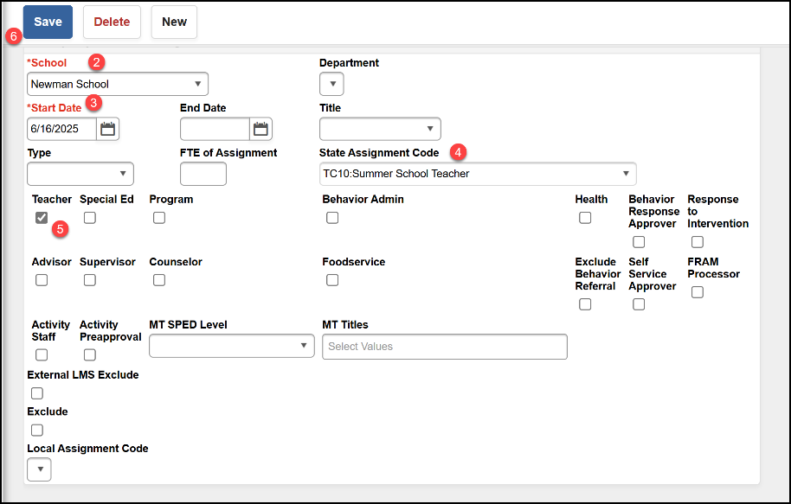

**STEP SIX: CREATE COURSE, SECTION, AND ADD STUDENTS**

PATH: *Scheduling & Courses>Courses>Add Course*

1. Add Course.
   1. Enter course Number and Name.
   2. Check box for Attendance.
   3. NCES Data
      1. SCED Subject Area = 23
      2. SCED Course Identifier = 012 (for single grade level classes, choose the appropriate grade level (003 to 006)
      3. SCED Lowest Grade = KF
      4. SCED Highest Grade = 03
      5. SCED Course Level = GE: General Education
   4. Click Save.

1. Create a Course Section.
   1. 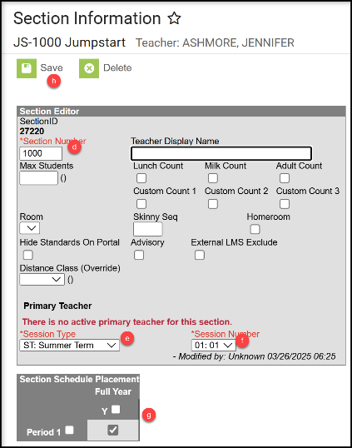Navigate to Course Sections.   
      PATH: Scheduling & Courses>Courses>Course Sections
   2. Search for new Jumpstart course.
   3. Click Add a Section

(or click on existing section, if copied from prior year).

* 1. Assign a Section Number.
  2. Session Type = **ST: Summer Term**.
  3. Select a Session Number.
  4. Check the box(es) under Section Schedule Placement.
  5. Click Create Section (or save).

1. Graphical user interface, text, application, Word

   Description automatically generatedClick Section Staff History to add a teacher.  
   PATH: Scheduling & Courses>Courses>Section Staff History
   1. Click New Primary Teacher.
   2. Select teacher name from the dropdown.
   3. Role = 00: Teacher of record.
   4. Click Save.

1. Add Students to the Roster.

PATH: Scheduling & Courses>Scheduling>Requests & Rosters

* 1. Click View by: Courses.
  2. Select the Section to build the roster.

* 1. Click Roster Builder.
  2. Add Students by Grade or click the student’s name to add to the Roster (Start and End Date are not required unless a student starts after the first day of the course or ends before the last day of the course).
  3. Click Save.

**STEP SEVEN: RUN END OF YEAR ATTENDANCE AFTER LAST DAY OF JUMPSTART (AND AFTER ALL ENROLLMENTS ARE ENDED)**

Follow these instructions if you take daily attendance in Infinite Campus.

PATH: *Reporting>MT State Reporting>MT EOY Attendance Totals*

1. Check the boxes for ADA - #Days Present and ADA - #Days Enrolled.
2. Select one or more Calendars.
3. Choose Validate and Test or Update Enrollments (recommend Validate and Test first). Common errors on this file include students with enrollments not ended, students without a schedule, or students with Service Type issues.
4. Submit to Batch.

**STEP EIGHT: RESYNC DATA**

PATH: *System Settings>Data Interchange Administration>Resync State Data - Batch*

1. Select the checkbox in front of DIS Objects to select all.
2. Click Send Resync.

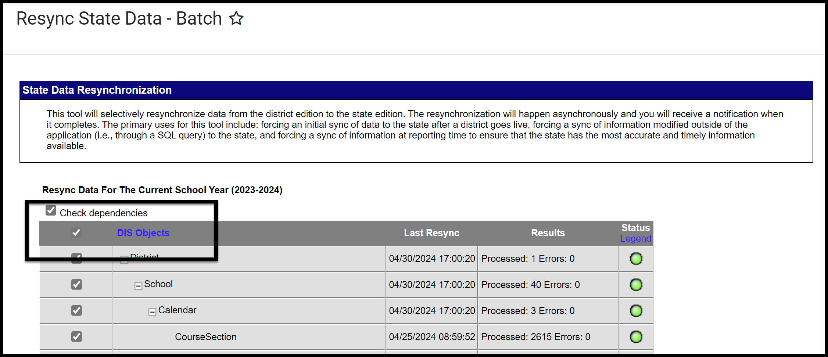

**STEP NINE: VALIDATE DATA**

PATH: *Reporting>Data Validation>Validation Groups OR Data Validation Reports*

1. Search for “Jumpstart Validation Errors and Warnings”.

Once all errors and warnings have been checked, run the above Validation Group as a Validation Report with the Run at State option selected. Running the report at both the district and state ensures that data has fully synced prior to certification. If there are mismatches between the state and district, repeat **STEP SEVEN** (Resync Data) and re-run the Validation Report at the state.

**STEP TEN: CERTIFY DATA**

*PATH: Reporting> Data Certification>Event Certification*

There are three separate files included in this certification: *Enrollment, Teacher Class, and Aggregate Hours*.

\**Please wait at least 60 minutes after a complete resync before certifying data.*

* + 1. Add a certifier for Jumpstart Early Literacy.

1. PATH: *Reporting>Data Certification>Type Membership Setup*
2. Select a Type: Jumpstart Early Literacy.
3. Click New Member.
4. Enter last name in search box and click the magnifying glass.
5. Select Name.
6. Select Type: Primary (only one primary certifier is recommended).

* + 1. Run Jumpstart Certification from Data Validation Report (must assign to user group first).

1. PATH: *Reporting>Data Validation>Data Validation Report*
2. Verify the information looks correct.
   * 1. Certify Jumpstart data using Event Dashboard.
3. PATH: *Reporting>Data Certification*
4. Select Jumpstart Early Literacy 2025-26.
5. Select Certify & Submit.

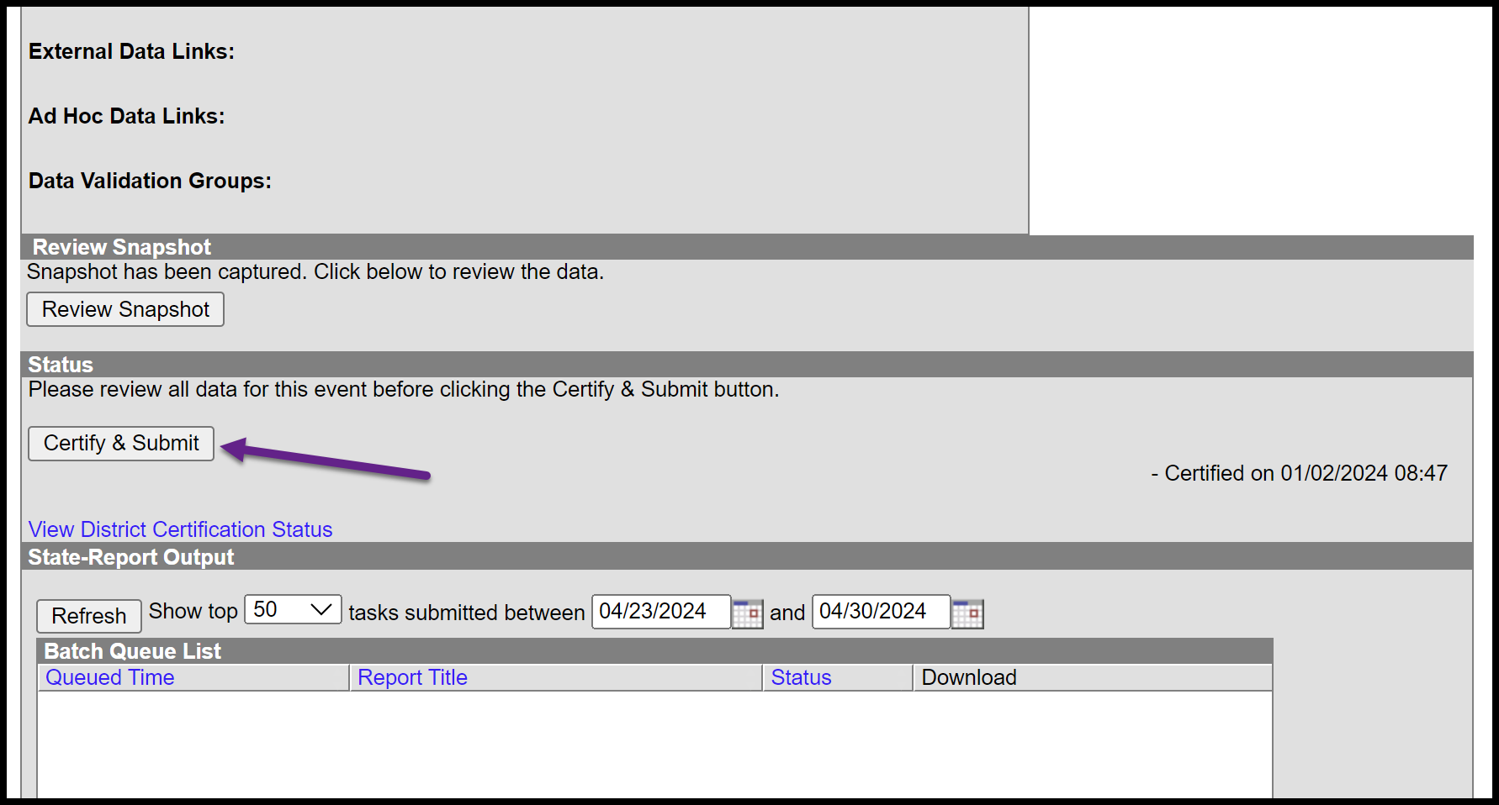

If the district discovers a reporting error, please contact the AIM Unit to request recertification. If the AIM Unit discovers an error the certifier(s) may receive a message requesting correction and recertification.

## APPENDIX

## File Upload Process

PATH: *Reporting>MT State Reporting>MT Data Upload*

1. Districts that use a 3rd party Student Information System (SIS) may use the file upload process to enroll students.
2. Upload the Student Demographics file (required only for newly enrolled students), followed by the Enrollment file.
3. Extract the upload file from the district’s SIS or create a text, tab delimited file from one of the AIM templates. Instructions for using the templates are embedded in the template file.
4. Select the Import Type, the Work to Perform and choose the file to be uploaded. Click Submit to Batch.
5. Review the Validate and Test results file located in the Batch Queue List located at the bottom of the page to identify and correct import errors and/or warnings.
   1. Select Refresh on the Batch Queue to retrieve the latest status of the Batch.
   2. When the Batch has completed processing, select "Get the report" to retrieve the Import Results Summary file.
6. For Student Demographic Uploads ONLY: Review New Student State ID File to ensure Student State IDs have been provided for students who previously did not have one. After the Import Results have been reviewed, please click the Refresh State ID File button, and select the New Student State ID file that corresponds to the date/time the Import completed processing. Click Generate to retrieve the new Student State ID file.

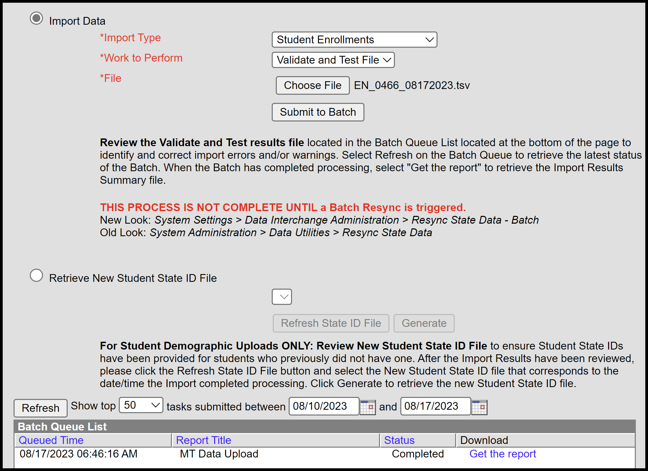

This process is not complete until a Batch Resync is triggered (see **STEP SEVEN**):  
PATH: *System Settings > Data Interchange Administration > Resync State Data - Batch*