

**2025-2026**

**Early Literacy**

**Classroom-Based and Home-Based**

This process is to be completed for all students participating in an Early Literacy program.

More information on Early Literacy programs can be found [here](https://opi.mt.gov/Educators/Teaching-Learning/Literacy).

**CREATING EARLY LITERACY ELIGIBILITY RECORD(S)**

PATH: *Student Information>State Programs>Early Literacy*

1. Search for the student.
2. Open Early Literacy.
   1. PATH: *Student Information>State Programs>Early Literacy*.
3. Click New to add a new record.
4. Enter Start Date – **Record Entry Date**
5. End Date**- June 30th, 2026**
6. Enter School Year and State Grade (for year of eligibility – e.g. student is tested at the end of kindergarten year, school year is ensuing year and grade is 1).
7. Select Eligibility Domain(s) – Select all that apply for specific student as eligible.
8. Select Methodology Tool – if Other is selected, comments are required in the Methodology Comments field. (If Other is not selected, the Methodology Comments field must be blank.)
9. Enter any additional information in the Comments field.
10. Click Save.

# Classroom-Based Early Literacy Program

**Program Requirements**

* Eligible child who is 4 years of age or older on or before September 10 of the year in which the child is to participate in the program, and not yet entering and who has not completed kindergarten.
* Programming must be between half and full-time (360 or 720 instructional hours).
* Must be determined eligible utilizing approved evaluation methodology.
* An eligible child may be included in enrollment counts for the purpose of ANB Calculations.
* Class size is capped at 10 students per 1 appropriately licensed teacher, with an early childhood paraprofessional for any additional students over ten, for up to no more than 18 total students in a classroom with two adults. See [10.63.107](https://rules.mt.gov/gateway/RuleNo.asp?RN=10%2E63%2E107)
* Student must be assigned to a course with a properly licensed and endorsed educator. Early childhood (P-3) endorsements are encouraged, but teachers with either an early childhood (P-3) endorsement or an elementary (K-8) endorsement shall be appropriately licensed, endorsed.
* Instruction must align with the [Early Learning Developmental Domains and Content Standards](https://rules.mt.gov/browse/collections/aec52c46-128e-4279-9068-8af5d5432d74/policies/216d3de5-3292-4145-8c86-e84a845f0a12).

**Infinite Campus Requirements**

1. Child must have a **PK** enrollment at the school.
2. The enrollment can be a **P: Primary** or **S: Partial** enrollment.
3. Check the Fall and/or Spring **Classroom-Based Early Literacy checkbox** to indicate participation on either count date (the MT Count Date Attendance tool does not populate the checkboxes).
4. The child must have an **Early Literacy** **eligibility record** for the current school year.
5. State reporting requirements for Title, FRAM, SPED, 504, and any other K-12 programs are also required for classroom-based Early Literacy students.

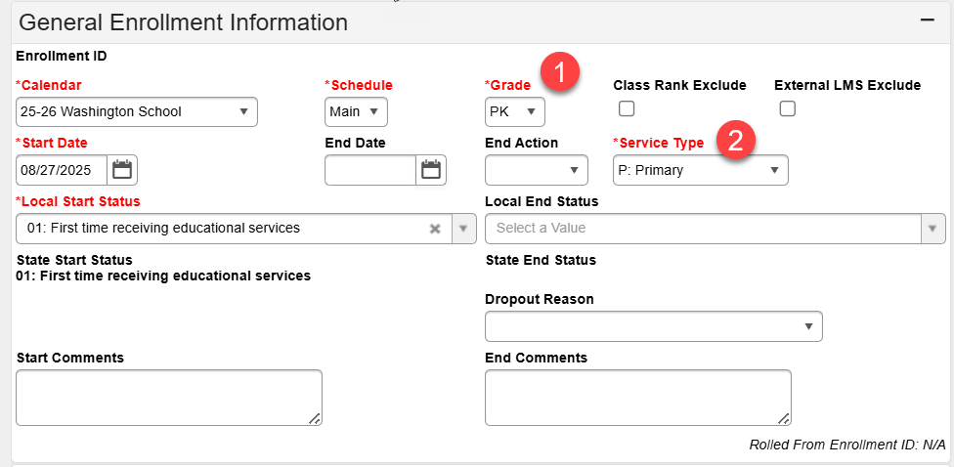

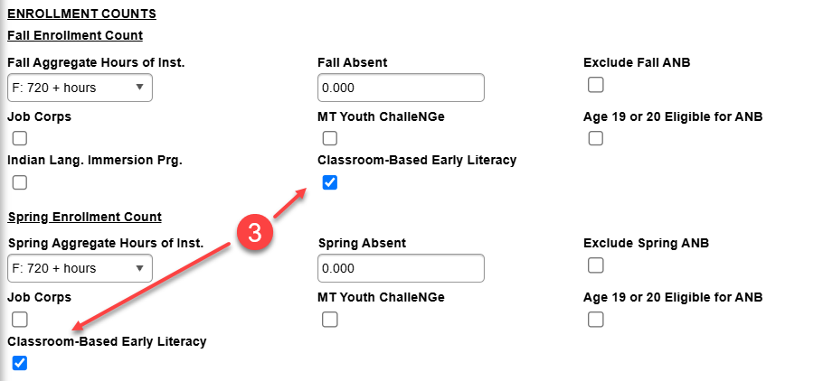

1. Early Literacy courses must be state-mapped to NCES Code 23001 (SCED Subject Area 23: Non-Subject Specific; SCED Course Identifier 001: MT-Early Childhood Education). For mixed grade classrooms, use NCES Code 23012 (SCED Subject Area 23: Non-Subject Specific; SCED Course Identifier 001: MT-Prior-to-Secondary Education).

# Home-Based Early Literacy

The home-based intervention program is designed to foster parental engagement and develop

early literacy skills in students at risk of not being proficient in reading by the end of 3rd grade.

The OPI and BPE have completed the request for proposal (RFP) process and have selected

Waterford as the provider of the home-based intervention program.

**Program Requirements**

* Eligible child who is 4 years of age or older on or before September 10, and not yet completed 2nd grade.
* Program must be research-based and proven effective at developing early literacy skills in populations at risk of not being reading proficient at the end of 3rd grade.
* Access/license provided to school districts on a first-come, first-served basis. 1,500 licenses will be available.

**Infinite Campus Requirements**

1. A separate calendar must be created for the home-based early literacy enrollments.
2. Each child in the program must have an enrollment in the home-based calendar with a grade level of **PK to 2nd** and an **S: Partial** service type.
   * The Start Status must be ***09: Transfer from home school within the state*** for all home-based enrollments, even if the student attends public or private school.
   * Check the box **Home-Based Early Literacy** in the enrollment (much like Extracurricular).
3. The child must have an early literacy eligibility record for the current school year.
4. Home-Based Early Literacy has no ANB eligibility (program is paid from another source).

# Home-Based Early Literacy Calendar Setup

**CREATE HOME-BASED CALENDAR(S)**

PATH: *Scheduling & Courses>Calendar Setup>Calendar Wizard*

1. Select **Create new Calendars by rolling forward selected data** or **Create new blank Calendars** and click Next.
2. Select Year (25-26).
3. Enter Start and End dates that correspond with the fiscal year.
4. 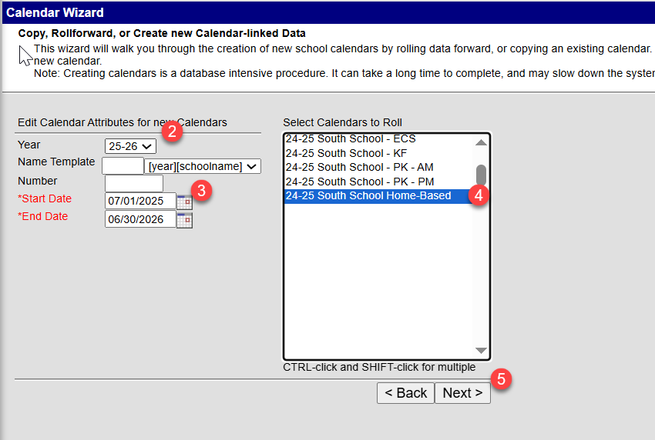 Select prior year home-based calendar/school to roll or   
   select school(s) to add new calendar
5. Click Next
6. Check boxes to copy data (rolled calendars) and Run Wizard.
7. Refresh browser page and select 25-26 home-based calendar.

**EDIT CALENDAR INFORMATION**

1. Calendar Information

PATH: *Scheduling & Courses>Calendar Setup>Calendar Information*

* 1. 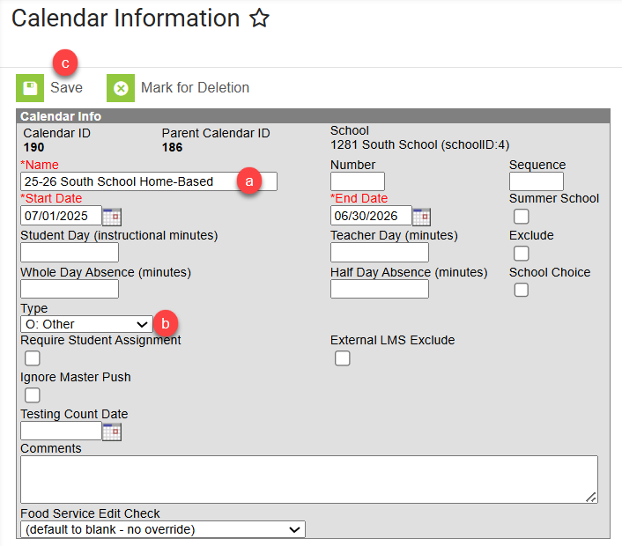Change Calendar Name (optional) to identify as home-based calendar/program.
  2. Select **Type O: Other** (required).
  3. Click Save.

1. Grade Level Setup

PATH: *Scheduling & Courses>Calendar Setup>Grade Level Setup*

* 1. Review existing Grade Level(s) or click New to add Grade Level(s) to selected home-based calendar.
  2. Enter Name, Sequence Number, and State Grade Level Code  
     Home-based Early Literacy is limited to grades PK, KG, 01, 02.
  3. 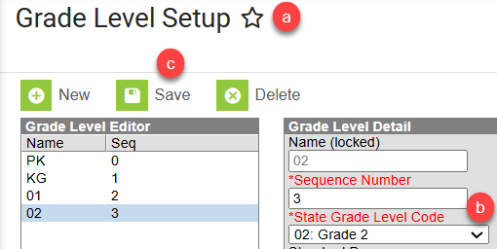Click Save (repeat for additional grade levels).

1. Term Setup

PATH: *Scheduling & Courses>Calendar Setup>Term Setup*

* 1. Review existing Schedule/Terms or click New Term Schedule/Terms to add.
  2. Schedule/Term Name should be ‘Full Year’.
  3. 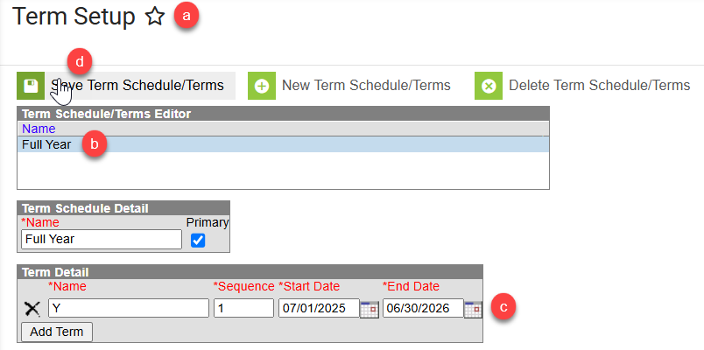Select ‘Full Year’ and enter fiscal year start and end dates.
  4. Click Save Term Schedule/Terms.

# Home-Based Early Literacy Enrollment

**ENROLL STUDENTS USING THE STUDENT LOCATOR WIZARD**

1. Verify the 25-26 home-based calendar is selected.
2. Open the Student Locator Wizard.

PATH: *Student Information>General>Student Locator Wizard*

* 1. Enter the Last Name, First Name, and Gender of the student to enroll.
  2. Click Search.
  3. There are 3 scenarios for creating an enrollment:
     1. If the student is in district, the student name will be prefaced with a back arrow in the search list. Click the student name to create a new enrollment.
        1. Click New to add an Enrollment.
        2. Verify the Calendar is correct.
        3. Choose applicable Grade.
        4. Add Start Date
        5. Select Service Type S: Partial (required for home-based)
        6. Select a Local Start Status: 09 (required for home-based)
        7. Select the Home-Based Early Literacy checkbox (required home-based)
        8. Click Save.
     2. If the student is out of district, the student’s name will not be prefaced with a back arrow. Hover over the student’s name to verify the match and click to add enrollment.
     3. If the student is new to Montana or to public school, click Create New Student to add enrollment.

