

**2025-2026**

**Early Targeted Interventions**

*(Early Literacy & Early Numeracy)*

**HOME-Based Program**

This process is to be completed for all students participating in an   
Early Targeted Intervention Home-Based Program during the school year.

More information on Early Targeted Interventions programs may be found [here](https://opi.mt.gov/Educators/Teaching-Learning/Literacy).

*IMPORTANT: Students who are assessed and deemed eligible for Early Targeted Interventions for Jumpstart, Classroom-Based or Home-Based programs but do not participate in any of the programs should still have an eligibility record entered in Infinite Campus.*

**CREATING EARLY TARGETED INTERVENTIONS ELIGIBILITY RECORD(S)**

PATH: *Student Information>State Programs>Early Targeted Interventions*

NOTE: Eligibility records (Literacy or Numeracy) are valid for all Early Targeted Interventions program enrollments of the applicable year (Jumpstart, Classroom-Based, and/or Home-Based).

1. 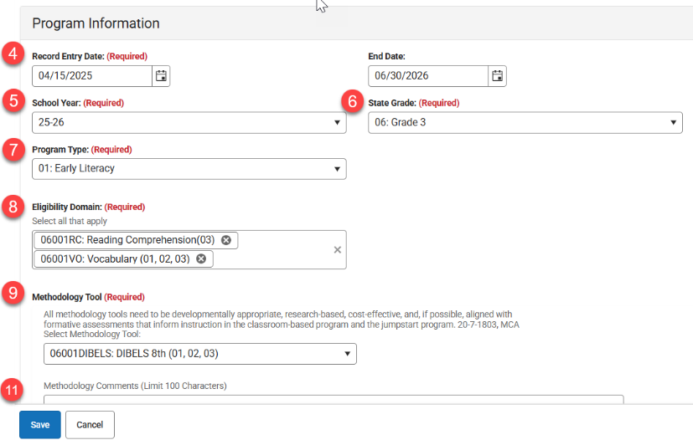Search & find the student.
2. Navigate to Early Targeted Interventions.
3. Click **New** to add a new record.  
   *NOTE: must input items in specific order as detailed*
4. Enter Record Entry Date – **Student Assessment Date**   
   Enter End Date – June 30th of Early Targeted Interventions School Year
5. Enter School Year – year for which program eligibility is applicable
6. Enter State Grade – grade level of the assessment tool used to determine eligibility (grade selection limits available options for Domains and Methodology Tools)
7. Select Program Type – Early Literacy or Early Numeracy (Program Type selection limits applicable options for Domains and Methodology Tools).

**!! Early Numeracy should not be entered until the Board of Public Education approves Eligibility Domains and Methodology Tools !!**

1. Select Eligibility Domain(s) – Select all that apply for specific student as eligible.
2. Select Methodology Tool – if Other is selected, comments are required in the Methodology Comments field. (If Other is not selected, the Methodology Comments field must be blank)
3. **\*\***Contact Information is required for Homebased Early Intervention students only. Enter Parent Contact Name, Email and Phone Number (used for outreach to setup program access).
4. Click Save.
5. A picture containing table

   AI-generated content may be incorrect.Comments field can be used at district discretion
6. Repeat steps to create eligibility record for both

**\*\*HOME-BASED ONLY:** Once a student has an eligibility record and the district has indicated participation in the home-based program, the student will be allocated a Waterford license.

Please reference the specific Jumpstart, Classroom-Based or Home-Based guidance regarding each program.

# Home-Based Early Targeted Interventions Program

The home-based intervention program is designed to foster parental engagement and develop

early literacy and/or numeracy skills in students at risk of not being proficient in reading or math by the end of 3rd grade. The OPI and BPE completed the request for proposal (RFP) process and awarded Waterford as the provider of the home-based intervention program.

**Program Requirements**

* Eligible child who is 4 years of age or older on or before September 10, and not yet completed 2nd grade.
* Program must be research-based and proven effective at developing skills in populations at risk of not being proficient at the end of 3rd grade.
* Access/license provided to school districts on a first-come, first-served basis.
* Programming contract has been awarded to Waterford.

**Infinite Campus Requirements**

1. A separate calendar must be created for the Home-Based Early Targeted Interventions enrollments.
2. Each student in the program must have an enrollment in the Home-Based calendar with a grade level   
   of **PK to 2nd** and an **S: Partial** service type.
   * The Start Status must be ***09: Transfer from home school within the state*** for all home-based enrollments, even if the student attends public or private school.
   * Select the **Home-Based Early Intervention** checkbox on the student enrollment record
3. The student must have an **Early Targeted Interventions** **eligibility record** for the current school year.
4. Home-Based Early Targeted Interventions has no ANB eligibility (program is paid from another source).
5. Students may be enrolled in a regular school program (including a Classroom-Based Early Targeted Interventions Program) and enrolled in the Home-Based Early Targeted Interventions Program.   
   For this scenario, an enrollment is required in both an instructional calendar and in a Home-Based Early Targeted Interventions calendar.

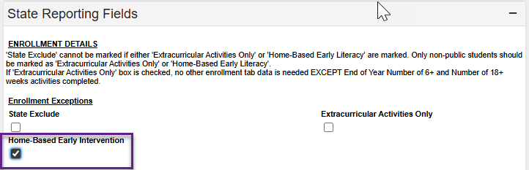

**NOTE** Once a student has an eligibility record and the district has indicated participation in the home-based program, the student will be allocated a Waterford license.

# Home-Based Early Targeted Interventions Calendar Setup

**CREATE HOME-BASED CALENDAR(S)**

PATH: *Scheduling & Courses>Calendar Setup>Calendar Wizard*

1. 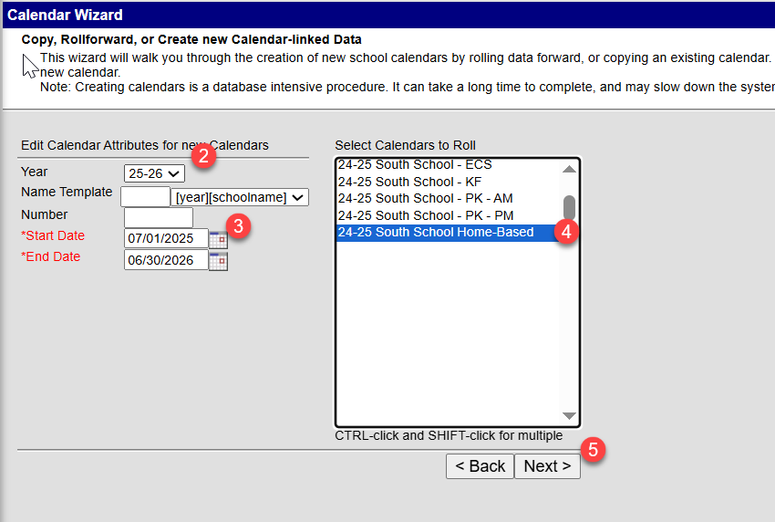Select **Create new Calendars by rolling forward selected data** or **Create new blank Calendars** and click Next.
2. Select Year (25-26).
3. Enter Start and End dates that correspond with the fiscal year (07/01/xx-06/30/xx).
4. Select prior year home-based calendar/school to roll or select school(s) to add new calendar
5. Click Next
6. Check boxes to copy data (rolled calendars) and Run Wizard.
7. Refresh browser page and select 25-26 home-based calendar.

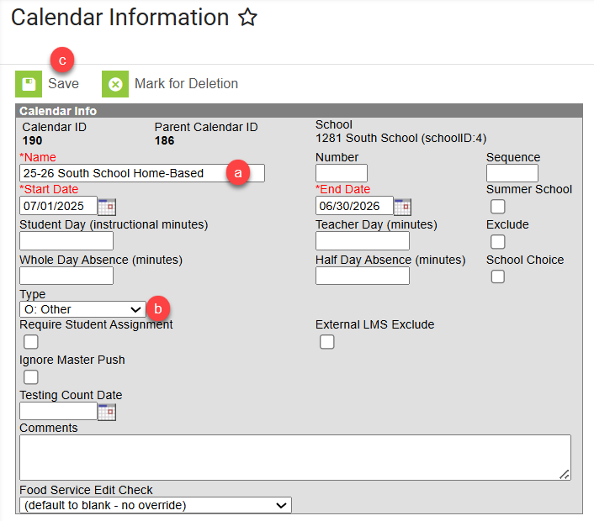**EDIT CALENDAR INFORMATION**

1. Calendar Information

PATH: *Scheduling & Courses>Calendar Setup> Calendar Information*

* 1. Change Calendar Name (optional) to identify as home-based calendar/program.
  2. Select **Type O: Other** (required).
  3. Click Save.

1. 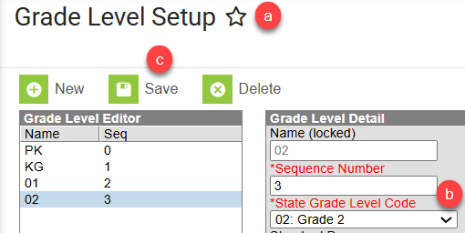Grade Level Setup

PATH: *Scheduling & Courses>Calendar Setup>Grade Level Setup*

* 1. Review existing Grade Level(s) or click New to add Grade Level(s) to selected home-based calendar.
  2. Enter Name, Sequence Number, and State Grade Level Code. Home-based Early Targeted Interventions is limited to grades PK, KG, 01, 02.
  3. Click Save (repeat for additional grade levels).

1. 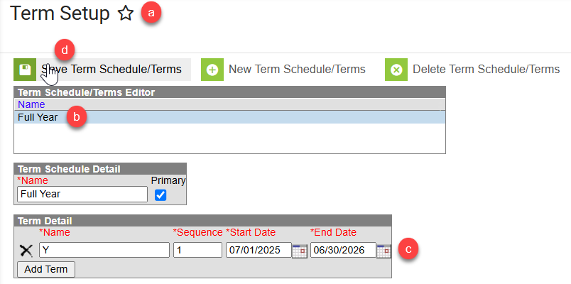Term Setup

PATH: *Scheduling & Courses>Calendar Setup>Term Setup*

* 1. Review existing Schedule/Terms or click New Term Schedule/Terms to add.
  2. Schedule/Term Name should be ‘Full Year’.
  3. Select ‘Full Year’ and enter program start and end dates (fiscal year dates).
  4. Click Save Term Schedule/Terms.

For support with enrollment(s), calendar setup, or other elements related Home-Based program participation, please contact the EDUCATE Unit.