**Economic Impact Statement**

**Administrative Rule of Montana,**

**Chapter 54 and Chapter 53:**

**World Languages Content Standards**

**Prepared by the Office of Public Instruction - April 2024**



**Table of Contents**

**Executive Summary 3**

Introduction 4

**Economic Impact Statement Required Elements 4**

a) Affected Classes of Persons 4

b) Economic Impact 5

Cost to State Agencies 5

c) Costs and Benefits of the Proposed Rule 6

d) Less Costly or Less Intrusive Methods 6

e) Selection of Proposed Rule 6

f) Efficient Allocation of Public and Private Resources 6

**Conclusion 7**

Appendix A – Economic Impact Survey Responses 8

Appendix B: Negotiated Rulemaking Committee (NRC) 14

Appendix C: Montana Office of Public Instruction Project Leadership 15

## Executive Summary

The Superintendent of Public Instruction, Elsie Arntzen, supported by the staff of the Montana Office of Public Instruction (OPI), launched a process to review the Administrative Rule of Montana (ARM),[**Title 10, Chapter 54, Subchapter 85**](https://rules.mt.gov/gateway/Subchapterhome.asp?scn=10%2E54.85), the World Languages Content Standards. The Superintendent’s vision was to update this set of standards that had not been updated in more than 24 years. The most current research and developments on how students learn world languages was reflected in the updated standards. Her vision and direction included the charge to make the revised standards more approachable and understandable by parents and other non-educators while retaining rigor and high expectations for students. Specifically, the Superintendent sought to improve the standards to provide simplicity, practicality, and clarity.

Using a task force of Montana educators in the World Languages content area and the negotiated rulemaking process, the Superintendent of Public Instruction, has developed recommendations for amendments to ARM 10, Chapter 54, Subchapter 85. Part of the recommendations includes moving the World Languages Content Standards from Chapter 54 to Chapter 53 to unite with the rest of the content standards, as requested by the Board of Public Education (BPE).

The content standards, as part of the accreditation standards, must be adopted by the BPE upon the recommendation of the Superintendent after development through the negotiated rulemaking process, as is stated in [§20-7-101, MCA](https://leg.mt.gov/bills/mca/title_0200/chapter_0070/part_0010/section_0010/0200-0070-0010-0010.html). The agency has created this economic impact statement in consultation with the NRC under the provisions of § [2-4-405, MCA](https://leg.mt.gov/bills/mca/title_0020/chapter_0040/part_0040/section_0050/0020-0040-0040-0050.html).

The OPI surveyed school personnel and stakeholders about the probable economic impact of the proposed rule amendments for ARM 10.56.85. The survey was distributed through the monthly OPI Compass newsletter that is sent to 18,116 stakeholders in the OPI bulk email system, as well as in a press release posted on February 23, 2024. Upon too few stakeholders responding by the first due date, it was also sent directly to superintendents and school board trustees through a direct email listserve and was left open for an additional three weeks. Only 3 submissions were garnered during that time. The OPI then partnered with School Administrators of Montana (SAM), to also send the survey out in SAM’s weekly message to school leaders.

## Introduction

The Superintendent and OPI staff initiated a World Languages Standards Revision Task Force, comprising Development and Review Teams listed in Appendix B, including educators, administrators, tribal leaders, and stakeholders, to revise Montana's World Languages Standards. The Development Team proposed revisions based on research, while the Review Team provided feedback. A Reconciliation team finalized proposed standards for submission to the Superintendent and the Negotiated Rulemaking Committee. The OPI facilitated virtual and in-person meetings, utilized a Teacher Learning Hub course, and posted information on the OPI website to engage Task Force members and share resources.

OPI staff collaborated with the Task Force to conduct inclusive work sessions, generating proposed revisions to the Montana State World Languages Standards. The core of the work meant aligning with the American Council on the Teaching of Foreign Languages (ACTFL) standards. The task force indicated that several districts and curricular materials are already aligned to the ACTFL standards. The task force presented its rationale to the Negotiated Rulemaking Committee and sought feedback from the Montana Advisory Council on Indian Education (MACIE) regarding the integration of Indian Education for All and honoring Montana Indigenous languages within the standards.

The Negotiated Rulemaking Committee (NRC) considered eight rule adoptions from the task force. Out of the proposed rules, the NRC chose to make amendments to eight of them. Superintendent Arntzen selected 12 members to serve on the NRC and reflect the necessary role diversity.

**The rules proposals are listed below with a summary of changes:**

* 10.54.8510-10.54.8593 World Languages Content Standards:
  + Repeal all standards for revisions
* 10.54.8607-10.54.8618 World Languages Performance Standards:
  + Repeal all standards for revisions
* 10.53.1401 - 10.53.1405 World Languages Content Standards
  + Adopt new standards in alignment with the American Council on the Teaching of Foreign Languages (ACTFL)
  + Integration of Montana Indigenous Peoples/Indian Education for All
* 10.53.1406-10.53-1408 World Languages Performance Descriptors
  + Adopt new performance level descriptors (Novice, Intermediate, and Advanced) standards in alignment with the American Council on the Teaching of Foreign Languages (ACTFL)
  + Integration of Montana Indigenous Peoples/Indian Education for All

## 

## Economic Impact Statement Required Elements

As required by § 20-7-101(1), MCA, the Montana Superintendent of Public Instruction, has prepared this economic impact statement in consultation with the NRC under the provisions of § 2-4-405, MCA. Each of the elements required to be addressed in the economic impact statement is outlined below.

### a) Affected Classes of Persons

*Describe the classes of persons who will be affected by the proposed rule, including*

*classes that will bear the costs of the proposed rule and classes that will benefit from the*

*proposed rule. Refer to § 2‐4‐ 405 (2)(a), MCA.*

The classes of persons affected by the rule changes include individuals from the following groups: school district trustees, K-12 school administrators, K-12 teachers (particularly World Languages educators), school counselors, school librarians, school clerks/business officials, parents, and taxpayers.

Costs associated with the rule changes are the responsibility of local school districts.

The beneficiaries of the rule changes are trustees, administrators, teachers, and students of local school districts, as well as Montana communities served by accredited schools.

### b) Economic Impact

*Describe the probable economic impact of the proposed rule upon affected classes of*

*persons, including but not limited to providers of services under contracts with the state*

*and affected small businesses, and quantify, to the extent practicable, that impact. Refer*

*to § 2‐4405 (2)(b), MCA.*

The OPI surveyed school personnel and stakeholders about the probable economic impact of the proposed amendments for the World Languages Content Standards, (10.53.14/10.54.85) with a single survey, sent in multiple manners as listed previously. The three individuals who responded comprised of a teacher, superintendent, and district curriculum director.

The summary results of the surveys are shown in Appendix A.

### Cost to State Agencies

*Describe and estimate the probable costs to the agency and any other agency of the implementation and enforcement of the proposed rule and any anticipated effect on state revenue. Refer to § 2‐4‐ 405 (2)(c), MCA*

The Office of Public Instruction (OPI), per [§ 20-7-101, MCA](https://leg.mt.gov/bills/mca/title_0200/chapter_0070/part_0010/section_0010/0200-0070-0010-0010.html), has incurred costs associated with the task force, including in-person meetings for writing and development. The approximate total for conducting the task force’s work is about $7,500 for the in-person writing days. The negotiated rulemaking process, including contracting with a facilitator and convening the NRC. The total cost to the OPI for the negotiated rulemaking process is approximately $8,000. In looking to create guidance documents to support integration, the agency is anticipating about $4,000 in related costs. Outside of agency staff wages aligned with their job responsibilities, this brings the total estimated cost to $19,500.

The BPE is responsible for filing fees of notices of public hearing of proposed rule changes and publication fees of notices of adoption and amendments with the Secretary of State at $60 per page. The costs associated with board member attendance at public hearings will be paid within the existing budget of the BPE.

### c) Costs and Benefits of the Proposed Rule

*Analyze and compare the costs and benefits of the proposed rule to the costs and*

*benefits of inaction. Refer to § 2‐4‐405 (2)(d), MCA.*

Based on legislative action, the State Superintendent initiated the process of amending the accreditation and aligning content standards. The agency did not undertake an analysis of the costs and benefits of "inaction."

### d) Less Costly or Less Intrusive Methods

*Are there less costly or less intrusive methods for achieving the purpose of the proposed*

*rule? Refer to § 2‐4‐405 (2)(e), MCA.*

There is no less costly or less intrusive method for achieving the purpose of the proposed rule changes.

### e) Selection of Proposed Rule

*Analyze any alternative methods for achieving the purpose of the proposed rule that*

*were seriously considered by the agency and the reasons why they were rejected in*

*favor of the proposed rule. Refer to § 2‐4‐405 (2)(f), MCA.*

After exploring alternative methods to achieve the proposed rule's purpose, it was determined that given the substantial influence of content standards on school quality and instruction, especially in the realm of World Languages education, and the statutory requirement for negotiated rulemaking, no alternative method would sufficiently produce content standards based on learner outcomes conducive to educational excellence.

### f) Efficient Allocation of Public and Private Resources

*Does the proposed rule represent an efficient allocation of public and private resources?*

*Refer to § 2‐4‐405 (2)(g), MCA.*

The proposed new rules do not involve any specific allocation of public and private resources.

## 

## Conclusion

The NRC, through consensus, determined that the rule amendments should be surveyed. Appendix A shows the responses and the demographics of those who completed the survey. No specific comments were made about the individual rule amendments, just overall impressions of the probable economic impact.

The stakeholders shared that their textbooks are significantly outdated, and they require new instructional materials such as books and audio/visual aids to align with American Council on the Teaching of Foreign Languages (ACTFL) standards. This entails potentially making curricular purchases for new language offerings and developing materials to support their existing programs, like the Blackfeet Language curriculum. Some schools rely on world language instruction solely facilitated through Montana Digital Academy, as they lack the necessary staff and materials for in-person instruction on campus. Survey participants indicate that the estimated cost for implementing these standards ranges from minimal expenses to potentially up to $10,000.

The core impact on educators revolves around the time and funding required for professional learning on the ACTFL standards as they align with the Montana content standards. Suggestions for virtual learning, including a Montana Teacher Learning HUB course, were suggested as an avenue to reach teachers in a timely and cost-effective manner.

The Superintendent's recommendations to the BPE will be evaluated by the BPE and then facilitated through the Montana Administrative Procedure Act (MAPA) process before any adoption of proposed standards changes are implemented.

## Appendix A – Economic Impact Survey Responses

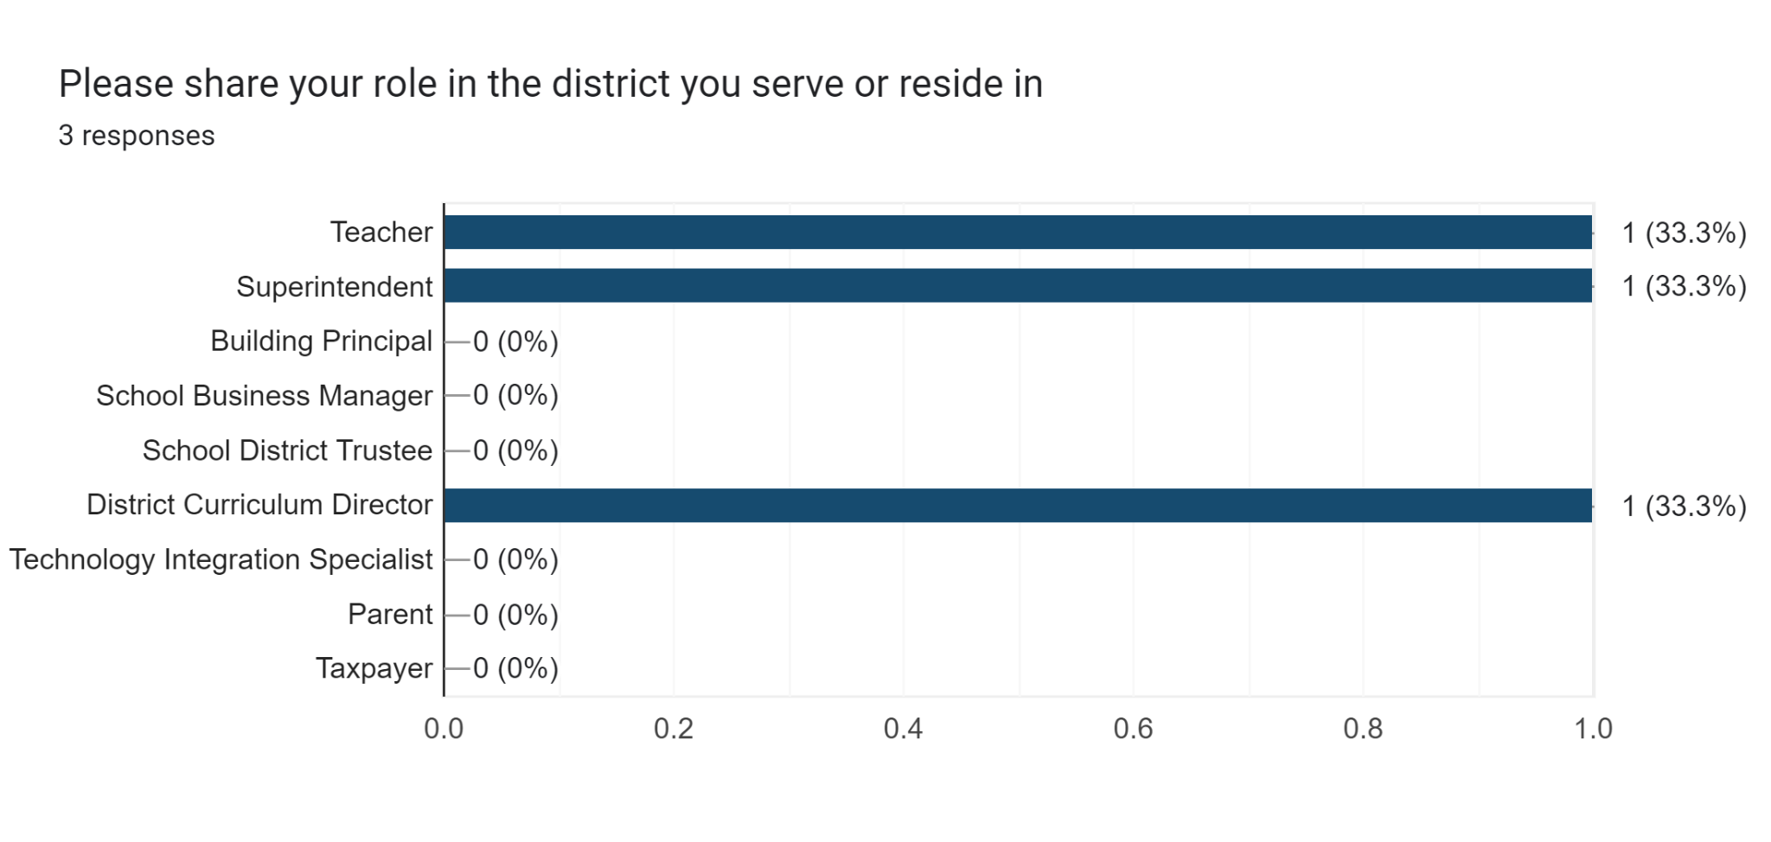

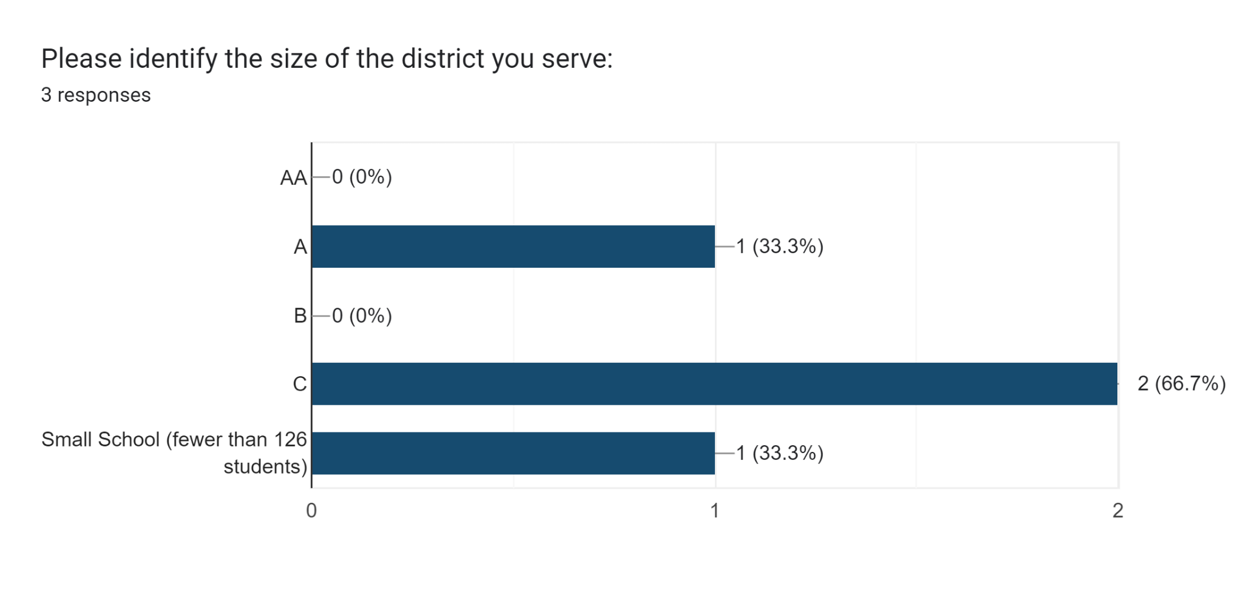

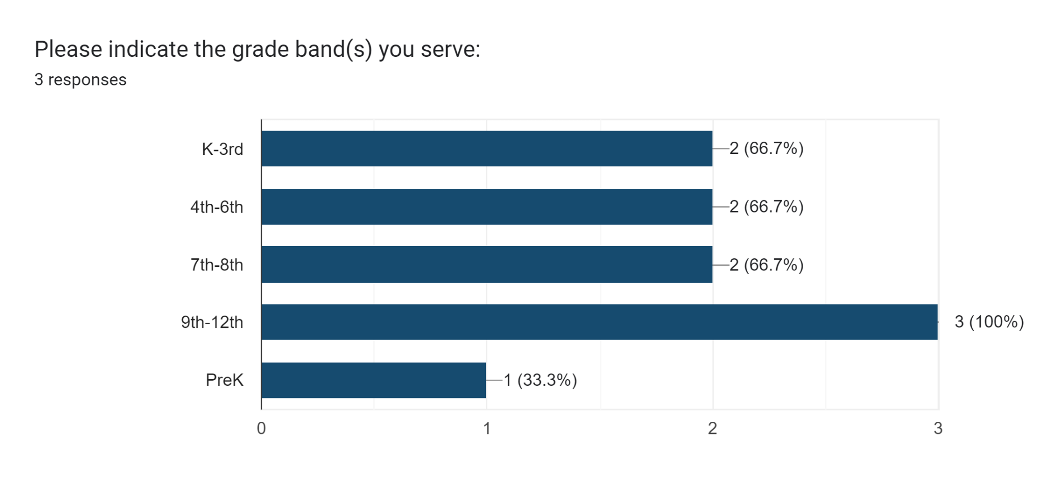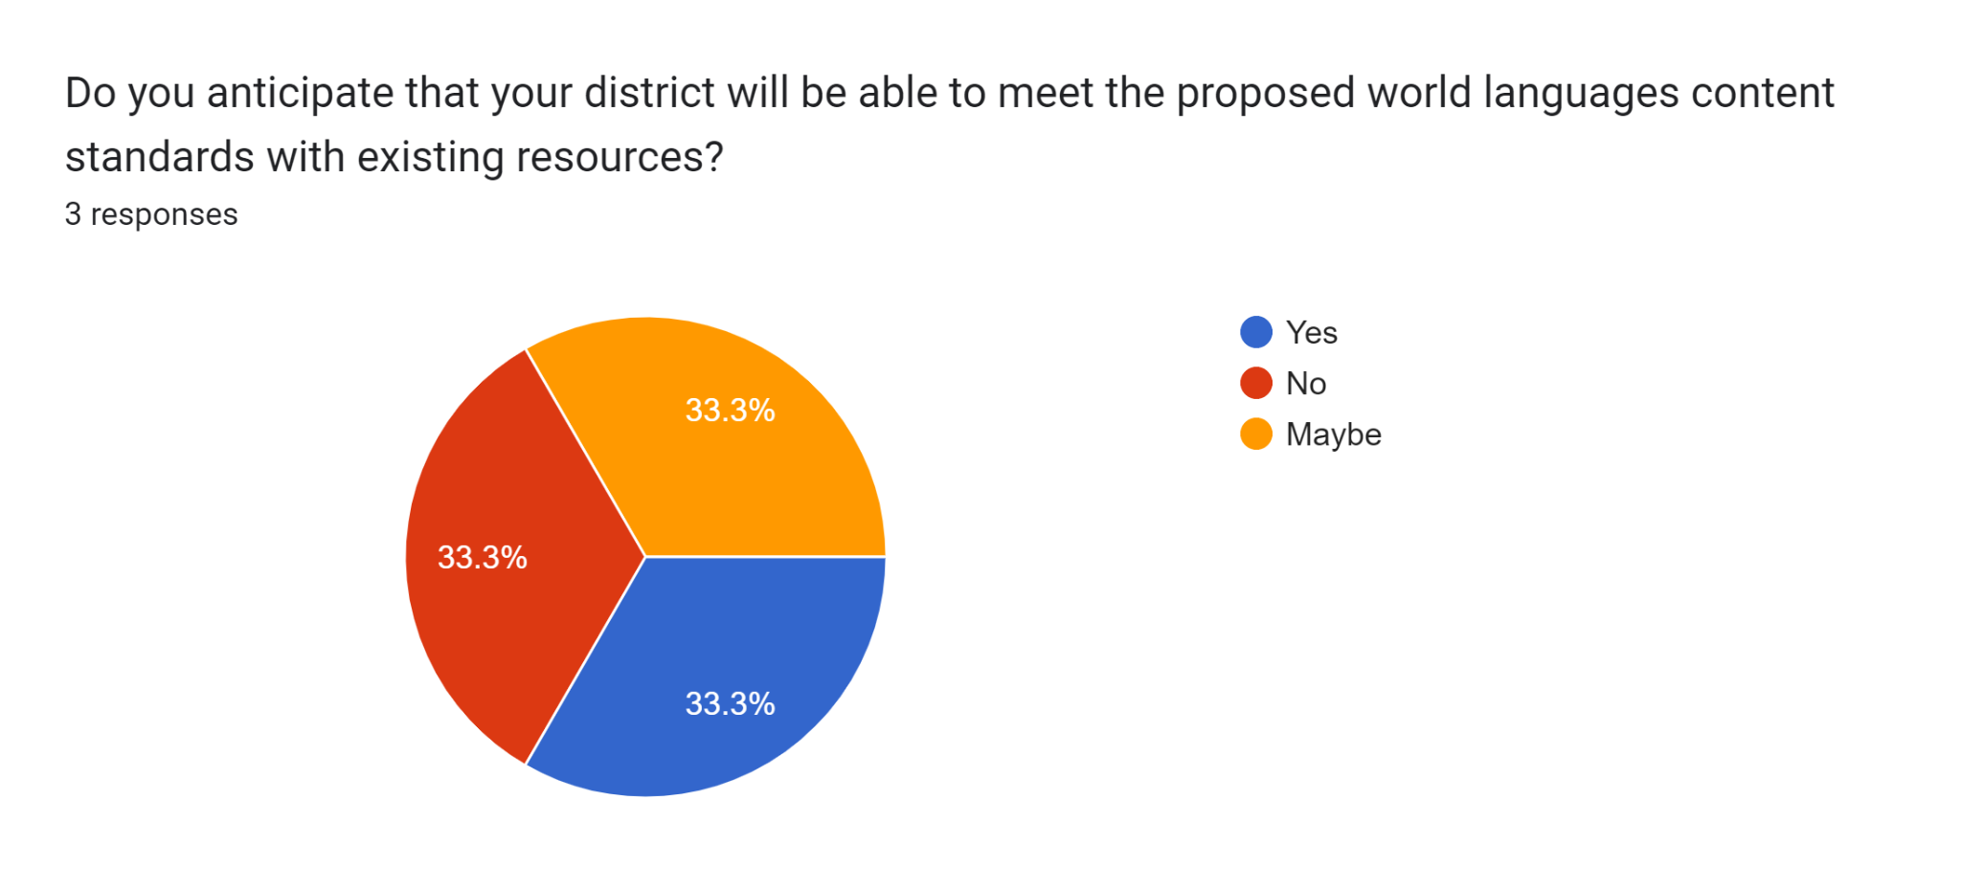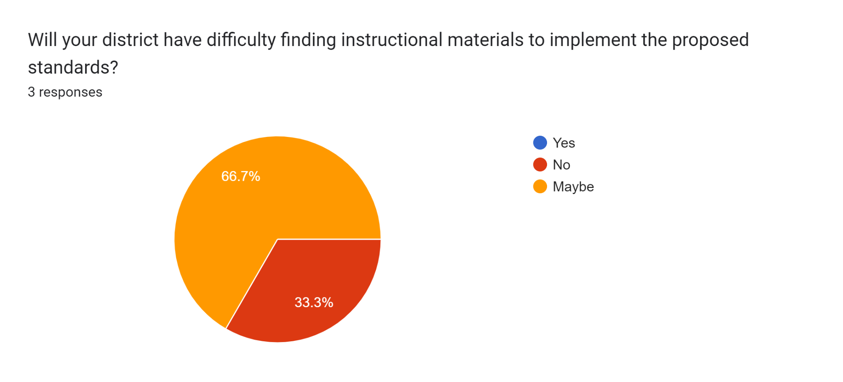

Forms response chart. Question title: Would the proposed standards impose a cost for instructional materials beyond that required to implement the current world languages content standards?
. Number of responses: 3 responses.

**Forms response chart. Question title: What increase in total dollars would be required to cover the cost associated with Instructional Materials? (best estimate)
. Number of responses: 3 responses.**

**If you answered “yes, please provide additional information:**

* Our textbooks are significantly outdated, necessitating the acquisition of new instructional materials such as books, audio/visual aids, etc., to meet ACTFL standards.
* Curriculum purchases are required for new language offerings and the development of materials to support our existing language program, particularly the Blackfeet Language curriculum.
* Foreign language instruction is exclusively provided through Montana Digital Academy due to a lack of staff and materials for in-person instruction on campus.

Forms response chart. Question title: Would the proposed standards impose a cost for personnel beyond what is required to implement the current standards?
. Number of responses: 3 responses.

**If you answered “yes, please provide additional information:**

* We do not provide on-site, in-person foreign language instruction. We only utilize MTDA.

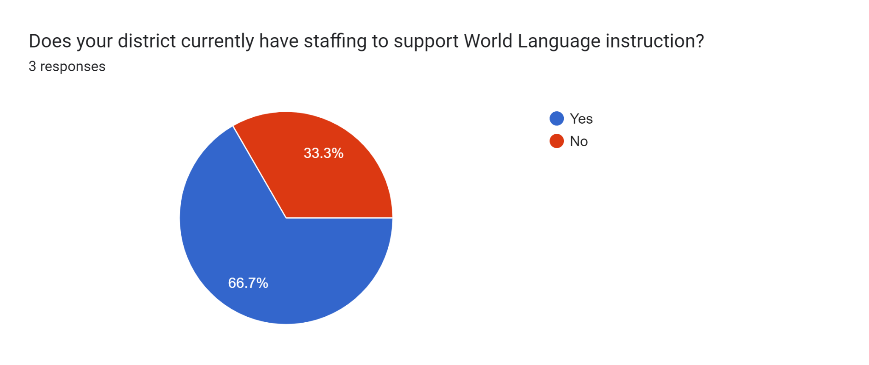

**Please share any relevant information about your district's personnel needs for World Languages.**

* I am a high school Spanish teacher in addition to being a high school English teacher. I am only able to offer two Spanish classes, so higher levels are unavailable to students.

**Forms response chart. Question title: Will your district have difficulty funding professional development opportunities for world languages educators to support implementation of the rule amendments?
. Number of responses: 3 responses.**

**What type, format, and frequency of professional development would be needed to support the implementation of the proposed World Languages standards?**

* Training in ACTFL assessment strategies, comprehensible input, etc.
* Initial training of the revised content standards, ongoing follow-up training throughout the school year for staff, and implementation training for new staff
* Virtual instruction, College course work or Teacher Learning Hub opportunities would most likely be effective.

**What are the time implications related to your district implementing the proposed World Languages Content Standards (professional development, reviewing resources, etc.)?**

* Planning and feedback time would need to be increased in order to be able to facilitate World Language courses that meet the proposed standards. Time would need to be allotted to review resources and potentially select new ones.
* 18-24 hours
* This would be a very time-sensitive circumstance for us.

# 

## Appendix B: World Languages Revision Task Force Members

| **Task Force Members** | **Roles** | **Location** |
| --- | --- | --- |
| Adrienne Barnes, M.A. | Writing and Review Teams | Polson |
| Dr. Galen Brokaw | Writing and Review Teams | Bozeman |
| Dr. Patricia Catoira | Writing Team | Bozeman |
| Lachelle Davis-Monnett | Writing Team | Kalispell |
| Naomi Delaloye, M.A. | Writing Team | Whitefish |
| Brooke Gardner, M.A. | Writing Team | Whitefish |
| Dr. Dora LaCasse | Review Team | Missoula |
| M. Alice Nation, M.A. | Writing and Review Teams | Billings |
| Dr. Velma Pretty On Top | Writing Team | Crow Agency |
| Brandy Reinhardt | Writing Team | Missoula |
| Tabitha Smail, M.A. | Writing Team | Helena |
| Lisa Werner, M.A. | Writing and Review Teams | Lewistown |
| Dr. Cecily Whitworth | Writing Team | Missoula |
| Dr. Megan Wong | Writing Team | Bozeman |

## 

## Appendix C: Negotiated Rulemaking Committee (NRC)

| **Member** | **NRC Role** | **Location** |
| --- | --- | --- |
| Charlene Jonsson | K-12 Teacher | Savage |
| Carolyn Rusche | Instructional Coach, Montana Tribe Representative | Shepard |
| Norah Barney | K-12 School Administrator, Curriculum Director | Anaconda |
| Garth Sleight | Higher Education | Miles City |
| Erik Pritchard | K-12 Teacher | Helena |
| Kerri Norrick | School District Trustee, K-12 Educator, Parent | Bozeman |
| Kevin Kicking Woman | K-12 Teacher, Montana Tribe Representative | Browning |
| Carrie Fisher | School Business Official | Belgrade |
| Kathy Milodragovich | School District Trustee, Retired Educator | Butte |
| Julie Murgel | OPI | Helena |
| Christy Mock-Stutz | OPI | Helena |

## 

## 

## Appendix D: Office of Public Instruction Project Leadership

**Elsie Arntzen,** Superintendent of Public Instruction

**Christy Mock-Stutz,** Assistant Superintendent

**Julie Murgel,** Chief Program Officer

**Marie Judisch,** Teaching and Learning Senior Manager

**Stephanie Swigart,** English Language Arts & Literacy Instructional Coordinator

**Michelle McCarthy,** Science Instructional Coordinator

**Sheri Harlow,** Administrative Support