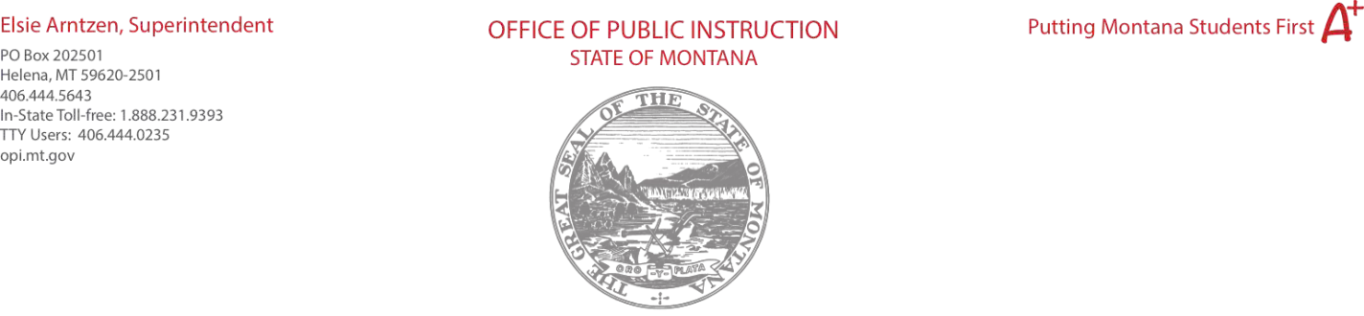

Object Codes

100 | Personal Service Salaries – Salaries (examples)  - CTE Teacher to initiate a new program of study in an emerging or in demand area.  - CTE Teacher stipend for serving as Chapter Advisors for a CTSO.  - Substitute Teacher Salary while CTE teachers are attending CTSO events, WBL activities, or CTE professional development.  - Career Coaches or CTE Counselors
200 | Employee Benefits – Benefits  - Should be calculated at 20% of salary cost.
300 | Purchased Professional and Technical Services – Contracted services for administrative, professional, educational, technical, and cooperative services. (examples)  - Curriculum Consortia  - Speakers for Industry, Careers, or Professional Development  - Technical Services (equipment repair or training)  - Professional Training (Chef, CNA, RN, Welding etc.)
400 | Purchased Property Services – Utilities, building usage charges, repairs and maintenance services, rent, minor construction. (examples)  - This is not typically used for Perkins funding- please contact CTE Specialist for approval.
500 | Other Purchased Services – Student travel, employee travel, professional development, registrations, communications, printing. (examples)  - Student and advisor travel: registration, hotels, and transportation.  - Professional development: registrations, hotel, and transportation.  - Printing or marketing for CTE Pathways, CTE or CTSO recruitment.
600 | Supplies – Instructional supplies and materials, textbooks, library materials software, minor equipment. (examples)  - Upgrading technology for CTE classrooms and laboratories.  - Minor equipment specific to the program area; power/ and hand tools, culinary items, digital equipment, medical equipment, PPE, etc.  - Textbooks for a new CTE program area or enrichment of a program resource library. (Not ongoing textbook updates- this should be a district expense)  - Subscriptions for software (Adobe, iCEV, MyCAERT, PLTW, etc.)
700 | Property – Capital outlay, including major construction and equipment usually>5000 (Requires Pre-Approval by the OPI)
800 | Other Objects – Rare-Dues, fees, student organization costs. (examples)  - Teacher memberships for AAFCS, MAFCS, ACTE, MACTE, MAAE, NAAE, MBEA, WBEA, MITEA, ITEA, NCHE etc.  - CTSO memberships for teachers or students: BPA, DECA, FCCLA, FFA, HOSA, SkillsUSA, TSA  - Instructional or organizational supplies for CTSO’s  - Classroom set of Official Dress for CTSO students (cannot be for student ownership)
900 | Transfers – Transfers to other districts or cooperatives under a consortium or cooperative.

(Note: The Office of Public Instruction recommends budgeting all 900 Transfers under Purpose Code 10 Instruction, rather than breaking down transfers into multiple purpose codes.) Used only for IDEA B and Preschool. NCLB/ESEA Transfers and REAP-flex are handled on the Allocations page.

*Perkins does not allow consumable items. Examples: wood, metal, gas, groceries, seeds, soils, printer ink, filament, etc.

Purpose Categories
10 Instruction - Activities dealing directly with the interaction between teachers and students.

20 Support Services –
- Instructional Staff – Activities associated with assisting the instructional staff with the content and process of providing learning experiences for students (i.e., improvement of instruction services, designing curriculum).
- Students – Activities designed to assess and improve the well-being of students and to supplement the teaching process. Non-instructional paraprofessionals should be recorded here.
21 Parental/Family Involvement – Activities provided by and for parent/guardians to learn about the intellectual and developmental needs of their children and to participate constructively in their children's education.
22 Professional Development – Activities associated with high-quality professional development and training of school system personnel including in-service training and workshops.

23 Administration – Includes support services for general administration, school administrators (i.e., federal program staff at the district office, district facilitators), and business office.
27 Pupil Transportation – Activities concerned with the conveyance of students to and from school, as provided by state and federal law. Includes trips between home and school.
33 School and Community Support – Activities concerned with providing community services to students, staff, or other community participants. Activities performed by students that address a given community need and provide for structured opportunities linking tasks to the acquisition of values, skills, or knowledge by participating youths.
40 Facilities – Activities concerned with the acquisition of land and buildings; remodeling and maintenance of buildings; construction of buildings and additions to buildings.
(return to top)

