

**2025-2026**

**Early Targeted Interventions***(Early Literacy & Early Numeracy)* **JUMPSTART PROGRAM**

Early Targeted Interventions **summer** Jumpstart program setup and reporting must be completed by the conclusion of the district’s 25-26 Jumpstart program and certified no later than ***August 29, 2025***.

Qualified students, entering grades Kindergarten to 3rd grade (for the 25-26 school year), enrolled in an Early Targeted Interventions **summer** Jumpstart program are eligible for an additional 0.25 ANB. Jumpstart participants must have an Early Targeted Interventions eligibility record, an enrollment record in a Jumpstart calendar with a program duration of at least 4 weeks and 120 instructional hours and be included in the district's Jumpstart certification. Districts will create calendars, courses/sections, enrollments and eligibility records, then certify Jumpstart program information at the end of the session.

*Students who are assessed and deemed eligible but do not participate in the summer Jumpstart program (or any other Early Targeted Interventions program) should still have an eligibility record entered.*

**STEP ONE: CREATE JUMPSTART CALENDAR(S)**

PATH: *Scheduling & Courses>Calendar Setup>Calendar Wizard*

1. 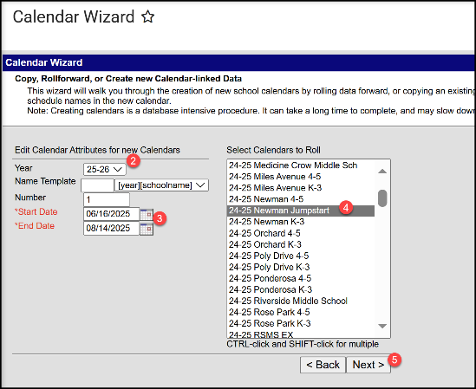Select **Create new Calendar(s) by rolling forward selected data** or **Create new blank Calendars** and click Next.
2. Select Year (25-26).
3. Enter Start Date and End Date (program start and end date for summer Jumpstart).
4. Select prior year Jumpstart calendar(s)/school(s) to roll or   
   select school(s) to add new calendar.
5. Click Next.
6. Check boxes to copy data (rolled calendars) and Run Wizard.
7. Refresh browser page and select 25-26 Jumpstart calendar.

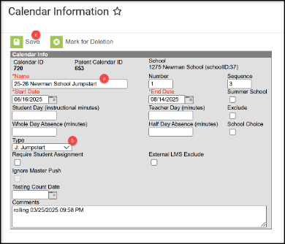**STEP TWO: EDIT CALENDAR INFORMATION**

PATH: *Scheduling & Courses>Calendar Setup>Calendar Information*

1. Calendar Information
   1. Change Calendar Name to identify as Jumpstart calendar/program (optional).
   2. Select **Type J: Jumpstart** (required).
   3. Click Save.
2. Grade Level Setup

PATH: *Scheduling & Courses>Calendar Setup>Grade Level Setup*

* 1. 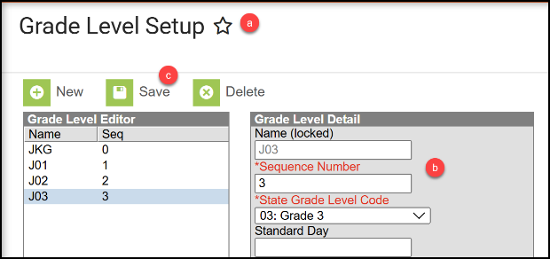Review existing Grade Level(s) or click New to add Grade Level(s) to selected Jumpstart calendar.
  2. Enter Name, Sequence Number, and State Grade Level Code (KG, 01, 02, 03).
  3. Click Save (repeat for additional grade levels).

1. Term Setup

PATH: *Scheduling & Courses>Calendar Setup>Term Setup*

* 1. Graphical user interface, text, application

     Description automatically generatedReview existing Schedule/Terms or click New Term Schedule/Terms to add.
  2. Schedule/Term Name should be ‘Full Year’.
  3. Select ‘Full Year’ and enter program start and end dates.
  4. Click Save Term Schedule/Terms.

1. Period Setup

PATH: *Scheduling & Courses>Calendar Setup>Period Setup*

* 1. Review existing Period Schedule(s) or click New Period Schedule to add.
  2. Review/enter the Number of Period Schedules (create 1, unless schedule varies by day).
  3. Select Period Schedule.
  4. 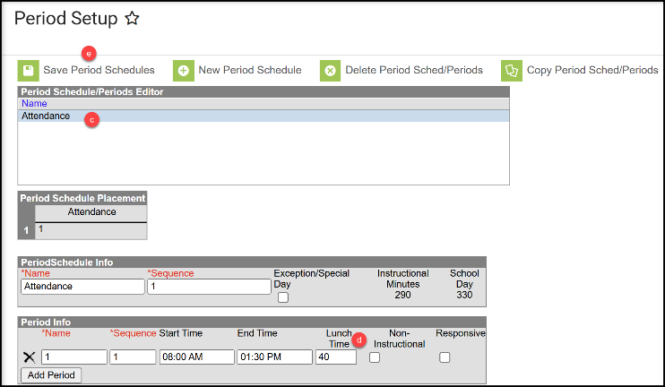Review/enter Start Time and End Time. Review/Enter the total non-instructional minutes (lunch, recess, etc.) in the Lunch Time field.
  5. Click Save Period Schedules. Repeat for any additional Period Schedules (if applicable).

1. Day Setup

PATH: *Scheduling & Courses>Calendar Setup>Day Setup*

* 1. Click Day Reset.
  2. Enter Student/Instructional Start and End Dates.
  3. Select days of the week students will attend.
  4. Click Create Days.
  5. Remove non-school days by clicking the day and unchecking School Day, Instruction, and Attendance (e.g. July 4th). Then Save Day/Day Events. Repeat as applicable.
  6. Add school days by clicking the day and checking School Day, Instruction, and Attendance. Then Save Day/Day Events. Repeat as applicable.

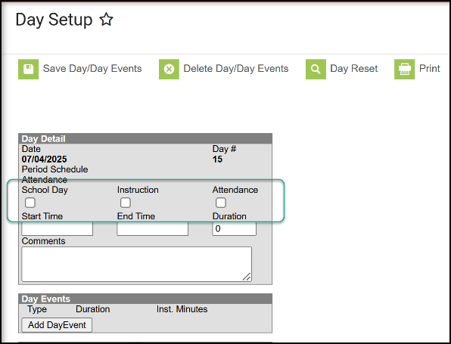

1. Copy attendance codes into this calendar [NOTE: Step 6 & 7 only necessary if using Infinite Campus tools for attendance records]

PATH: *Attendance Office>Settings>Excuse Code Copier Wizard*

* 1. 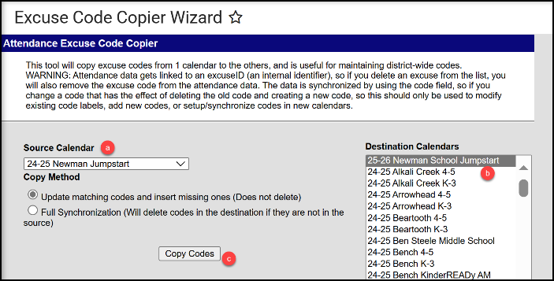Select the Source Calendar to copy from.
  2. Select the new 25-26 Jumpstart calendar.
  3. Click Copy Codes.

1. Verify Attendance Codes.

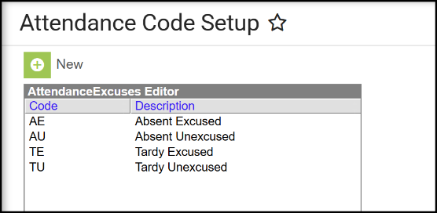PATH: *Attendance Office>Settings>Attendance Code Setup*

Recommended Attendance/Excuse Codes:

* 1. EA – Excused Absent
  2. UA – Unexcused Absent
  3. ET – Excused Tardy
  4. UT – Unexcused Tardy

**STEP THREE: ENROLL STUDENTS USING THE STUDENT LOCATOR WIZARD**

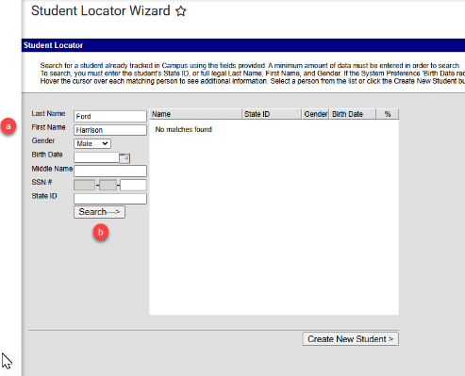PATH: *Student Information>General>Student Locator Wizard*

1. Verify the 25-26 Jumpstart calendar is selected.
2. Open the Student Locator Wizard.
   1. Enter the Last Name, First Name, and Gender.
   2. Click Search.

(refer to Appendix for upload instructions/options)

There are 3 scenarios for creating an enrollment:

1. 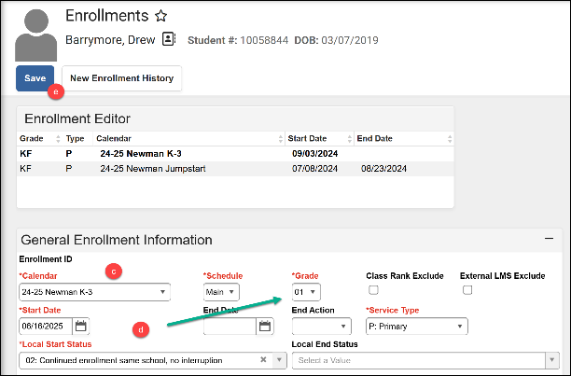If the student had a previous enrollment in the district, the student’s name will be prefaced with a back arrow.
   1. Select the student.
   2. Click New to add an Enrollment.
   3. Verify the Calendar is correct.
   4. Enter Start Date, Local Start Status, and Grade.
   5. Save.

1. If the student did not have a previous enrollment in the district but was enrolled in another Montana district, the search will return a match (hover over student name to verify match):
   1. Select the student.
   2. Review name and birthdate. Enter Race/Ethnicity.
   3. Verify the Calendar is correct.
   4. 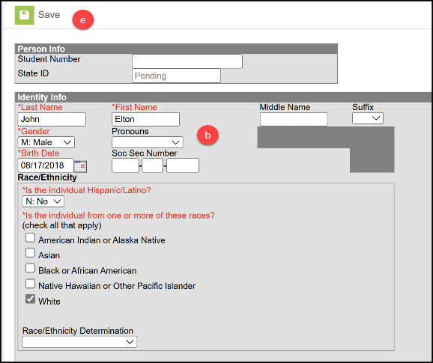Enter Start Date, Local Start Status, and Grade.
   5. Save.

1. If the student was never enrolled in a Montana district (new to Montana or public school) the search will return no match:
   1. 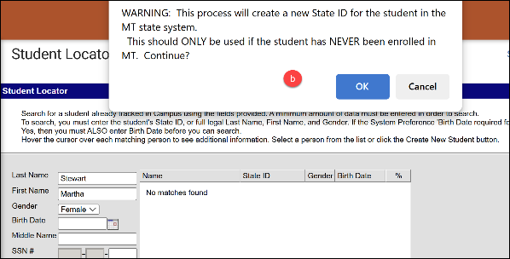Click Create New Student.
   2. Review the warning (pop-up) and click OK.
   3. Enter Birthdate and Race/Ethnicity.
   4. Verify the Calendar is correct.
   5. Enter Start Date, Local Start Status, and Grade.
   6. Save

**STEP FOUR: CREATE ELIGIBILITY RECORD(S)**

PATH: *Student Information>State Programs>Early Targeted Interventions*

NOTE: Eligibility records (Literacy or Numeracy) are valid for all Early Targeted Interventions program enrollments of the applicable year (Jumpstart, Classroom-Based, and/or Home-Based).

1. 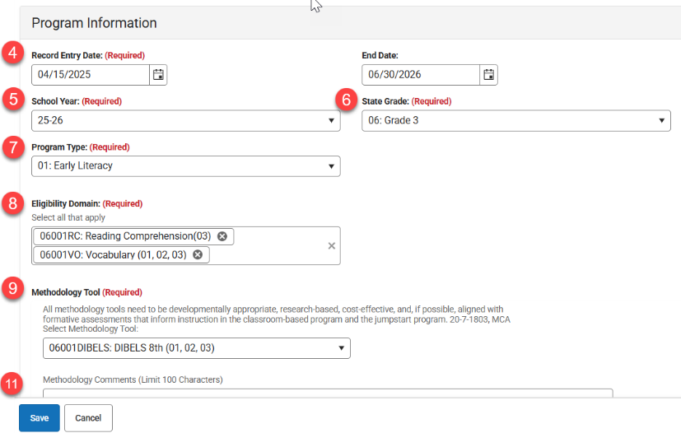Search & find the student.
2. Navigate to Early Targeted Interventions.
3. Click **New** to add a new record.  
   *NOTE: must input items in specific order as detailed*
4. Enter Record Entry Date – **Student Assessment Date**   
   Enter End Date – June 30th of Early Targeted Interventions School Year
5. Enter School Year – year for which program eligibility is applicable
6. Enter State Grade – grade level of the assessment tool used to determine eligibility (grade selection limits available options for Domains and Methodology Tools)
7. Select Program Type – Early Literacy or Early Numeracy (Program Type selection limits applicable options for Domains and Methodology Tools).

**\*\* Early Numeracy should not be entered until the Board of Public Education approves Eligibility Domains and Methodology Tools\*\***

1. Select Eligibility Domain(s) – Select all that apply for specific student as eligible.
2. Select Methodology Tool – if Other is selected, comments are required in the Methodology Comments field. (If Other is not selected, the Methodology Comments field must be blank)
3. **Contact Information is required for Homebased Early Intervention students only. Enter Parent Contact Name, Email and Phone Number (used for outreach to setup program access).
4. A picture containing table

   AI-generated content may be incorrect.Click Save.
5. Comments field can be used at district discretion
6. Repeat steps to create eligibility record for both

**\*\*HOME-BASED ONLY:** Once a student has an eligibility record and the district has indicated participation in the home-based program, the student will be allocated a Waterford license.

**STEP FIVE: ADD DISTRICT ASSIGNMENTS FOR TEACHERS**

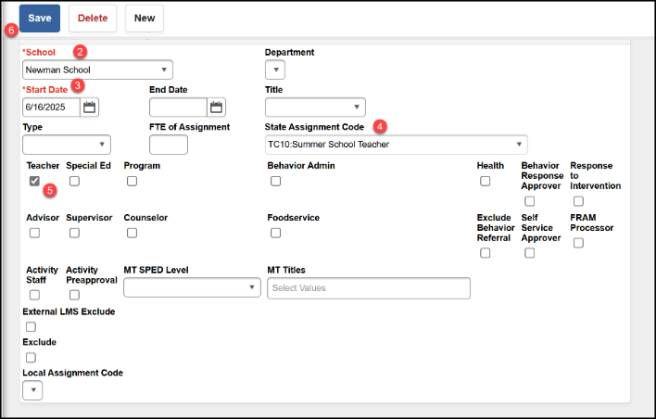PATH: *Census>Staff>District Assignments*

1. Click New.
2. Select the school where the Jumpstart program is located.
3. Enter the Start Date (End Date can be added if the teacher will not continue this assignment).
4. For the State Assignment Code select TC:10 Summer School Teacher. No FTE for this code.
5. Select the Teacher checkbox.
6. Click Save.

**STEP SIX: CREATE COURSE, SECTION, AND ADD STUDENTS**

1. Add Course.

PATH: *Scheduling & Courses>Courses>Add Course*

* 1. Enter course Number and Name.
  2. Select NCES data
     1. SCED Subject Area = 23
     2. SCED Course Identifier
* 012 (multi-grade level classes)
* or 003 to 006 (for single grade level classes)
  + 1. SCED Course Level = GE: General Education
    2. SCED Lowest Grade = Kindergarten (or as applicable)
    3. SCED Highest Grade = Grade 3 (or as applicable)
  1. Check box for Attendance (in Course Setup area)
  2. Click Save.

1. 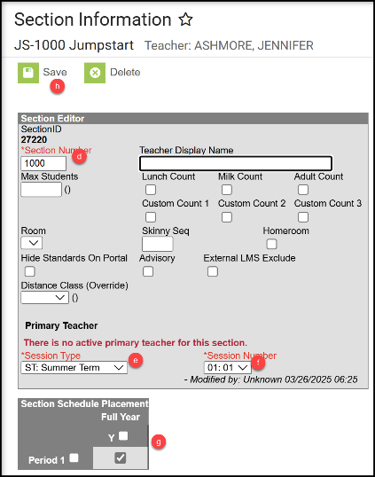Create a Course Section.

PATH: *Scheduling & Courses>Courses>Course Sections*

* 1. Navigate to Course Sections.
  2. Search for new Jumpstart course.
  3. Click Add a Section

(or click on existing section, if copied from prior year).

* 1. Assign a Section Number.
  2. Session Type = **ST: Summer Term**.
  3. Select a Session Number.
  4. Check the box(es) under Section Schedule Placement.
  5. Click Create Section (or Save).

1. Click Section Staff History to add a teacher.  
   PATH: *Scheduling & Courses>Courses>Section Staff History*
   1. Click New Primary Teacher.
   2. Select teacher name from the dropdown.
   3. Role = 00: Teacher of record.
   4. Click Save.

1. Add Students to the Roster.

PATH: *Scheduling & Courses>Scheduling>Requests & Rosters*

* 1. Click View by: Courses.
  2. Select the Section to build the roster.

* 1. Graphical user interface, text, application

     Description automatically generatedClick Roster Builder.
  2. Add Students by Grade or click the student’s name to add to the Roster (Start and End Date are not required unless a student starts after the first day of the course or ends before the last day of the course).
  3. Click Save.

**STEP SEVEN: POPULATE END OF YEAR ATTENDANCE TOTALS  
(complete after program ends; requires ALL Jumpstart enrollments are ended)**

For districts taking daily attendance in Infinite Campus:   
PATH: *Reporting>MT State Reporting>MT EOY Attendance Totals*

1. Graphical user interface, text

   AI-generated content may be incorrect.Check the boxes for ADA - #Days Present and ADA - #Days Enrolled   
   (NOTE: ESSA Absent data is not required for Summer Jumpstart enrollments)
2. Select one or more Calendars.
3. Choose Validate and Test or Update Enrollments (recommend Validate and Test first). Common errors on this file include students with enrollments not ended, students without a schedule, or students with Service Type issues.
4. Submit to Batch.

For districts NOT taking daily attendance in Infinite Campus:

1. Refer to Appendix for upload instructions/options
2. Or manually input each students End of Year Attendance Totals

PATH: *Student Information>General>Enrollments*

* 1. Select the student.
  2. Select the Jumpstart enrollment record
  3. Input the ADA - #Days Present
  4. Input the ADA - #Days Enrolled
  5. Click Save.

**STEP EIGHT: RESYNC DATA**

PATH: *System Settings>Data Interchange Administration>Resync State Data - Batch*

1. Select the checkbox in front of DIS Objects to select all.
2. Click Send Resync.

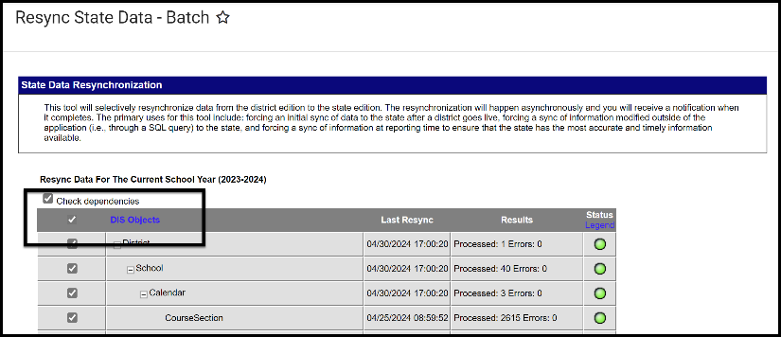

**STEP NINE: VALIDATE DATA**

PATH: *Reporting>Data Validation> Data Validation Reports*

1. Review the following Validation Reports to check for errors and review the data before certifying. Choose applicable report from drop-down.
   1. Jumpstart Validation Errors and Warnings   
      (review errors/info; make corrections; rerun as applicable until error free; resync)
   2. Jumpstart Certification (collective data being certified – review for accuracy)

Once all errors and warnings have been checked, choose the Report Data Source option of ‘Run at State’. Running the report at both the district and state ensures that data has fully synced prior to certification.

If there are mismatches between the state and district, repeat **STEP EIGHT** (Resync Data) and re-run the Validation Report at the state until district and state data matches.

**STEP TEN: CERTIFY DATA**

*PATH: Reporting> Data Certification>Event Certification*

There are three separate files included in this certification: *Enrollment, Teacher Class, and Aggregate Hours*.

\**Please wait at least 60 minutes after a complete resync before certifying data.*

* + 1. Add a certifier for Jumpstart Early Intervention.

PATH: *Reporting>Data Certification>Type Membership Setup*

1. Select a Type: Jumpstart Early Intervention
2. Click New Member.
3. Enter last name in search box and click the magnifying glass.
4. Select Name.
5. Select Type: Primary (only one primary certifier is recommended).
6. Graphical user interface

   AI-generated content may be incorrect.Click Save.
   * 1. Certifier can review Jumpstart data for accuracy – refer to **STEP NINE** (Validate Data)
     2. Graphical user interface, application

        AI-generated content may be incorrect.Certify Jumpstart data using Event Dashboard.

PATH: *Reporting>Data Certification*

1. Select Jumpstart Early Targeted Intervention 2025-26.
2. Select Certify & Submit.

If the district discovers a reporting error, please contact the EDUCATE Unit to request recertification.   
If the OPI/EDUCATE Unit discovers an error the certifier(s) may receive a message requesting correction and recertification.

## APPENDIX

## ENROLLMENT - File Upload Process

PATH: *Reporting>MT State Reporting>MT Data Upload*

Districts that use a 3rd party Student Information System (SIS) may use the file upload process to enroll students.

1. Upload the Student Demographics file (required only for newly enrolled students), followed by the Enrollment file.
2. Extract the upload file from the district’s SIS or create a text, tab delimited file from one of the AIM templates. Instructions for using the templates are embedded in the template file.
3. Select the Import Type, the Work to Perform and choose the file to be uploaded. Click Submit to Batch.
4. Review the Validate and Test results file located in the Batch Queue List located at the bottom of the page to identify and correct import errors and/or warnings.
   1. Select Refresh on the Batch Queue to retrieve the latest status of the Batch.
   2. When the Batch has completed processing, select "Get the report" to retrieve the Import Results Summary file.
5. For Student Demographic Uploads ONLY: Review New Student State ID File to ensure Student State IDs have been provided for students who previously did not have one. After the Import Results have been reviewed, please click the Refresh State ID File button, and select the New Student State ID file that corresponds to the date/time the Import completed processing. Click Generate to retrieve the new Student State ID file.

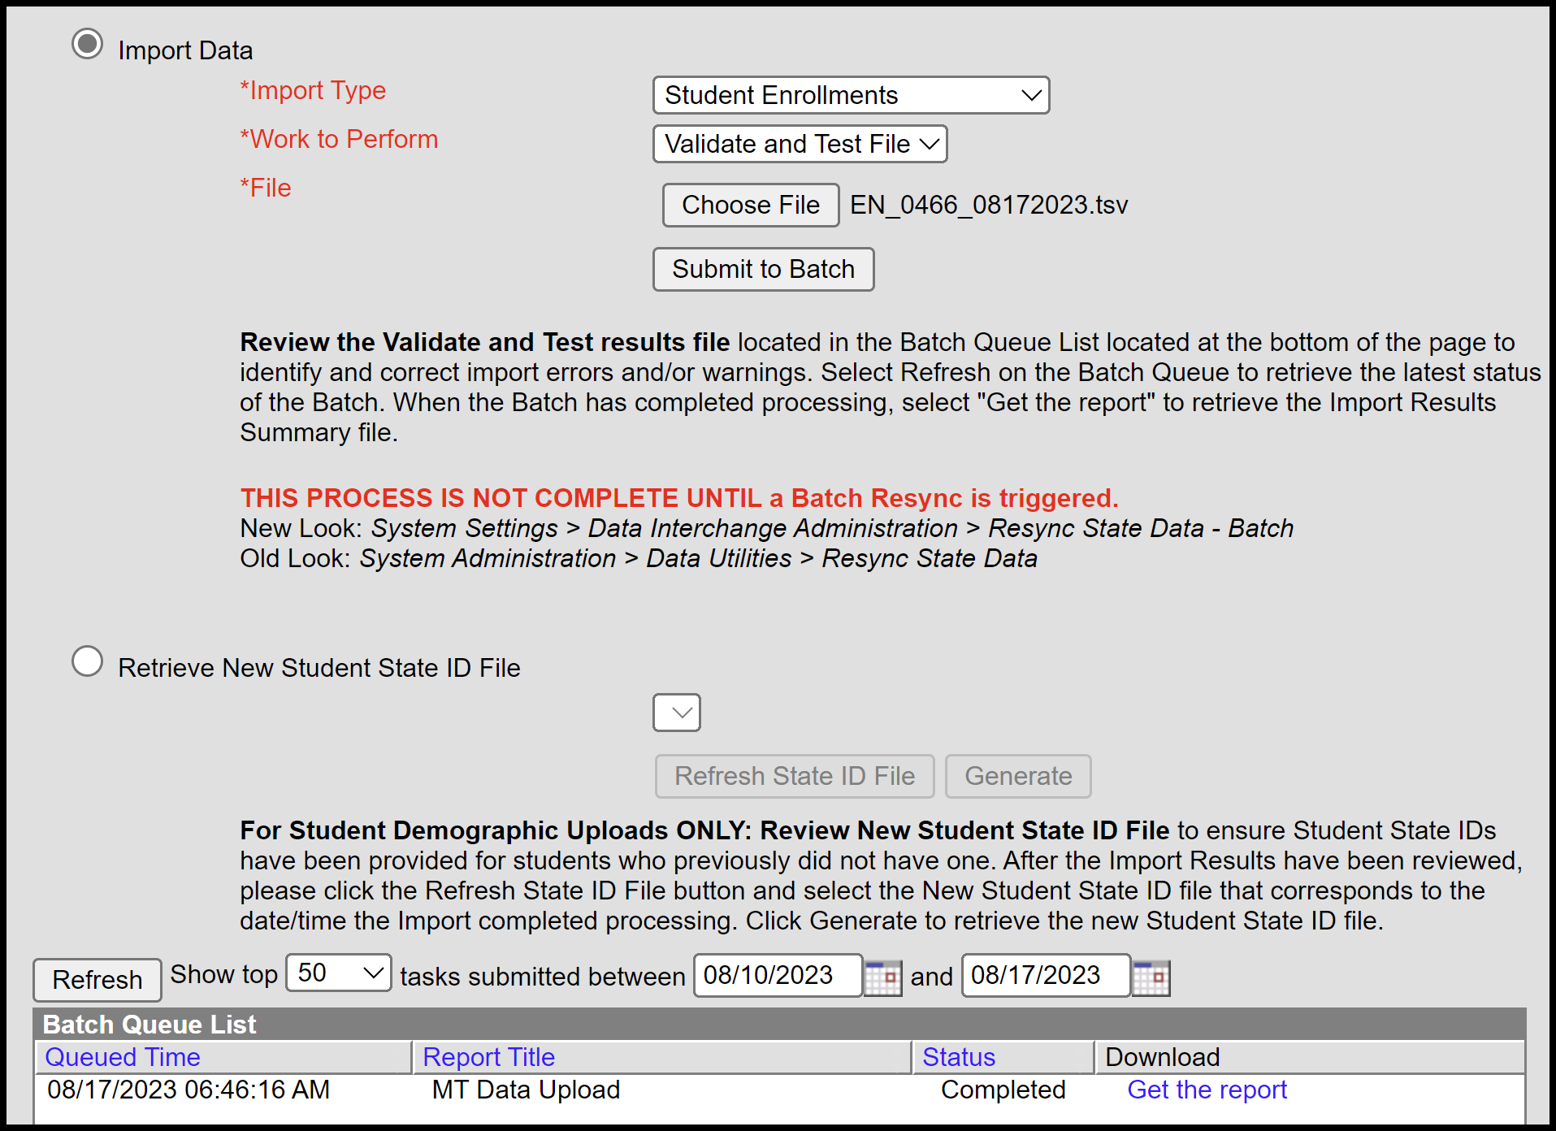

NOTE: This process is not complete until a Batch Resync is triggered (see **STEP EIGHT**)  
PATH: *System Settings > Data Interchange Administration > Resync State Data – Batch*

## END OF YEAR ATTENDANCE TOTALS - File Upload Process

PATH: *Reporting>MT State Reporting>MT Data Upload*

Districts that use a 3rd party Student Information System (SIS) or other attendance method may use the file upload to populate End of Year Attendance Totals for Jumpstart enrollments.

1. Upload the End of Year Attendance Totals file.
2. Refer to **STEP EIGHT – STEP NINE – STEP** to complete the Jumpstart Data Validation & Certification process.