School Name

*Image*

Integrated Strategic Action Plan

Updated YYYY

*This template is not required for accreditation submission. It is only an example for districts wishing to complete a formal document.*

# Table of Contents

*Once information is completed, click on the table of contents below. Select the refresh symbol* ⟳ *to include your updated pages.*

**Table of Contents 2**

**Graduate Profile 3**

**Comprehensive Needs Assessment 5**

**Educational Goals 6**

**Family and Community Engagement 7**

**Educator Effectiveness 8**

Professional Development Plan 8

Mentorship and Induction Information 8

Staff Evaluation Process 9

**Proficiency-based Learning Model 10**

**Indian Education for All 11**

**Academic Programming 12**

**School Climate 13**

# Graduate Profile

[ARM 10.55.601(4a)](https://rules.mt.gov/browse/collections/aec52c46-128e-4279-9068-8af5d5432d74/policies/b8553068-533e-489c-a901-8f6f4dda01e4)

*Insert image or link of completed Graduate Profile, and if no link is provided, explain how it is made publicly available.*

*In Google Docs, you can change your page setup to landscape or portrait for this section only by selecting File>Page Setup. Then select the section you would like to adjust.*

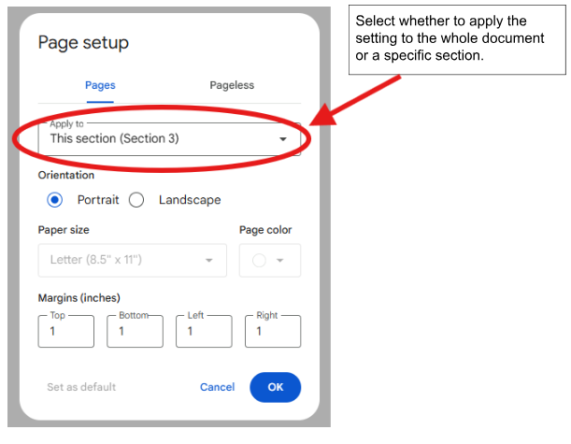

*In Word, you can change your page setup to landscape or portrait for this section only by placing your cursor at the beginning of the page, selecting Layout, and then selecting either portrait or landscape.*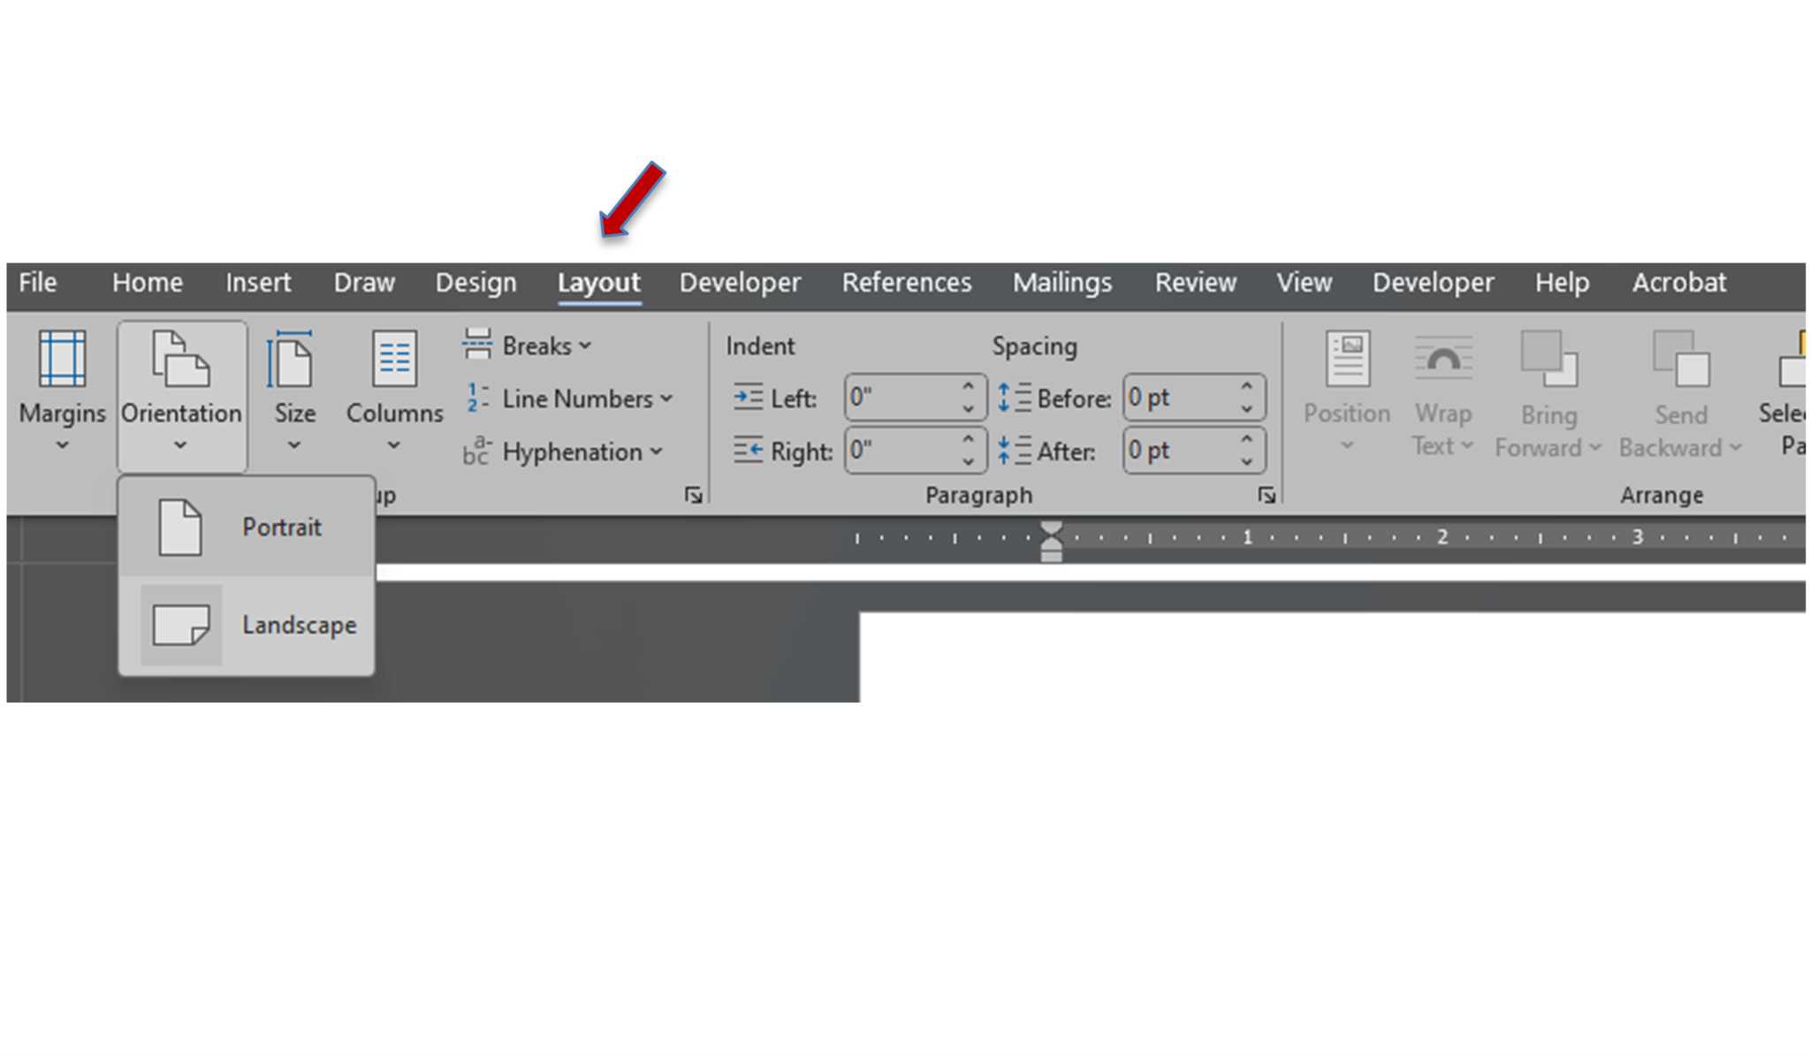

| **Evidence of Meaningful Stakeholder Input and Feedback in Creation of Graduate Profile.** |
| --- |
|  |
| **Specific Steps to Implement the Graduate Profile** |
|  |

# Comprehensive Needs Assessment

[ARM 10.55.601(3)](https://rules.mt.gov/browse/collections/aec52c46-128e-4279-9068-8af5d5432d74/policies/b8553068-533e-489c-a901-8f6f4dda01e4)

[ARM 10.55.602 (8)](https://rules.mt.gov/browse/collections/aec52c46-128e-4279-9068-8af5d5432d74/policies/abbe4b68-a84d-470e-9cb0-5b99d7f7fb48)

*Provide your information here*.

# Educational Goals

[ARM 10.55.601 (3)](https://rules.mt.gov/browse/collections/aec52c46-128e-4279-9068-8af5d5432d74/policies/b8553068-533e-489c-a901-8f6f4dda01e4)

[ARM 10.55.601 (4b)](https://rules.mt.gov/browse/collections/aec52c46-128e-4279-9068-8af5d5432d74/policies/b8553068-533e-489c-a901-8f6f4dda01e4)

*Enter your information on your educational goals here.*

***Due to the request for templates by several districts, some sections will include examples or templates that may be used when formulating evidence. Any templates provided are only examples and not to be construed as required pieces or formatting.***

[Goals Template](https://docs.google.com/document/d/1X56vB4BNZCFtdoptwFM22VKUszJI_4g-/edit)

# Family and Community Engagement

[ARM 10.55.722 (1)(a-d)](https://rules.mt.gov/browse/collections/aec52c46-128e-4279-9068-8af5d5432d74/policies/88c07c49-f688-4f0b-b753-3bc8ca5442cf)

*Enter your Family and Community Engagement information and/or plan.*

***Due to the request for templates by several districts, some sections will include examples or templates that may be used when formulating evidence. Any templates provided are only examples and not to be construed as required pieces or formatting.***

[Family and Community Engagement Template](https://docs.google.com/document/d/1n8Yf7loEW_xV-L6TK7X2HZ6cnooLgjuN4SDAu2qr4gI/edit?usp=sharing)

# Educator Effectiveness

[ARM 10.55.714(1&3)](https://rules.mt.gov/browse/collections/aec52c46-128e-4279-9068-8af5d5432d74/policies/6c0f5c72-f365-40d7-8187-5aa3ca9deebc)

[ARM 10.55.723](https://rules.mt.gov/browse/collections/aec52c46-128e-4279-9068-8af5d5432d74/policies/ecf32af8-3139-4851-bddb-98bf81134ca6)

[ARM 10.55.724(1&2)](https://rules.mt.gov/browse/collections/aec52c46-128e-4279-9068-8af5d5432d74/policies/302fc887-1071-4f95-853e-140c9dd8c982)

***Due to the request for templates by several districts, some sections will include examples or templates that may be used when formulating evidence. Any templates provided are only examples and not to be construed as required pieces or formatting.***

## Professional Development Plan

### Introduction

*Provide a brief description on how the plan was developed. Examples of evidence can include links to meeting minutes or agendas and/or consortium evidence if applicable. This section could also include information on how the Professional Development Plan aligns to the district’s Vision and/or Mission statement and to educational goals.*

Members of the Advisory Committee *(Required Evidence)*

| *List Members’* *Stakeholder Positions* | |
| --- | --- |

### Professional Development Opportunities

*Include Professional Development calendar or schedule of activities and how the plan is made public.*

### Evaluation of the Professional Development Plan

*Include steps taken for the advisory committee to evaluate the Professional Development Plan. This section can include links to meeting minutes or agendas and/or consortium evidence if applicable.*

## Mentorship and Induction Information

### Mentorship and Induction Overview of Program

*Be sure to include program evidence and/or consortium evidence if applicable.*

### Implementation Process

*Include implementation evidence if you have new teachers.*

## Staff Evaluation Process

### Certified Staff Evaluation Tool

*Provide a sample of the evaluation instrument.*

### Evaluation Process

*Provide evidence or a brief description of determining the schedule for the evaluation of certified instructional staff. Evidence could also include a link to district policy, CBA, and/or Staff Handbook. Be sure to include the page number for documents that are linked.*

# Proficiency-based Learning Model

[ARM 10.55.603](https://rules.mt.gov/browse/collections/aec52c46-128e-4279-9068-8af5d5432d74/policies/9e741a78-16d6-479a-9d63-d0af123fdb92)

ARM 10.55.1001

ARM 10.55.1003

*Enter your Curriculum information and Assessment Plan here.*

***Due to the request for templates by several districts, some sections will include examples or templates that may be used when formulating evidence. Any templates provided are only examples and not to be construed as required pieces or formatting.***

[Curriculum Template](https://docs.google.com/document/d/1CLkEimwSZGA3D1dFiuUXBkLkSoX6s4QT7J_IFXPqlZs/edit?tab=t.0)

[Assessment System Review Tool](https://docs.google.com/document/d/1GNwjFaa4MCNrdaZNG2S3BzxlhIDIy1o2/edit) with [Spreadsheet Inventory](https://docs.google.com/spreadsheets/d/1rbFA2U5_kKnvUbBMlaABAL98CxU3u2outYBDiI4sQCw/edit?gid=2025833458#gid=2025833458)

*\*Make sure to include a list of the assessments used and include emphasis on ways the assessments inform growth and proficiency.*

# Indian Education for All

[ARM 10.55.901(1)](https://rules.mt.gov/browse/collections/aec52c46-128e-4279-9068-8af5d5432d74/policies/e3f42227-64d2-463f-88dd-80248e1fc6a6)

[ARM 10.55.902(1)](https://rules.mt.gov/browse/collections/aec52c46-128e-4279-9068-8af5d5432d74/policies/ddf4f022-5e69-4d11-8732-d35cb7bca9d0)

[ARM 10.55.904(1)](https://rules.mt.gov/browse/collections/aec52c46-128e-4279-9068-8af5d5432d74/policies/2eaf0097-bd4e-4409-8b4b-0ec8252b402c)

[ARM 10.55.1003(2)(a)(i)](https://rules.mt.gov/browse/collections/aec52c46-128e-4279-9068-8af5d5432d74/policies/d39b6f3d-dd43-445c-815d-481fa3f0a751)

*Enter Indian Education for All information here*

# School Climate

[ARM 10.55.801](https://rules.mt.gov/browse/collections/aec52c46-128e-4279-9068-8af5d5432d74/policies/7f4bfb6a-a160-40e6-af5b-92c69fcace47)

*Enter information on your school climate tool and data*