Meal Ideas for using USDA and Local Foods during COVID-19
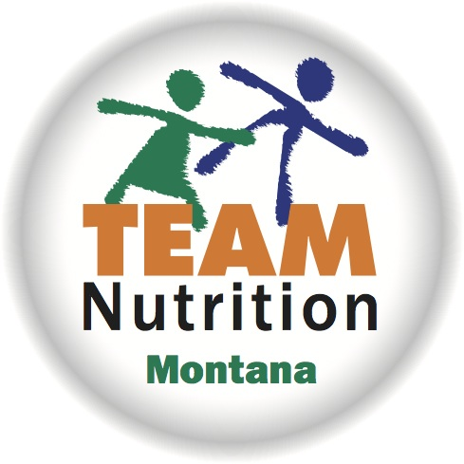
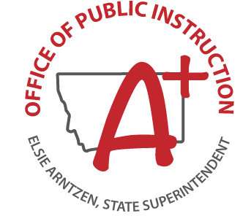

USDA Foods available to Montana Schools Spring 2020

Entrees
Ground beef
Beef Crumbles
Beef patty
Fish
Ham slices
Pulled pork
Smoked deli turkey
Chicken fajita strips
Chicken tenders
Cheese slices
Mozzarella string cheese
Peanut Butter
Yogurt cup

Grains
Pancakes
Macaroni, whole grain
Blueberry bread
Fruits
Cherries, sweet, pitted
Pears, diced
Peaches, sliced
Applesauce cup
Blueberries
Strawberry cup
Mixed berry fruit cup
Peach cup, diced, frozen

Vegetables
Green beans
Vegetarian baked beans
Peas
Tomato sauce
Sweet potato crinkle cut fry

Hot Menu ideas:
Chili Mac
Sloppy Joes
Beef burritos/tacos
Pulled pork sandwich or rice bowl
Chili
Warm pancakes with peanut butter

Try these colorful, tasty Harvest of the Month recipes:
Roasted Chickpeas
Turkey, Spinach, Apple Wrap
Lentil Squash Hummus
Magenta Root Slaw

Cold Menu ideas:
Macaroni salad with a cold meat and cheese
Chef salad
Chicken fajita wrap sandwiches
Lettuce wraps
Chicken tender sandwiches
Peanut butter and jelly sandwiches (made on regular bread or blueberry bread)
Yogurt, fruit and blueberry bread
Deli sandwiches

s

- For more information about the USDA Foods Program, contact Pam Fruh, OPI School Nutrition Programs Food Distribution Program Manager, at 406-444-4412 or Pamela.Fruh@mt.gov
- South Dakota State University Extension Program has an excellent resource on Grab and Go Style Meal Service Resources for Schools which provides menu planning tips and provides a 4 week lunch menu for grades K-8 and 9-12.
https://extension.sdstate.edu/grab-and-go-style-meal-service-resources-schools

