

2026-2027

Early Targeted Interventions
(Early Literacy & Early Numeracy)
JUMPSTART PROGRAM

Early Targeted Interventions Summer Jumpstart program setup and reporting must be completed by the conclusion of the district’s 26-27 Jumpstart program and certified no later than September 4, 2026.

Qualified students, entering Kindergarten to 3rd grade (for the 26-27 school year), enrolled in an Early Targeted Interventions Summer Jumpstart program are eligible for an additional 0.25 ANB. Jumpstart participants must have an Early Targeted Interventions eligibility record, an enrollment record in a Jumpstart calendar with a program duration of at least 4 weeks and 120 instructional hours and be included in the district's Jumpstart certification. Districts will create calendars, courses/sections, enrollments and eligibility records, then certify Jumpstart program information at the end of the session.

Students who are assessed and deemed eligible but do not participate in the summer Jumpstart program (or any other Early Targeted Interventions program) should still have an eligibility record entered.

Step 1: Create jumpstart calendar(s)
PATH: Scheduling & Courses>Calendar Setup>Calendar Wizard
- Select Create new Calendar(s) by rolling forward selected data or creating a new blank calendar and click Next.
- Select Year (26-27).
- Enter Start Date and End Date (program start and end date for summer Jumpstart).
- Select prior year Jumpstart calendar(s)/school(s) to roll or
select school(s) to add new calendar.
- Click Next.
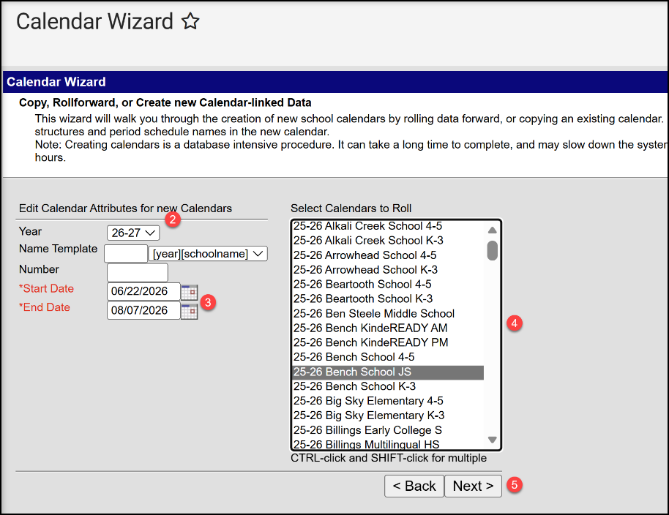

- Check boxes to copy data from prior year calendar (if not copying from a prior year Jumpstart calendar, it’s recommended to Create New Blank Calendar and add calendar attributes individually).
- Click Run Wizard.
- Refresh browser page and select 26-27 Jumpstart calendar.

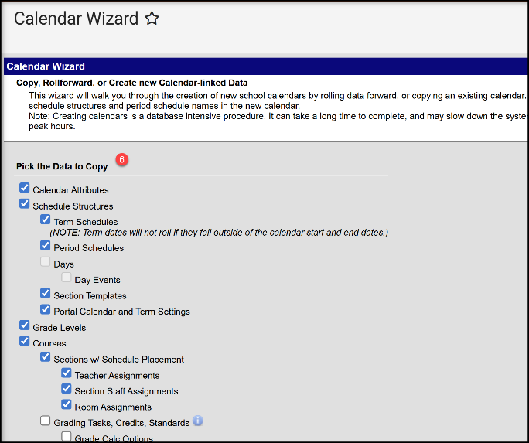
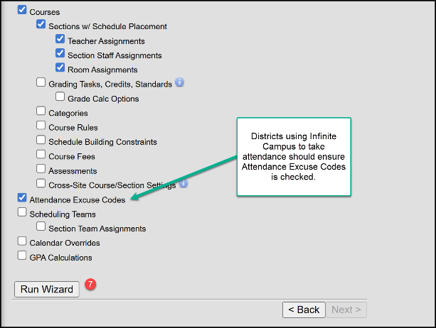

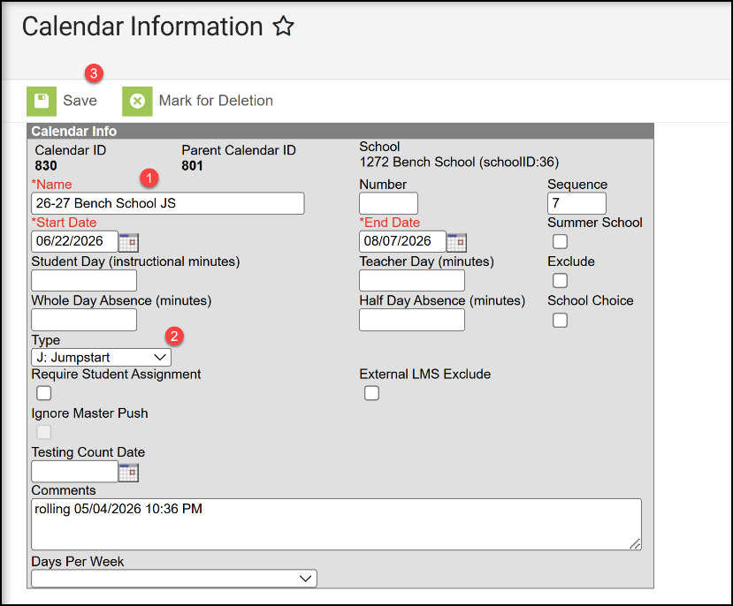
Step 2: Edit calendar information
PATH: Scheduling & Courses>Calendar Setup>Calendar Information
- Calendar Information
  - Change Calendar Name to identify as Jumpstart calendar/program (optional).
  - Select Type J: Jumpstart (required).
  - Click Save.

- Grade Level Setup
PATH: Scheduling & Courses>Calendar Setup>Grade Level Setup
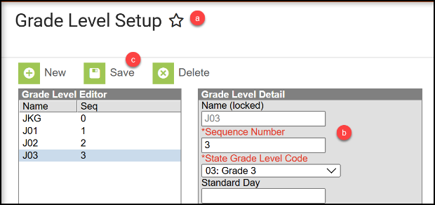
  - Review existing Grade Level(s) or click New to add Grade Level(s) to selected Jumpstart calendar.
  - Enter Name, Sequence Number, and State Grade Level Code. To avoid confusion with other grade levels, it is recommended to customize the grade Name (JKG, J01, J02, J03).
  - Click Save (repeat for additional grade levels).

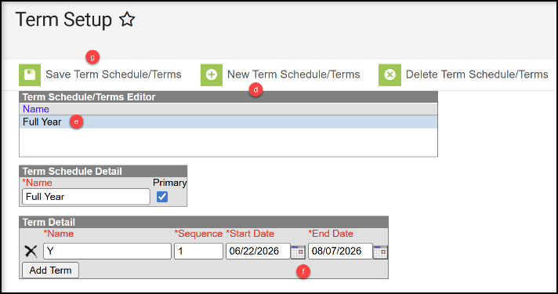
3. Term Setup
PATH: Scheduling & Courses>Calendar Setup>Term Setup
  - Review existing Schedule/Terms or click New Term Schedule/Terms to add.
  - Schedule/Term Name should be ‘Full Year’.
  - Select ‘Full Year’ and enter program start and end dates.
  - Click Save Term Schedule/Terms.

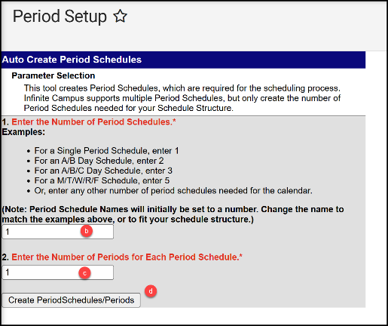
- Period Setup
PATH: Scheduling & Courses>Calendar Setup>Period Setup
Option 1: Create New Period Schedule
  - Click New Period Schedule
  - Enter the Number of Period Schedules (enter 1, unless schedule varies by day).
  - Enter Number of Periods (the number of times attendance is taken per day)
  - Click Create Period Schedules/Periods

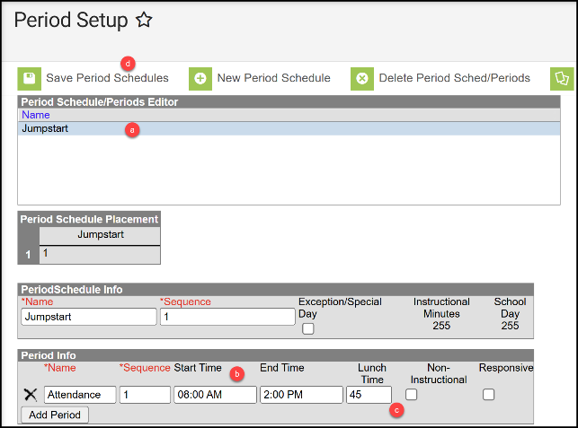
Option 2: Existing Period Schedule
- Select Period Schedule.
- Review/enter Start Time and End Time.
- Review/enter total non-instructional minutes (lunch, recess, etc.) in the Lunch Time Field.
- Click Save Period Schedules. Repeat for any additional Period Schedules (if applicable).

- Day Setup
PATH: Scheduling & Courses>Calendar Setup>Day Setup
- Click Day Reset.
- Enter Student/Instructional Start and End Dates.
- Select days of the week students will attend.
- Click Create Days.
- To remove non-school days, click the date and select Delete Day/Day Events (e.g. July 4th). Repeat as applicable.
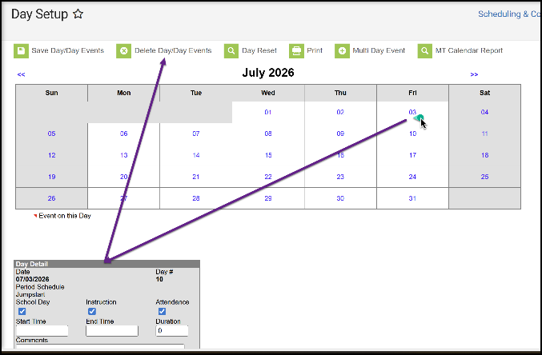
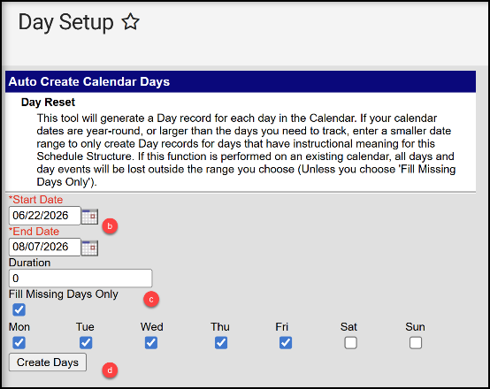

- Verify Attendance Codes.
PATH: Attendance Office>Settings>Attendance Code Setup
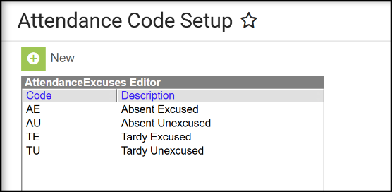
Recommended Attendance/Excuse Codes:
  - EA – Excused Absent
  - UA – Unexcused Absent
  - ET – Excused Tardy
  - UT – Unexcused Tardy

Step 3: Enroll students using the student locator wizard
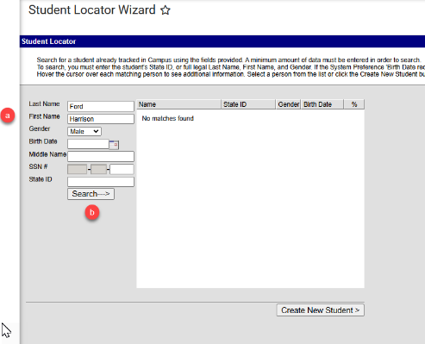
PATH: Student Information>General>Student Locator Wizard
- Verify the 26-27 Jumpstart calendar is selected.
- Open the Student Locator Wizard.
  - Enter the Last Name, First Name, and Gender.
  - Click Search.

*Refer to Appendix for upload instructions/options

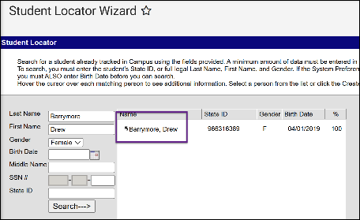
There are 3 scenarios for creating an enrollment:
- If the student had a previous enrollment in the district, the student’s name will be prefaced with a back arrow.
  - Select the student.
  - Click New to add an Enrollment.
  - Verifying the Calendar is correct.
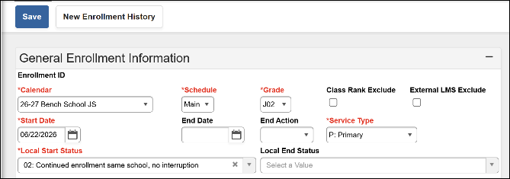
  - Enter Start Date, Local Start Status, and Grade.
  - Save.

- If the student did not have a previous enrollment in the district but was enrolled in another Montana district, the search will return a match (hover over student name to verify match):
  - Select the student.
  - Review name and birthdate. Enter Race/Ethnicity.
  - Verifying the Calendar is correct.
  - Enter Start Date, Local Start Status, and Grade.
  - Click Save.
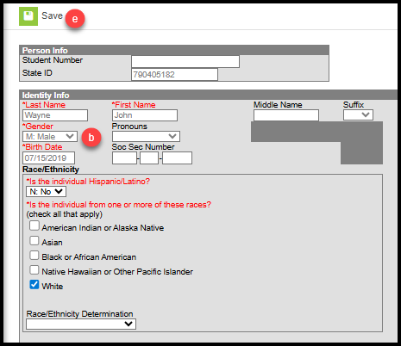

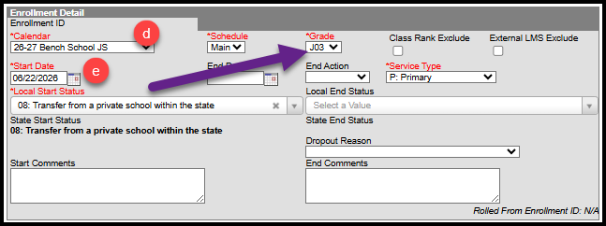

- If the student was never enrolled in a Montana district (new to Montana or public school) the search would return no match:
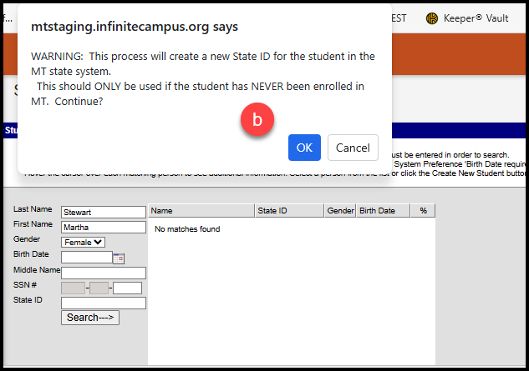
  - Click Create New Student.
  - Review the warning (pop-up) and click OK.
  - Enter Birthdate and Race/Ethnicity.
  - Verifying the Calendar is correct.
  - Enter Start Date, Local Start Status, and Grade.
  - Save

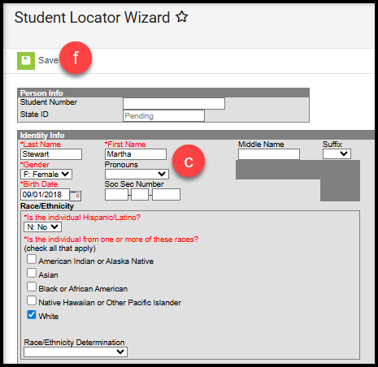

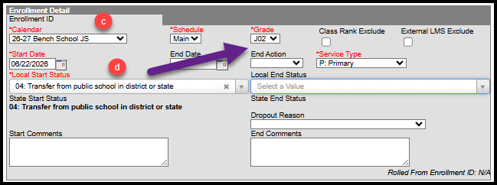

Step 4: Create eligibility record(s)
PATH: Student Information>State Programs>Early Targeted Interventions
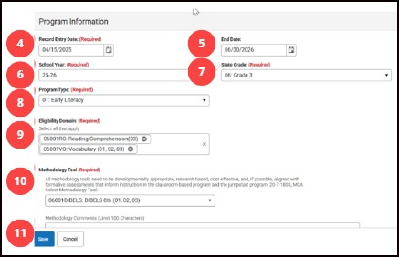
NOTE: Eligibility records (Literacy or Numeracy) are valid for all Early Targeted Interventions program enrollments of the applicable year (Jumpstart, Classroom-Based, and/or Home-Based).

- Search & find the student.
- Navigate to Early Targeted Interventions.
- Click New to add a new record.
NOTE: must input items in specific order as detailed record
- Enter Record Entry Date. Input the date assessment was given. Note: this field may be renamed “Assessment Date” later.
- End Date: Defaults to June 30 of the selected School Year.
- Enter School Year: year for which program eligibility is applicable.
- Enter State Grade: grade level of the assessment tool used to determine eligibility (grade selection limits available options for Domains and Methodology Tools).
- Select Program Type: Early Literacy or Early Numeracy (Program Type selection limits applicable options for Domains and Methodology Tools). Only one eligibility record is required for program participation in any ETI programs (classroom-based, home-based, and jumpstart).
- Select Eligibility Domain(s) – Select all Domains that indicate student eligibility.
- Select Methodology Tool – if Other is selected, comments are required in the Methodology Comments field. (If Other is not selected, the Methodology Comments field must be blank)
- Click Save.

Step 5: Add district assignments for teachers
PATH: Census>Staff>District Assignments
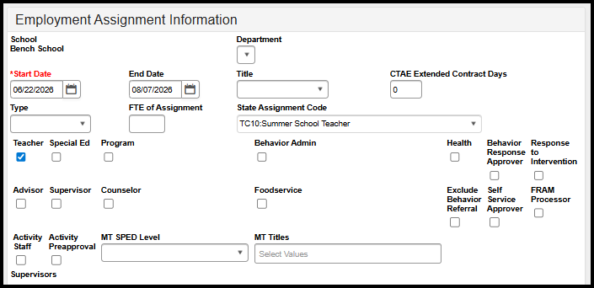
- Click New.
- Select the school where the Jumpstart program is located.
- Enter the Start Date (End Date can be added if the teacher will not continue this assignment).
- For the State Assignment Code select TC:10 Summer School Teacher. No FTE for this code.
- Select the Teacher checkbox.
- Click Save.

Step 6: Create courses, sections, and add students
- Add Course.
PATH: Scheduling & Courses>Courses>Add Course
  - Enter course Number and Name.
  - Select NCES data
    - SCED Subject Area = 23
    - SCED Course Identifier
- 012 (multi-grade level classes)
- or 003 to 006 (for single grade level classes)
    - SCED Course Level = GE: General Education
    - SCED Lowest Grade = Kindergarten (or as applicable)
    - SCED Highest Grade = Grade 3 (or as applicable)
  - Check box for Attendance (in Course Setup area)
  - Click Save.

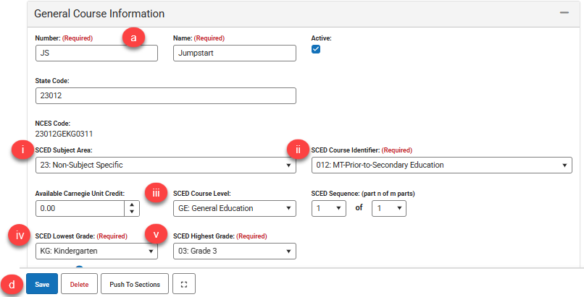
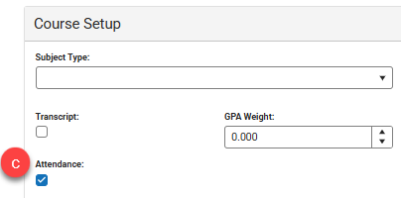
Create a Course Section.

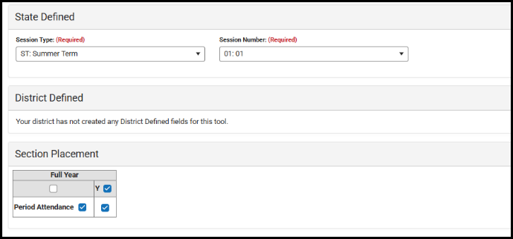
- Create a course section.
PATH: Scheduling & Courses>Course Sections
  - Navigate to Course Sections.
  - Search for new Jumpstart course.
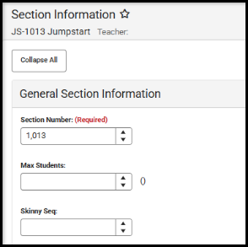
  - Click Add Section
(or click existing section, if copied from prior year).
  - Assign a Section Number.
  - Session Type = ST: Summer Term.
  - Select a Session Number.
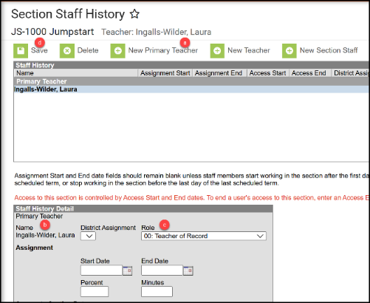
  - Check the box(es) under Schedule Placement.
  - Click Save.

- Click Section Staff History to add a teacher.
PATH: Scheduling & Courses>Courses>Section Staff History
  - Click New Primary Teacher.
  - Select teacher name from the dropdown.
  - Role = 00: Teacher of record.
  - Click Save.

- Add Students to the Roster.
PATH: Scheduling & Courses>Scheduling>Requests & Rosters
  - Click View by: Courses.
  - Select the Section to build the roster.
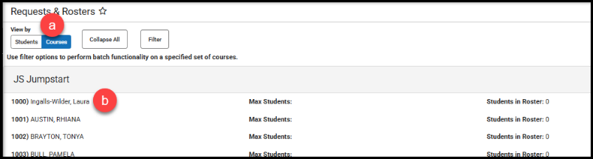

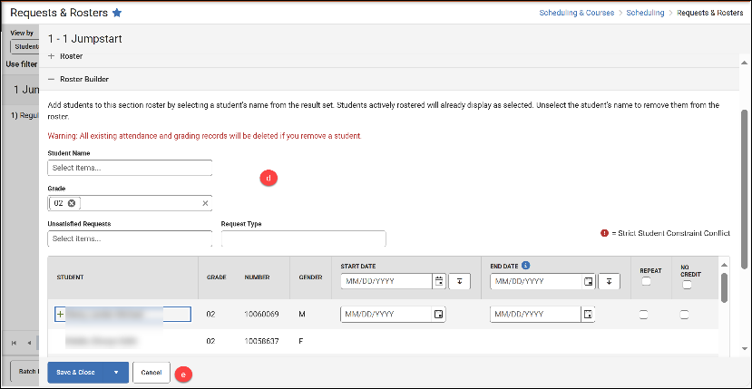
  - Click Roster Builder.
  - Add Students by Grade or click the student’s name to add to the Roster (Start and End Date are not required unless a student starts after the first day of the course or ends before the last day of the course).
  - Click Save.

Step 7: Populate end of year attendance totals
(complete after program ends; requires ALL Jumpstart enrollments are ended)

For districts taking daily attendance in Infinite Campus:
PATH: Reporting>MT State Reporting>MT EOY Attendance Totals
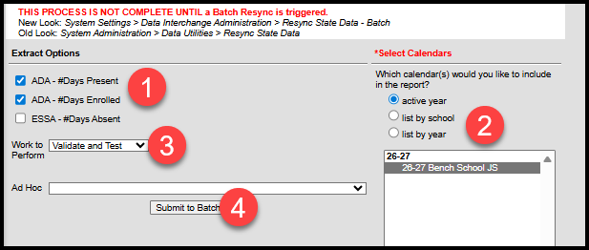
- Check the boxes for ADA - #Days Present and ADA - #Days Enrolled
(NOTE: ESSA Absent data is not required for Summer Jumpstart enrollments)
- Select one or more Calendars.
- Choose Validate and Test or Update Enrollments (recommend Validate and Test first). Common errors on this file include students with enrollments not ended, students without a schedule, or students with Service Type issues.
- Submit to Batch.

For districts NOT taking daily attendance in Infinite Campus:
- Refer to Appendix for upload instructions/options
- Alternatively, the End of Year Attendance Totals for each student can be entered manually.
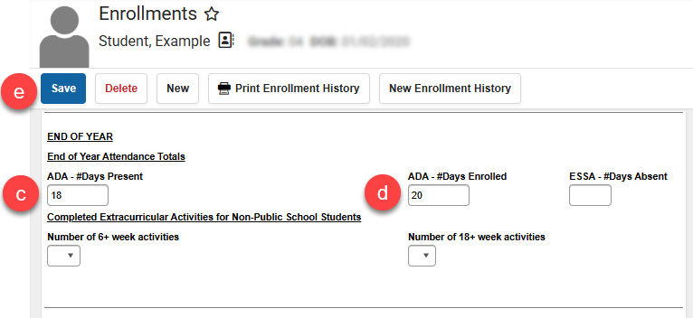
PATH: Student Information>General>Enrollments
  - Select the student.
  - Select the Jumpstart enrollment record
  - Input the ADA - #Days Present
  - Input the ADA - #Days Enrolled
  - Click Save.

Step 8: Resync data
PATH: System Settings>Data Interchange Administration>Resync State Data - Batch

- Select the checkbox in front of DIS Objects to select all.
- Click Send Resync.
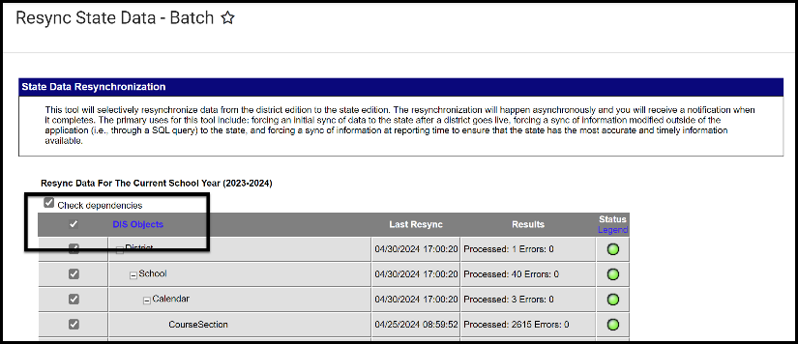

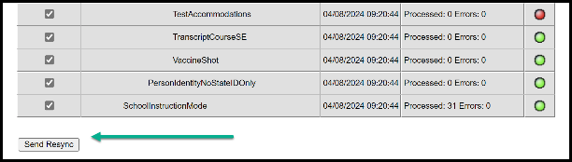

Step 9: Validate data
PATH: Reporting>Data Validation> Data Validation Reports
- Review the following Validation Reports to check for errors and review the data before certifying. Choose applicable report from drop-down.
  - Jumpstart Validation Errors and Warnings
(review errors/info; make corrections; rerun as applicable until error free; resync)
  - Jumpstart Certification (collective data being certified – review for accuracy)
Once all errors and warnings have been checked, choose the Report Data Source option of ‘Run at State’. Running the report at both the district and state ensures that data has fully synced prior to certification.
If there are mismatches between the state and district, repeat step 8 (Resync Data) and re-run the Validation Report at the state until district and state data matches.

Step 10: Certify data
PATH: Reporting> Data Certification>Event Certification
There are three separate files included in this certification: Enrollment, Teacher Class, and Aggregate Hours.
*Please wait at least 60 minutes after a complete resync before certifying data.

Follow these steps to complete data certification.
Certification Category
- Select Certification Category.
- Current certifier has the Role of Certifier and Active is checked.
- To remove a Certifier, un-check Active and change Role to Reviewer.
- To change from Active Certifier to Active Reviewer (or vice-versa), click Role (blue highlight is selected Role).
- To add a new Certifier, click Add Member.
  - Enter Staff Name or Staff State ID (SEID).
  - Click Name, choose Role, and select Active.
  - Click Save.
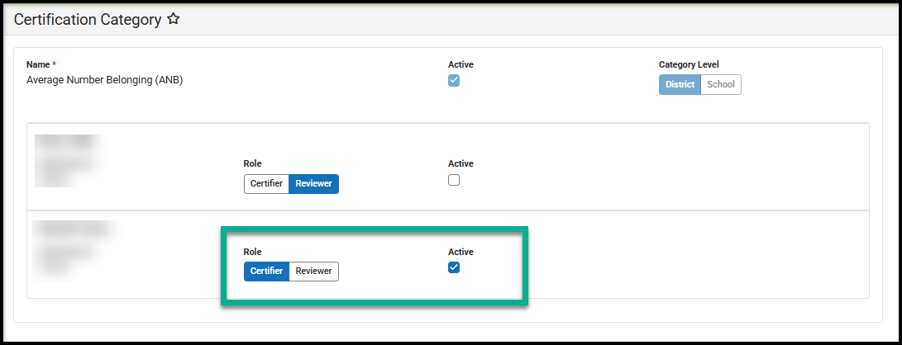
Certification Event
Districts must validate their data at the District, then the State – before taking a snapshot and completing data certification. Click Start Certification to begin the process.
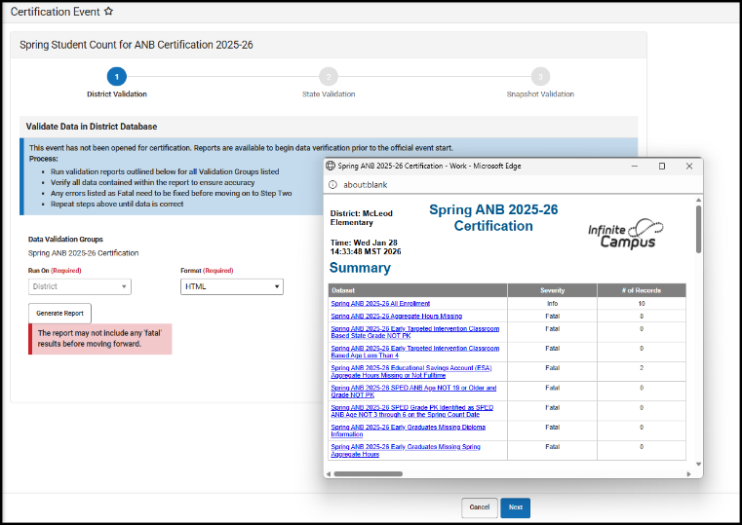
Step 1: District Validation
Click Generate Report to run the Certification validation at the District. The state identifies errors that will prevent a district from certifying. If there are errors on the District Validation you will not be able to continue with Certification. Clear the errors, then re-run the District report. Once the report is clear, continue to Step 2.

Step 2: State Validation
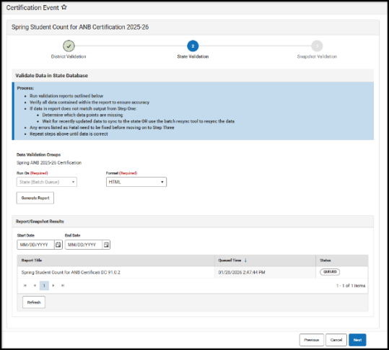
Click Generate Report to run the Certification validation at the State. The results will queue in the Report/Snapshot Results. Click Refresh until the report Status shows Completed. Click the Report Title to review results. If there are errors on this report, data is not fully synced. Return to the Resync Data step above and complete a full data resync. Once that step is completed, start with Step 1 again. Once the State Validation is clear, continue to Step 3.

Step 3: Snapshot Validation
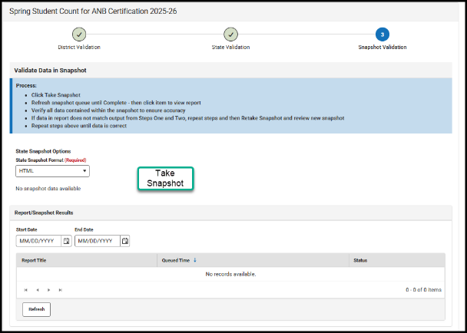
Click Take Snapshot to create a district snapshot. The results will generate in the Report/Snapshot Results table below. Open the snapshot to review data. If the snapshot is accurate, click Next to continue to Step 4.

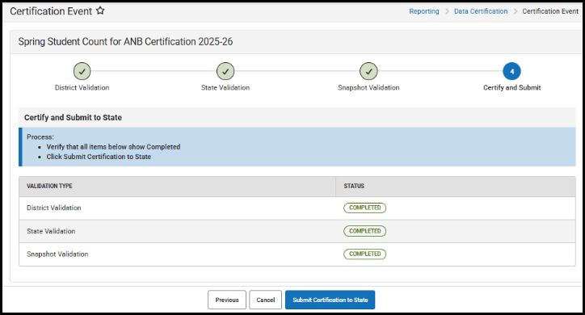
Step 4: Certify and Submit
Review Steps 1-3 are completed.
When satisfied with the results of the snapshot created,
click Submit Certification to State.

APPENDIX

ENROLLMENT - File Upload Process
PATH: Reporting>MT State Reporting>MT Data Upload

Districts that use a 3rd party Student Information System (SIS) may use the file upload process to enroll students and enter attendance.

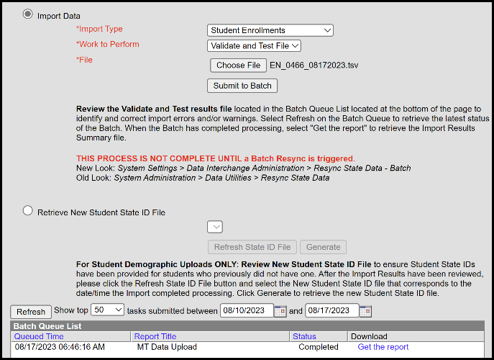
- Upload the Student Demographics file (required only for newly enrolled students), followed by Student Enrollments, then End of Year Attendance Totals.
- Extract the upload file from the district’s SIS or create a text, tab delimited file from one of the upload templates. Instructions for using the templates are embedded in the template file.
- Select the Import Type, the Work to Perform and choose the file to be uploaded. Click Submit to Batch.
- Review the Validate and Test results file located in the Batch Queue List located at the bottom of the page to identify and correct import errors and/or warnings.
  - Select Refresh on the Batch Queue to retrieve the latest status of the Batch.
  - When the Batch has completed processing, select "Get the report" to retrieve the Import Results Summary file.
- For Student Demographic Uploads ONLY: Review New Student State ID File to ensure Student State IDs have been provided for students who previously did not have one. After the Import Results have been reviewed, please click the Refresh State ID File button, and select the New Student State ID file that corresponds to the date/time the Import completed processing. Click Generate to retrieve the new Student State ID file.

NOTE: This process is not complete until a Batch Resync is triggered (see step 8)
PATH: System Settings > Data Interchange Administration > Resync State Data – Batch

END OF YEAR ATTENDANCE TOTALS - File Upload Process
PATH: Reporting>MT State Reporting>MT Data Upload

Districts that use a 3rd party Student Information System (SIS) or other attendance method may use the file upload to populate End of Year Attendance Totals for Jumpstart enrollments.

- Upload the End of Year Attendance Totals file.
- Refer to step 8 – step 9 – step 10 to complete the Jumpstart Data Validation & Certification process.

