
This process is to be completed for all students participating in an Early Targeted Intervention Classroom-Based Program during the regular school year.

2026-2027

Early Targeted Interventions

(Early Literacy & Early Numeracy)

Classroom-Based Program

Please visit our Early Targeted Interventions page for more information.

IMPORTANT: Students who are assessed and deemed eligible for Early Targeted Interventions for Jumpstart, Classroom-Based or Home-Based programs but do not participate in any of the programs should still have an eligibility record entered in Infinite Campus.

Creating Early Targeted Interventions Eligibility Record(s)
PATH: Student Information>State Programs>Early Targeted Interventions
NOTE: Eligibility records (Literacy or Numeracy) are valid for all Early Targeted Interventions program enrollments of the applicable year (Jumpstart, Classroom-Based, and/or Home-Based).
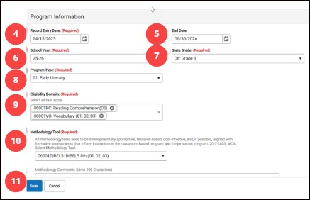
- Search & find the student.
- Navigate to Early Targeted Interventions.
- Click New to add a new record.
Note: must input items in specific order as detailed record
- Enter Record Entry Date. Input the date assessment was given. Note: this field may be renamed “Assessment Date” later.
- Enter End Date – June 30th of Early Targeted Interventions School Year
- Enter School Year – year for which program eligibility is applicable
- Enter State Grade – grade level of the assessment tool used to determine eligibility (grade selection limits available options for Domains and Methodology Tools)
- Select Program Type – Early Literacy or Early Numeracy (Program Type selection limits applicable options for Domains and Methodology Tools). Only one eligibility record is required for program participation in any ETI programs (classroom-based, home-based, and jumpstart).
- Select Eligibility Domain(s) – Select all that apply for specific student as eligible.
- Select Methodology Tool – if Other is selected, comments are required in the Methodology Comments field. (If Other is not selected, the Methodology Comments field must be blank)
- Click Save.

**HOME-BASED ONLY: Once a student has an eligibility record, home-based record, and the district has indicated participation in the home-based program, the student will be allocated a Waterford license.

Classroom-Based Early Targeted Interventions Program

Program Requirements
- Eligible child who is 4 years of age or older on or before September 10, and who is not entering and who has not completed kindergarten.
- Programming must be between half and full-time (minimum of 360 instructional hours) during the regular school year.
- Must be determined eligible utilizing approved evaluation methodology.
- An eligible child may be included in enrollment counts for the purpose of ANB Calculations.
- Class size is capped at 10 students per 1 appropriately licensed teacher (Early Childhood or Elementary Education endorsed). An Early Childhood qualified paraprofessional allows overload for class size up to 18. See ARM 10.63.107.
NOTE: If combined Early Targeted Invention and Kindergarten class, the class size is limited by the Early Targeted Interventions classroom maximums.
- Students must be rostered to course section(s) assigned with properly licensed and endorsed Primary Teacher. Paraprofessional(s) should be assigned as additional Section Staff specific to class overload requirements. Teachers assigned to the classroom-based program must hold one of the following endorsements: Early Childhood (P-3) or Elementary (K-8).
- Instruction must align with the Early Learning Developmental Domains and Content Standards.

Infinite Campus Requirements
- Students must have an enrollment at the school, mapped to State Grade PK. Recommend custom grade (example: ETI) mapped to state grade PK.
- The enrollment Service Type is P: Primary (S: Partial if student has concurrent Head Start enrollment)
- Check the Fall and/or Spring Classroom-Based Interventions checkbox to indicate participation on either count date (the MT Count Date Attendance tool does not populate the checkboxes).
- The student must have an Early Targeted Interventions eligibility record for the current school year.
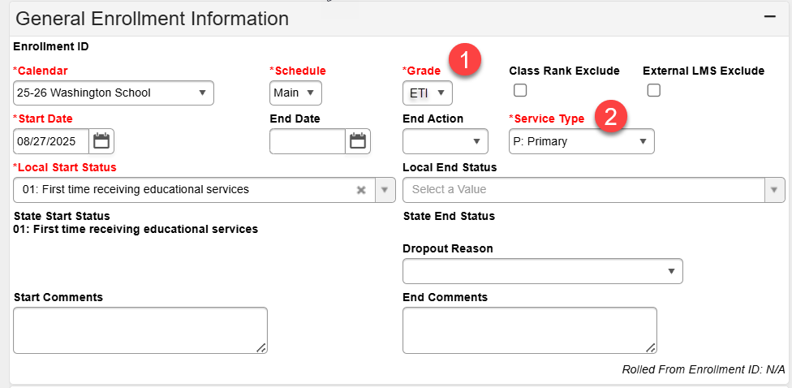
- State reporting requirements for Title, FRAM, SPED, 504, and any other K-12 programs are also required for Classroom-Based Early Targeted Interventions students.

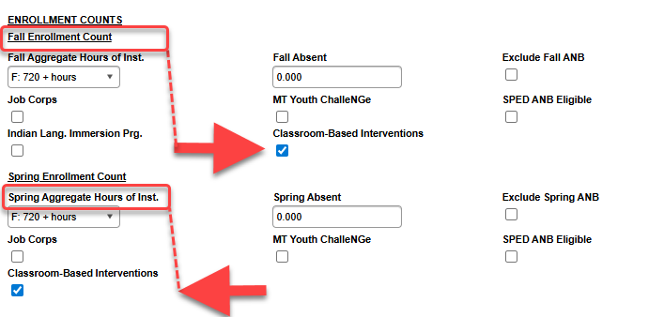

Infinite Campus Requirements (continued)

- Map Course Code for Early Targeted Interventions courses
- Grade-specific classrooms: NCES Code 23001
[SCED Subject Area 23: Non-Subject Specific; SCED Course Identifier 001: MT-Early Childhood Education]
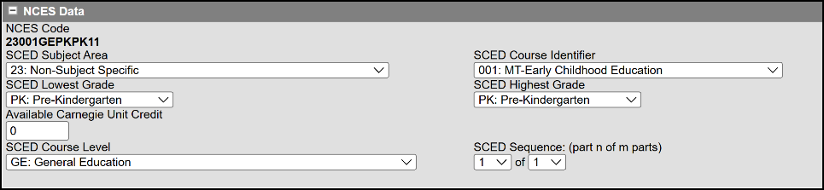

- Mixed-grade classrooms: NCES Code 23012
(combined Early Targeted Interventions [PK] and Kindergarten [KG] class)
[SCED Subject Area 23: Non-Subject Specific; SCED Course Identifier 001: MT-Prior-to-Secondary Education]
Assign properly licensed and endorsed educator as Primary Teacher (Role: Teacher of Record) to the course (must be either Early Childhood or Elementary Education endorsed). Class size is limited to 10. With classrooms exceeding 10 students, an early childhood paraprofessional is required at a rate
of one hour per day, per student overload up to 15 students. At 16 to 18 students, a minimum of
one appropriately licensed and endorsed teacher and one early childhood paraprofessional is
required. See ARM 10.63.107
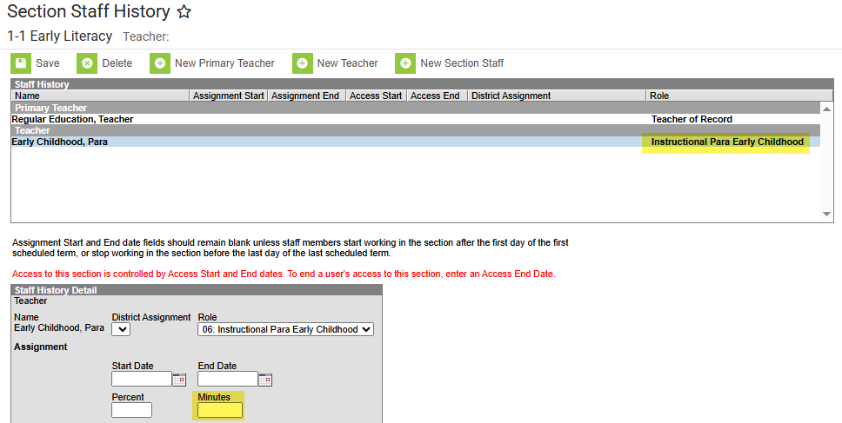

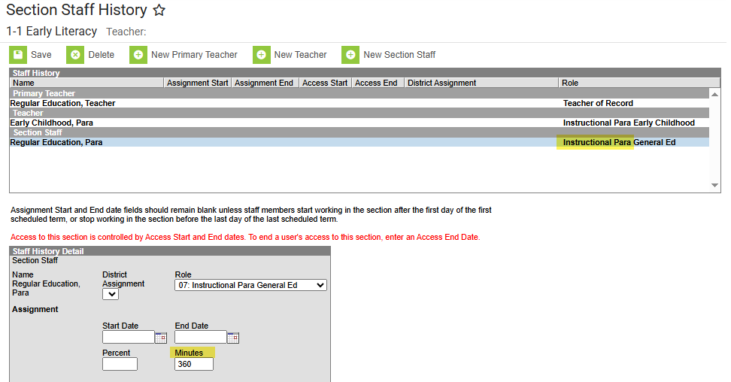

For support with calendar setup, enrollment(s), teacher assignment(s), course/section details, rostering, or other elements related Classroom-Based programs, please contact the EDUCATE Unit.

