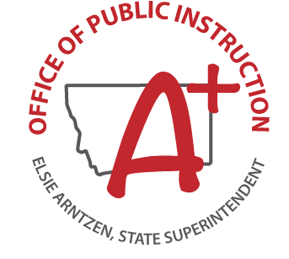
Montana Council on Educational Opportunity for Military Children – MIC3
Fall Meeting Agenda
August 10, 2018 ∙ 12:30 PM – 3:00 PM
Chief Joseph Elementary
5305 3rd Ave. S. Great Falls, MT 59405

- 12:30 PM – 1:00 PM Visit the “Welcome Fair” for Malmstrom AFB Families at Chief Joseph Elementary (See attached flier)
- 1:00 PM – Begin Meeting
- Approve Minutes May 2018 meeting
- Welcome New Member: Captain Michelle Bogden
- Logo for Approval
- Budget Draft
- By-laws Draft
- 3:00 PM - Conclude Meeting
Current Membership:
Elsie Arntzen, Superintendent of Public Instruction
Mark Beckman, Executive Director MHSA
Captain Michelle Bogden, Service Member & Family Support Branch Chief
Senator Ed Buttrey
Leisa Drain, Malmstrom AFB
Tammy Lacey, Great Falls Public Schools Superintendent
Representative Jean Price
Harold Stearns, Compact Commissioner, Ret. Brigadier General

