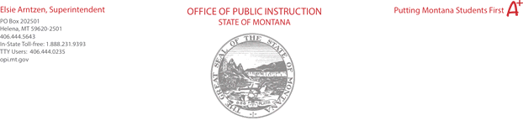

Guidance on Determining Attendance for the Fall 2020 ANB Collection Student Count

Released 9.17.2020

Administrative Rule 10.20.102 (4)(a) states …
A school district may not count as enrolled for purposes of ANB calculations a student who has been absent for the 11th consecutive pupil instruction day immediately prior to and including the official count date.

All district should carefully review this ARM as it highlights specific requirements for counting students. Remember a school district must conduct the minimum number of hours of instruction, in order to collect full ANB, See ARM 10.20.102 (15) (a), unless the district’s board has adopted proficiency as found in 20-9-311 (4) (d) MCA.

Today, attending school looks different for many students. One issue that has arisen is how to take attendance during remote learning or other offsite settings. Examples for taking attendance in offsite learning include but are not limited to: check-in process with a specific teacher, student digital login to the district’s learning management system, date and time stamped work submitted during the day in google classroom, calling students, Zoom check-in, emails from students, etc.

District questions should be directed to the OPI Chief Financial Officer Ken Bailey at kbailey HYPERLINK "mailto:kbailey2@mt.gov"2 HYPERLINK "mailto:kbailey2@mt.gov"@mt.gov.

